UNIVERSITY OF WAIKATO

Hamilton
New Zealand

Does repeated cross-section data help explain consumer inflation expectations revisions?
Harold Glenn A. Valera, Cymon Kayle Lubangco, and Mark J. Holmes

Department of Economics

Working Paper in Economics 3/26
February 2026
Corresponding Author
Harold Glenn A. Valera
BSP Research Academy
Bangko Sentral ng Pilipinas
Malate 1004, Manila
Philippines
Email: ValeraHA@bsp.gov.ph

Cymon Kayle Lubangco
BSP Research Academy
Bangko Sentral ng Pilipinas
Malate 1004, Manila
Philippines
Email: LubangcoC@bsp.gov.ph

Mark J. Holmes
School of Accounting, Finance and Economics
University of Waikato
Hamilton, 3240
New Zealand
Email: holmesmj@waikato.ac.nz

Abstract

We propose a new measure of revisions to consumer inflation expectations using repeated cross-sections rather than requiring panel data. We calculate the value of group average expectations in a prior period as a proxy for what an individual’s expectations might have been using micro data in the Philippines for Q1 2010 to Q2 2024. In contrast to existing mixed evidence, the resulting revisions show sensitivity to price changes in 14 food and energy goods. The equivalence testing finds that the group-based coefficients are valid, as they are: (a) different from an overall sample average-based revision results with Philippine data, and (b) similar to rotating panel-based revision results using data from the Michigan Survey of U.S. households. Using Philippine data, we also provide new evidence of significant effects of a firm’s frequency of price changes on expectation revisions.

Key words
Inflation expectations
Forecast revision
Repeated cross-section
Rotating panel
Food and energy prices
Equivalence testing
Rational inattention
Sticky information

JEL Classification
C53
D84
E31

Acknowledgements
We are grateful for helpful suggestions from Calla Wiemer of the American Committee on Asian Economic Studies and from participants of the 20th East Asian Economic Association International Convention, the 65th New Zealand Association of Economists Annual Conference, and the BSP Research Huddle. The authors also thank the BSP Department of Economic Statistics for providing the Consumer Expectations Survey microdata and Jessie G. Esquivel from the BSP Research Academy for his excellent research assistance.

Disclaimer: This paper presents a draft research output and is disseminated for discussion purposes. Comments are welcome and may be sent to the corresponding author's email address. The views expressed in this discussion paper are those of the author/s and do not represent the official position of the Bangko Sentral ng Pilipinas.
1. Introduction

Macroeconomists are keenly interested in consumer inflation expectations because they are a crucial input into economic models and significantly influence household and firm decision-making—from consumption and investment to wage bargaining. These expectations are fundamental to the monetary policy transmission mechanism, as agents' beliefs about future prices often become a self-fulfilling prophecy. Expectations are typically measured via household surveys, such as the U.S. Michigan Survey of Consumers (MSC) where individuals are directly asked about the rate of inflation they expect over a specific future horizon.

Analyzing how these expectations change over time, or how they are revised, is vital for understanding how consumers acquire and process information. The literature on consumer expectation revisions traditionally requires a rotating panel, such as the ones used in Drager and Lamla (2012) and Kim and Binder (2023). With a rotating panel, obtaining the revision to an individual’s expectations is a simple matter of subtracting the value of his or her expectations in a prior period from the value for the current period. However, estimating revisions to expectations poses a challenge if microdata only has repeated cross-sections. Because microdata lacks individual level continuity, a suitable proxy for prior expectations and a standard for verifying it are necessary. However, there are no studies yet on the said topics in existing literature.

In this paper, we propose a group-based methodology for estimating revisions to consumer inflation expectations. This approach is a novel methodological contribution for studies that rely on repeated cross-sections rather than rotating panel data. Using data from the Bangko Sentral ng Pilipinas (BSP)’s Philippine Consumer Expectations Survey (CES) for Q1 2010 to Q2 2024, which include about 5,000 respondents in each wave, we classify demographic groups based on details like gender, age, income, and education to calculate averages for inflation expectations. Consistent with existing literature (Binder, 2018; Malmendier & Nagel, 2016), we first establish that demographic factors influence expectations. We then argue that within-group average expectations in a prior period can provide insights into what an individual’s expectations might have been.

Our approach complements related studies that model the formation of inflation expectations using repeated cross-section data (Sheen & Wang, 2023; Bachmann et al., 2015; Easaw et al., 2013). It differs from work like Patzelt and Reis (2024), which also uses cross-sectional variation but focuses on repeat participants. Our methodology does not require repeat participants. We estimate how group-based revisions react to price changes in 14 specific food and energy goods. While existing evidence on the sensitivity of inflation expectations to food prices (Kikuchi & Nakazono, 2023) or oil prices (Coibion & Gorodnichenko, 2015) is mixed, we find that changes in prices of food and energy goods induce an upward revision in the expectations of CES households. This outcome supports the idea that consumers use a heuristic in which "bad news" prompts them to revise expectations upward (Binder, 2017; Ehrmann et al., 2017). Unlike Patzelt and Reis (2024), who focus on the aggregate energy price effect, we explicitly model and control price changes in specific food and energy goods, thereby extending the work of Kikuchi and Nakazono (2023). This empirical investigation also complements other rotating panel-based studies focused on updating frequency or determinants (Binder, 2017; Pfajfar & Santoro, 2013; Drager & Lamla, 2012; Zhao, 2019; Drager & Lamla, 2017).

To ensure confidence in our method, we propose a two-way check using Fitzgerald’s (2025) equivalence testing. We reformulate the equivalence testing to compare our group-based estimates against two alternatives: (a) revisions calculated using an overall sample-average regression with CES data, and (b) individual-level revisions calculated using the MSC’s rotating panels. We define the region of practical equivalence (ROPE) based on policy-relevant inflation thresholds derived from Goodspeed’s (2025) work on forecasting inflation under various regimes, suggesting a level at which consumers begin to pay close attention to inflation news. The equivalence testing validates our approach, showing that the group-based coefficients are significantly different from the overall sample-average-based revision results using Philippine data and are similar to results derived from the rotating-panel data in the MSC.

Finally, we link the Philippine consumer data with firms-level microdata from the BSP’s Business Expectations Survey (BES) to perform an empirical analysis focusing on how the frequency of price changes as a proxy for the price signals that consumers observe. Building on Buckle et al. (2025), we calculate regional price change metrics for firms reporting increases, decreases, or changes in either direction. We document new findings regarding the role of the frequency of price changes in consumer expectation revisions.

The paper is organized as follows: Section 2 discusses literature on the formation and revision of consumer expectations. Section 3 describes the Philippine CES and the MSC microdata, and the specific food and energy price data used. Section 4 discusses the methodology, covering the details of the consumer forecast revisions model and the two-way validation check of the group-based methodology using equivalence testing. Section 5 discusses the empirical results for both the Philippines and the United States. The final section provides the conclusion.

2. The formation and revision process of consumer expectations
The literature suggests several models of the formation and revision process of consumer expectations. A key starting point is Mankiw and Reis’s (2002) influential paper, according to which the acquisition and processing of information entail costs and, thus, consumers update their information sets only sporadically. Their model emphasizes that new information disseminates gradually between individuals. This is consistent with Carroll’s (2003) epidemiological expectations-formation, in which information disseminates slowly. Carroll (2003) argues that consumers update their expectations by observing information circulating in the media, which is assumed to convey the forecasts made by professional analysts. While not everyone pays attention to economic news, Caroll (2003) argues that individuals attentive to economic news tend to adjust their expectations more often based on the news.

The tendency for frequent revision of expectations is also predicted by other models featuring endogenously sticky information, notably for consumers who face lower costs in interpreting inflation-related information (Mankiw et al., 2004; Reis, 2006). Meanwhile, a notable extension of Caroll’s (2003) epidemiological model made by Lanne et al. (2009) suggests a hybrid sticky-information model in which households form inflation expectations based on naïve reliance on recently released inflation data from professional forecasters. An alternative view gives rise to the so-called noisy information model. Specifically, Sims (2003) and Woodford (2003) argue that agents update their information continually, though imperfectly, owing to the noise that distorts the variables they observe. Using information theories, Sims (2003) advances a rational inattention model whereby agents optimally ignore certain macroeconomic data that are costly to obtain because of their limited information-processing capacity.

Xu et al. (2016) point out an important shortcoming of the sticky-information and rational inattention models: They do not account for the effect of memory of past inflation in shaping inflation expectations. In memory research, however, Morewedge et al. (2005) point out that people will likely use past memories, and notably extreme price changes, when they form their expectations about the future. However, Madeira and Zafar (2015) highlight that people’s memories of price changes have little to no correlation with the observed actual inflation.

However, recent literature focuses on how different information use influences the formation of a household's inflation expectations. Binder (2017) points out that when consumers update their inflation expectations, they have a model of the economy in mind that differs from the models used by economists and professional forecasters. In this respect, Ehrmann et al. (2017) explain that consumers may use some heuristics in which bad news leads them to revise inflation expectations upward. Using rotating MSC panels for 1978 to 2011, Drager and Lamla (2017) show that US households that hear inflation news raise their inflation expectations, while those who hear deflation news lower their inflation expectations.

Other authors argue that the formation of inflation expectations is directly influenced by demographic characteristics. Armantier et al. (2015) utilize panel data from the Federal Reserve Bank of New York (FRBNY) during the survey periods 10 July – 17 August 2010, and 3 January – 9 February 2011. They find that higher and more volatile inflation expectations are more likely to be observed by female, lower-income, and less-educated respondents with lower numeracy and financial literacy. More recently, Binder (2017) uses monthly panel data from the FRBNY Survey of Consumer Expectations and finds that consumers with high income and education are more likely to fine-tune their revision of inflation expectations. Using the panel data from the same survey source but for the period 2013 to 2018, Zhao (2019) reports contrasting evidence that updates to inflation expectations are unaffected by consumers’ education, income and numeracy level.

Another strand of literature concentrates on the determinants of revisions to household inflation expectations. Using quarterly panel data on Japanese consumers' inflation expectations collected by Intage Inc. from 2015 to 2019, Kikuchi and Nakazono (2023) show that a rise in food prices triggers upward forecast revisions while an energy price change has an insignificant influence on forecast revisions. On the contrary, using the MSC’s rotating panels from 1978 to 2014, Coibion and Gorodnichenko (2015) find that consumers’ inflation forecasts are highly sensitive to oil prices relative to that of professional forecasts. Using rotating panel from the MSC data for 2006–2015 in the context of the United States, Binder (2018) claims that consumers do not attach much weight to gas prices when forming their inflation expectations, even though gas prices are salient in everyday life. This finding is consistent with that of Zhao (2019), who reports that updates to overall inflation and those of gas, food, and other items have low correlations. By employing cross-sectional variation approach to repeat participants of the monthly CES for the Euro Area from 2020 to 2024, Patzelt and Reis (2024) find that a 1-percent rise in the price of electricity raises households’ average expected inflation by 1.0–1.3 basis points. These studies highlight that movements in food and energy prices are significant signals for consumers, and this leads them to update their inflation forecasts.

In terms of empirical investigation, our paper adds to the existing literature on revisions to consumers’ inflation expectations in a number of key aspects. We introduce and validate a novel group-based methodology for use with repeated cross-section data, provide new empirical evidence on the sensitivity of consumer revisions to specific food and energy prices, and document the role of the frequency of firm price adjustment in consumer expectation revisions.

3. Data
3.1 Repeated cross-section data from Consumer Expectations Survey

We construct our measure of inflation expectations in the Philippines using microdata from the CES, a nationally representative face-to-face survey launched in 2004. The CES is conducted quarterly by the Department of Economic Statistics (DES) of the Bangko Sentral ng Pilipinas (BSP). The CES seeks responses from household heads and covers households in the National Capital Region (NCR) and areas outside NCR, which consist of 51 provinces. The CES has been covering about 5,000 respondents each wave since 2013 and 2,000 respondents in earlier years. Our sample period covers Q1 2010 to Q2 2024, containing repeated-cross section data with 262,189 observations.

The survey contains information on individual characteristics like gender, age, education, and income. Gender has two categories (male and female), age has three categories (below 40, 40-60, above 60), education has three categories (primary, high school, college), and income level has three categories (low, medium, high). These classifications allow us to define 54 demographic groups.

The CES elicits year-ahead inflation expectations of specific items by asking respondents: “What do you think would happen to the prices of the following goods and services in the next 12 months?” Respondents are given the options: “Up”, “Same’, and “Down”. If the answer is up or down, the survey records the size of the expected price increase and decrease in percent.

To analyze the data, we construct the following consumer price index (CPI)-based inflation expectations variable:

$$π_{it}^{ec}=\frac{1}{24}\sum_{j=1}^{24}{D_{j}π_{itj}^{e}}$$

where $π_{it}^{ec}$ is the average of the sum of products of the expected direction of price change of a specific item $D_{j}$ and a respondent’s year-ahead inflation expectations $π_{itj}^{e}$ for $j=1,…, 24$. $D_{j}$ takes a value of 1, 0, or -1 if a respondent expects prices of items $j$ to increase, stay the same, or decrease, respectively.

Binder et al. (2024) and Kim and Binder (2023) employ a point estimate of expectations of the headline inflation using data from the FRBNY Survey of Consumer Expectations. In contrast, we use the CES data on point forecast for inflation of specific items to construct our CPI-based measure. The main reason is that the elicited data on expectations of the headline inflation rate in the CES might have a potential drawback due to the format of the following question: “The inflation rate of [the previous quarter] is at [provide inflation rate]. What do you think will the inflation rate be for the next 12 months?”

In this question, the information on the previous quarter’s actual inflation rate before asking the question may or may not be available to the respondents when they are forming their inflation expectations. However, Becker et al. (2023) point out that even minor variations in question format can influence the elicited expectations. Coibion et al. (2022) also suggest that giving additional information in the question, like the central bank’s statement about the inflation target, may influence survey responses. Moreover, Savignac et al. (2024) and Coibion et al. (2019) show that providing information about the previous inflation rate during the conduct of surveys makes the respondent’s inflation expectations biased.

3.2 Rotating panel data from Michigan Survey of Consumers

The consumer forecast-revisions literature traditionally requires a rotating panel. In this paper, we consider the MSC microdata to compare the individual level revisions from its rotating panels with the group-based revision approach discussed in Section IV. The MSC is a monthly survey with a minimum of 500 phone interviews (Kim & Binder, 2023) per wave. About 40 percent of respondents in each wave were also participants of the survey six months prior (Bachman et al., 2015).

As in the CES, we employ the same categories for gender and age groups in the MSC. As MSC has information on household income by income quintiles, we use two categories: the top 20 percent quintile (high-income), and the remaining quintiles (low-income). The MSC also identifies two levels of education: college and below-college levels. In turn, details on gender, age, education, and income allows for classification into 72 demographic groups. Our sample period for the MSC spans from January 2010 to June 2024. We focus on this sample period to align with the study period for the Philippines.

3.3 Price data of specific food and energy items

Aside from using the CES and MSC microdata, we obtain biannual CPI data for 14 specific food and energy goods from the Philippine Statistics Authority. The food items include prices of overall food, bread, cooking oil, fish, fruits, meat, milk, rice, sugar, and vegetables. Included in the energy items are prices of overall energy, overall fuel, diesel, and gasoline. Following Coibion and Gorodnichenko (2015), we use the biannual changes in food and energy prices rather than annual changes. Biannual changes allow researchers to regress individual revisions to inflation expectations on the changes in food and energy prices over the same period (Kikuchi & Nakazono, 2023). We also obtain biannual US CPI data for food, motor fuel, and other fuels corresponding to the region of residence (North Central, Northeast, South, West) of respondents in the MSC. The CPI data is sourced from the US Bureau of Labor Statistics.

The choice of specific items included in this study is guided by the literature on consumer inattention, which suggests that consumers use a change in goods prices they frequently observe as a signal of fluctuations in overall inflation rates. We might expect Filipino consumers to pay attention to the prices of both food and energy goods they frequently purchase, as implied by the consumption expenditure shares in Figure 1. However, they may be more attentive to the prices of food than energy items. For example, expenditure shares are especially large for rice, meat, and fish, and the shares for milk and vegetables are also larger than those for fuel. This pattern reflects that Filipino consumers have more opportunities to observe the change in food prices more often than oil prices. Thus, their inflation expectations may be more sensitive to a change in food price instead of oil price. Such sensitivity analysis of the Philippine case is important on account of the existing mixed evidence of high sensitivity of expected inflation by American (Coibion & Gorodnichenko, 2015) and Japanese (Kikuchi & Nakazono, 2023) consumers to gas price and food price, respectively.

Figure 1. Final consumption expenditure of consumers.
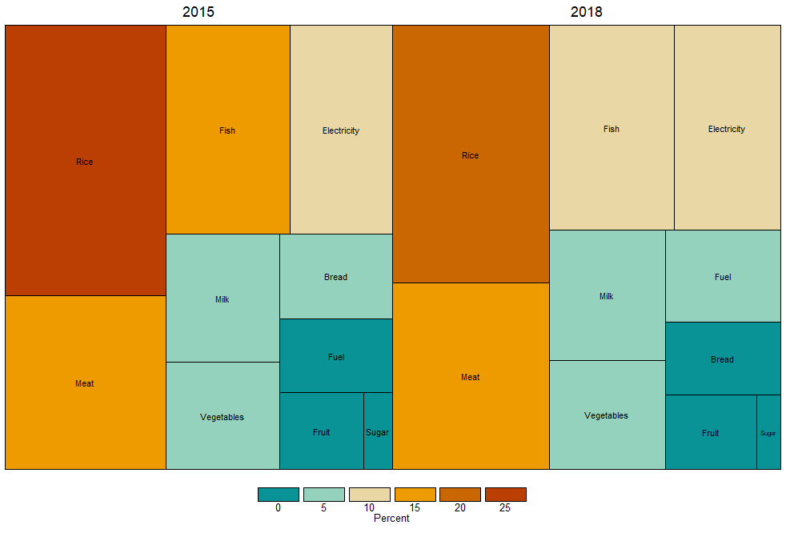
Source: Analysis of data from 2015 and 2018 Family Income and Expenditure Survey.

4. The group-based methodology and equivalence testing

4.1 The group-based methodology

For a repeated cross-section data c where individual continuity is absent, we propose a novel group-based methodology that defines the following inflation expectations revision ${Δπ}_{i,p,t}^{ec}$:

$${Δπ}_{i,p,t}^{ec}=π_{i,p,t}^{ec}-{\overline{π}}_{i,d,p,t-k}^{ec}$$

where $π_{i,p,t}^{ec}$ denotes the inflation expectations by respondent $i$, who is a resident of province $p$ in the current quarter $t$, and ${\overline{π}}_{i,d,p,t-k}^{ec}$ is the mean expectations in prior quarter $t-k$ of demographic group $d$ to which respondent $i$ belongs. The group-based method uses demographic factors such as gender, age, income, and education to take the average over the individual’s demographic group to proxy prior expectations. This methodological contribution is significant for broadening the scope of inflation-expectation research beyond the traditional requirement of a rotating panel.

Although rotating panel data are often used to investigate the sensitivity of consumers’ expectation revision to changes in aggregate food and energy prices, the repeated cross-section data is rarely used. We address this gap by estimating the following group-based revision ${Δπ}_{i,p,t}^{ec}$ regression model:

$${Δπ}_{i,p,t}^{ec}=φ_{i}+β_{j}^{c}π_{p,t}^{item}+μ_{p}+ω_{t}+ε_{i,p,t}$$

where $π_{p,t}^{item}$ refers to the biannual changes in the prices of specific food and energy goods with coefficients captured by the vector $β_{j}^{c}$, where $j=1,…,14$. The terms $μ_{q}$ and $ω_{t}$ control for the province and time-fixed effects, respectively. Following Patzelt and Reis (2024), we choose k = 2 quarters for our baseline estimate as it has relatively less noise.

Aside from the group-based approach’s benefit of estimating ${Δπ}_{i,p,t}^{ec}$ that can be applied to repeated cross-sections rather than requiring panel data, a key feature of our technique is that we explicitly model and control for price changes in specific food and energy goods. This allows us to extend the work of Kikuchi and Nakazono (2023) and to provide several important insights into consumer behavior in the Philippines. Considering the cross-section nature of our dataset, we run separate pooled ordinary least squares (OLS) regression of Eq. (3) to capture each effect of price change in specific good on ${Δπ}_{i,p,t}^{ec}$. Eq. (3) therefore features 14 $β_{j}^{c}$ coefficients. A priori, $β_{j}^{c}$ should be positive if consumers use a heuristic where "bad news" (price increases) prompts them to raise their inflation expectations.

4.2 Equivalence testing

We use the equivalence testing suggested by Fitzgerald (2025) to ensure confidence in our group-based method. According to Fitzgerald (2025), equivalence testing is a statistical framework designed to provide credible evidence that relationships are practically equal to zero. This testing procedure addresses limitations in standard null hypothesis significance testing and involves setting the ROPE. The ROPE, denoted as $\left[ϵ_{-},ϵ_{+}\right]$, is the smallest difference in coefficients $δ$ that are economically meaningful. $ϵ_{-}$ and $ϵ_{+}$ refer to the lower and upper bounds of the ROPE, respectively.
In this paper, we set the bounds of the ROPE over $ϵ∈[-0.03,0.03]$ and $ϵ∈[-0.04,0.04]$ using the evidence from Goodspeed (2025) about forecasting inflation under different regimes. The evidence shows an inflation target of 3.0–4.0 percent as a level at which consumers start paying close attention to inflation news. These ROPE values capture the policy-relevant transition point where consumer behavior shifts from rational inattention to increased sensitivity.
Fitzgerald (2025) suggests testing the null $H_{0}: δ≈0$, given that any value between $\left[ϵ_{-},ϵ_{+}\right]$ is considered practically zero. This null can be rewritten as $H_{0}^{TOST} : δ <ϵ_{-}$ or $δ > ϵ_{+}$ for the two one-sided tests (TOST) procedure, and $H_{0}^{\{N\}}:δ≥ϵ_{-}$ and $H_{0}^{\{P\}}:δ≤ϵ_{+}$ for the three-sided tests (TST) approach. These hypotheses can be tested using the following test statistics:

$$t_{-}=\frac{δ-ϵ_{-}}{s}$$ | $$t_{+}=\frac{δ-ϵ_{+}}{s}$$
$$t_{N}=\frac{δ-ϵ_{-}}{s}$$ | $$t_{P}=\frac{δ-ϵ_{+}}{s}$$

where $s$ is the standard error of $\hat{δ}$, and $t_{-}$ or $t_{N}$ and $t_{+}$ or $t_{P}$ distinguish between estimates that are significantly bounded below or above $\left[ϵ_{-},ϵ_{+}\right]$. The first and second test statistics correspond to the TOST and TST procedures, respectively. The test statistic $t_{TOST}=\underset{t∈\left\{t_{-},t_{+}\right\}}{arg min}\left\{\left|t\right|\right\}$ can be computed with the exact critical value $t_{α,df}^{*}=F^{-1}\left(1-α,df\right)$, which also applies to the critical value of the TST test statistics (Fitzgerald, 2025).

Using this equivalence testing, we propose a two-way definition of checking the validity of the group-based methodology as described below.

Definition 1. With Philippine data, we calculate expectation revisions using an overall sample average ${\overline{π}}_{i,p,t-k}^{ec}$ rather than the group averages ${\overline{π}}_{i,d,p,t-k}^{ec}$. Then, we estimate the following regression using the mean-based expectation revision:

$${Δπ}_{i,p,t}^{em}=φ_{i}+β_{j}^{m}π_{p,t}^{item}+μ_{p}+ω_{t}+ε_{i,p,t}$$

and obtain the coefficient $β_{j}^{m}$ and compare with the group-based regression results. Note that the mean-based revision is defined here as ${Δπ}_{i,p,t}^{em}=π_{i,p,t}^{ec}-{\overline{π}}_{i,p,t-k}^{ec}$.

If $β_{j}^{c}$ from Eq. (3) and $β_{j}^{m}$ from Eq. (4) are different, then the group-based approach is valid, which implies that differentiating by group adds much insight. To formalize the decision rules, let ${\hat{δ}}_{1}=\left|β_{j}^{c}-β_{j}^{m}\right|$. Under the TST framework, ${\hat{δ}}_{1}$ is significantly bounded above or below $\left[ϵ_{-},ϵ_{+}\right]$ if and only if $t_{P}>t_{α,df}^{*}$ and $t_{N}<{-t}_{α,df}^{*}$, respectively. In this case, rejecting the null $H_{0}^{\{N\}}:{\hat{δ}}_{1}≥ϵ_{-}$ and $H_{0}^{\{P\}}:{\hat{δ}}_{1}≤ϵ_{+}$means that there is practically significant positive or negative effect. In our empirical exercise, we use tsti application of the TST framework in Stata developed by Goeman et al. (2010) and Fitzgerald (2025).

For the TOST approach, if $t_{TOST}=t_{-}$ and $t_{TOST}=t_{+}$, ${\hat{δ}}_{1}$ is significantly bounded within the $\left[ϵ_{-},ϵ_{+}\right]$ if and only if $t_{TOST}≥t_{α,df}^{*}$ and $t_{TOST}≤{-t}_{α,df}^{*}$, respectively. Here, rejection of the null $H_{0}^{TOST} : {\hat{δ}}_{1} <ϵ_{-}$ or ${\hat{δ}}_{1} > ϵ_{+}$ indicates that practical equivalence is established. Another decision rule under the equivalence testing is that if the relationships with $\left[ϵ_{-},ϵ_{+}\right]$ cannot be determined, then the practical significance of ${\hat{δ}}_{1}$ is inconclusive.

Definition 2. With rotating panels of the MSC data, we calculate expectation revisions at the individual level and run the following panel fixed-effects regression model:

$${Δπ}_{i,t,s}^{er}=φ_{i}+β_{j}^{r}π_{i,t,s}^{item}+\sum_{s=2}^{12}{η_{s}τ_{s}+α_{i}+γ_{t}+ε_{it}}$$

where ${Δπ}_{i,t,s}^{er}=π_{i,t}^{er}-π_{i,t-k}^{er}$ for respondent i with survey experience (or tenure) s at time t , $τ_{s}$ is an indicator variable for tenure s,$α_{i}$ and $γ_{t}$are individual and time fixed effects to control for unobserved heterogeneity, and $ε_{it}$ is an error term. Eq. (7) also includes tenure dummies in line with Kim and Binder (2023).

We then obtain the rotating panel-based estimates $β_{j}^{r}$ from Eq. (7) and compare with its version of the group-based estimates $β_{j}^{c}$ using the MSC data. If results for estimates $β_{j}^{c}$ and $β_{j}^{r}$ are practically similar according to the ROPE criteria, then the group-based methodology is valid. Under the TOST definition, practical equivalence is indeed established if ${\hat{δ}}_{2}=\left|β_{j}^{c}-β_{j}^{r}\right|$ is significantly bounded within the $\left[ϵ_{-},ϵ_{+}\right]$, i.e., the null $H_{0}^{TOST} : {\hat{δ}}_{2} <ϵ_{-}$ or ${\hat{δ}}_{2} > ϵ_{+}$ is rejected.
Table 1 summarizes our two-way check for validating the group-based methodology. It specifically highlights the validity of the group-based estimates if they differ from the mean-based estimates using CES data and resemble with panel-based estimates using the MSC data.

Table 1. Two-way definition of checking the group-based methodology’s validity.
Microdata | Comparison | Group-based methodology is valid
Philippine CES | Mean-based | $H_{0}^{\{N\}}:{\hat{δ}}_{1}≥ϵ_{-}$ or $H_{0}^{\{P\}}:{\hat{δ}}_{1}≤ϵ_{+}$ rejected
 |  | ${\hat{δ}}_{1}$ is significantly bounded below or above $\left[ϵ_{-},ϵ_{+}\right]$
U.S. MSC | Panel-based | $H_{0}^{TOST}: {\hat{δ}}_{2}<ϵ_{-}$ or $H_{0}^{TOST}: {\hat{δ}}_{2}>ϵ_{+}$ rejected
 |  | ${\hat{δ}}_{2}$ is significantly bounded within $\left[ϵ_{-},ϵ_{+}\right]$

5. Empirical results

5.1 Descriptive statistics

Table 2 gives the full list of the demographic groups that are included in the dataset with some general descriptive statistics. Figure 2 displays the average inflation expectations and revisions for each group. A robust regularity is apparent; whereby all cohorts exhibit mean inflation expectations higher than 4.0 percent, and within these demographics, patterns of resemblance in expectations are observed across several cohort classifications. In the upper-right portion of Figure 2, females with a low-income group show much larger inflation expectations greater than 5.5 percent. Conversely, in the bottom-left section, the lower inflation expectations below 5.0 percent are noticeable among males from middle- to high-income group. Importantly, the similarity pattern observed for those cohorts matches the resemblance pattern in the direction of expectations revisions. Specifically, there is an upward revision for males from the middle- to high-income group, while a downward revision for females from a low-income group.

Female respondents tend to have higher inflation expectations, and this finding is in line with that of D’Acunto et al. (2021). According to Guillochon and Ellen (2025), women are more frequently responsible for grocery shopping and thus they directly observe fluctuations in food prices. Under this scenario, women tend to remember price increases more vividly than price decreases, such that these experiences may lead them to factor in recent price increases into their inflation expectations.

5.2 Estimated inflation expectations

We begin our empirical analysis by estimating the effects of demographic factors on inflation expectations. This empirical exercise is considered in line with previous studies that emphasize how household inflation expectations differ across demographic groups (Malmendier & Nagel, 2016; Binder, 2018; Cacnio & Basilio, 2022). To mitigate the influence of outliers, we exclude the upper and lower 2.5 percent of the distribution of $π_{i,p,t}^{ec}$. Figure 3 shows the estimation results for the model of inflation expectations estimated with pooled OLS, along with the confidence interval of the coefficient estimates. The figure displays estimation results for the full sample period 2010-2024 in blue bars. We also include the results for the two sub-sample periods 2010-2019 in red bars and 2020-2024 in green bars.

Table 2. Descriptive statistics of the group-based inflation expectations.
Group (sex: age: educ: income) | Group ID | Number of observations | Proportion of the total | Mean expectations | Mean revisions
Male: < 40: primary: low inc. | 1 MBPL | 3,346 | 0.013 | 5.35 | -0.59
Male: 40-60: primary: low inc. | 2 MMPL | 7,353 | 0.028 | 5.43 | -0.79
Male: > 60: primary: low inc. | 3 MAPL | 4,988 | 0.019 | 5.16 | -0.47
Male: < 40: primary: mid inc. | 4 MBPM | 1,172 | 0.004 | 4.56 | 0.01
Male: 40-60: primary: mid inc. | 5 MMPM | 2,940 | 0.011 | 4.95 | -0.04
Male: > 60: primary: mid inc. | 6 MAPM | 1,974 | 0.008 | 4.98 | -0.45
Male: < 40: primary: high inc. | 7 MBPH | 325 | 0.001 | 5.49 | 0.03
Male: 40-60: primary: high inc. | 8 MMPH | 974 | 0.004 | 4.92 | 0.97
Male: > 60: primary: high inc. | 9 MAPH | 702 | 0.003 | 4.67 | 1.12
Female: < 40: primary: low inc. | 10 FBPL | 3,712 | 0.014 | 5.72 | -0.92
Female: 40-60: primary: low inc. | 11 FMPL | 8,543 | 0.033 | 5.74 | -0.78
Female: > 60: primary: low inc. | 12 FAPL | 8,778 | 0.033 | 5.08 | -0.38
Female: < 40: primary: mid inc. | 13 FBPM | 1,381 | 0.005 | 5.18 | -0.41
Female: 40-60: primary: mid inc. | 14 FMPM | 4,585 | 0.017 | 5.31 | -0.39
Female: > 60: primary: mid inc. | 15 FAPM | 3,571 | 0.014 | 5.04 | -0.11
Female: < 40: primary: high inc. | 16 FBPH | 290 | 0.001 | 5.13 | -0.54
Female: 40-60: primary: high inc. | 17 FMPH | 1,150 | 0.004 | 5.35 | 0.23
Female: > 60: primary: high inc. | 18 FAPH | 1,087 | 0.004 | 5.12 | 0.03
Male: < 40: secondary: low inc. | 19 MBSL | 7,603 | 0.029 | 5.29 | -0.51
Male: 40-60: secondary: low inc. | 20 MMSL | 9,852 | 0.038 | 5.41 | -0.62
Male: > 60: secondary: low inc. | 21 MASL | 3,057 | 0.012 | 5.18 | -0.24
Male: < 40: secondary: mid inc. | 22 MBSM | 8,118 | 0.031 | 4.93 | -0.30
Male: 40-60: secondary: mid inc. | 23 MMSM | 10,288 | 0.039 | 4.96 | -0.07
Male: > 60: secondary: mid inc. | 24 MASM | 2,761 | 0.011 | 5.09 | -0.13
Male: < 40: secondary: high inc. | 25 MBSH | 2,600 | 0.010 | 4.89 | 0.18
Male: 40-60: secondary: high inc. | 26 MMSH | 3,791 | 0.014 | 4.72 | 0.17
Male: > 60: secondary: high inc. | 27 MASH | 1,360 | 0.005 | 4.93 | 0.45
Female: < 40: secondary: low inc. | 28 FBSL | 14,074 | 0.054 | 5.78 | -0.64
Female: 40-60: secondary: low inc. | 29 FMSL | 13,028 | 0.050 | 5.70 | -0.51
Female: > 60: secondary: low inc. | 30 FASL | 4,292 | 0.016 | 5.19 | -0.11
Female: < 40: secondary: mid inc. | 31 FBSM | 13,785 | 0.053 | 5.17 | -0.19
Female: 40-60: secondary: mid inc. | 32 FMSM | 15,073 | 0.057 | 5.27 | -0.23
Female: > 60: secondary: mid inc. | 33 FASM | 3,971 | 0.015 | 5.16 | -0.04
Female: < 40: secondary: high inc. | 34 FBSH | 3,727 | 0.014 | 5.03 | -0.03
Female: 40-60: secondary: high inc. | 35 FMSH | 5,482 | 0.021 | 4.95 | 0.14
Female: > 60: secondary: high inc. | 36 FASH | 1,779 | 0.007 | 5.04 | 0.24
Male: < 40: college: low inc. | 37 MBCL | 2,153 | 0.008 | 5.78 | -0.59
Male: 40-60: college: low inc. | 38 MMCL | 2,506 | 0.010 | 5.84 | -0.63
Male: > 60: college: low inc. | 39 MACL | 1,119 | 0.004 | 5.24 | -0.66
Male: < 40: college: mid inc. | 40 MBCM | 5,931 | 0.023 | 5.27 | -0.37
Male: 40-60: college: mid inc. | 41 MMCM | 5,895 | 0.022 | 5.50 | -0.20
Male: > 60: college: mid inc. | 42 MACM | 1,898 | 0.007 | 5.58 | -0.20
Male: < 40: college: high inc. | 43 MBCH | 5,113 | 0.020 | 5.04 | -0.11
Male: 40-60: college: high inc. | 44 MMCH | 6,190 | 0.024 | 4.98 | -0.04
Male: > 60: college: high inc. | 45 MACH | 2,312 | 0.009 | 5.32 | 0.01
Female: < 40: college: low inc. | 46 FBCL | 3,936 | 0.015 | 6.14 | -0.73
Female: 40-60: college: low inc. | 47 FMCL | 3,747 | 0.014 | 5.97 | -0.64
Female: > 60: college: low inc. | 48 FACL | 1,492 | 0.006 | 5.34 | -0.47
Female: < 40: college: mid inc. | 49 FBCM | 9,673 | 0.037 | 5.60 | -0.39
Female: 40-60: college: mid inc. | 50 FMCM | 8,393 | 0.032 | 5.68 | -0.34
Female: > 60: college: mid inc. | 51 FACM | 2,759 | 0.011 | 5.37 | -0.19
Female: < 40: college: high inc. | 52 FBCH | 7,017 | 0.027 | 5.28 | -0.02
Female: 40-60: college: high inc. | 53 FMCH | 7,955 | 0.030 | 5.28 | 0.01
Female: > 60: college: high inc. | 54 FACH | 2,588 | 0.010 | 5.18 | -0.16
Total |  | 262,189 | 1.000 | 5.32 | -.32

Figure 2. Mean inflation expectations and forecast revision by demographic groups.
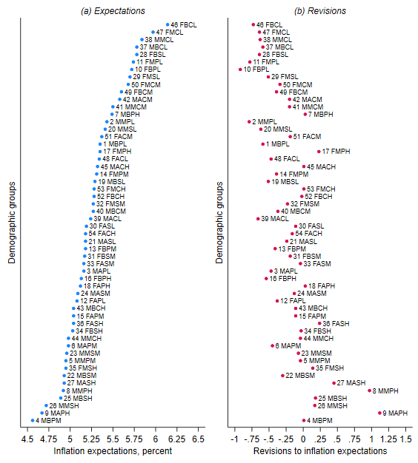

Figure 3. Demographics effects on inflation expectations.
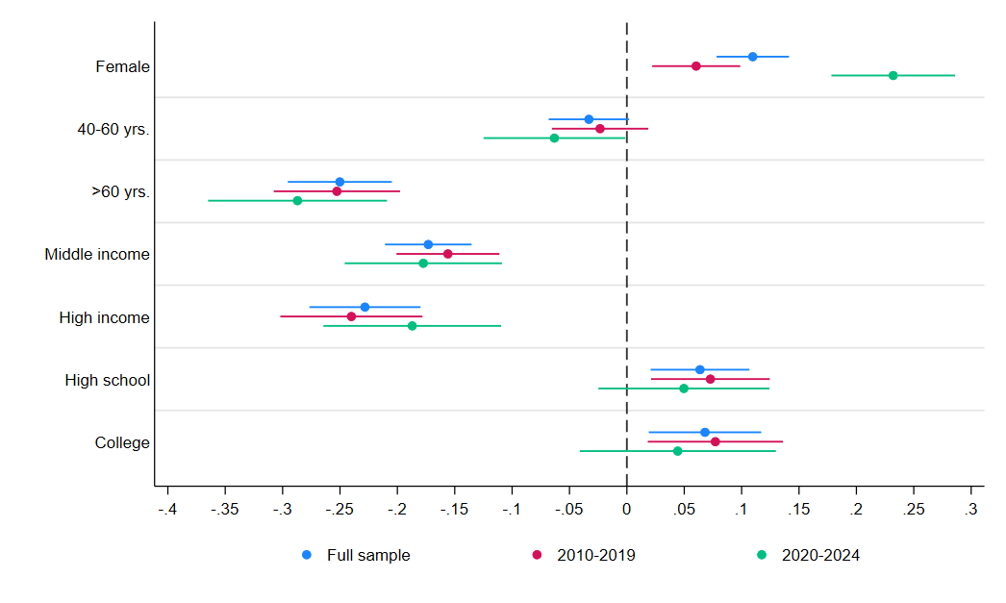
Overall, we find that demographic factors have significant effects on inflation expectations. Women consistently report higher inflation expectations, an observation that can be attributed to greater involvement of women in purchasing household goods and more frequent exposure to price changes, especially for everyday goods, such as food. Consistent with the age-dependent updating framework of Malmendier and Nagel (2016), we find that younger individuals tend to report higher inflation expectations than older cohorts. One potential reason for this finding is that younger individuals place more weight on recent inflation outcomes, and they are more sensitive to inflation surprises. On the other hand, older individuals’ expectations are shaped by a longer history of accumulated inflation experience. Another explanation is that as young respondents age, they are less likely to hit their budget constraint as their income rises and report lower expectations (Guillochon & Ellen, 2025). Overall, the crucial role of demographic factors in forming inflation expectations supports the use of the group-based method.

5.3 Empirical estimates for the ROPE

Since the ROPE used in the equivalence testing procedure in Section 4.2 is based on aggregate threshold effects, we attempt to use the CES CPI-based inflation expectations data discussed in Section 3.1 for comparison purposes. We build on Zhao (2019) in recording the size of revisions by group, but our paper departs from this work in one specific way. We model the revisions for fine-tuners and moderate revisers as a function of food and energy prices.

Table 3 reports the coefficient estimates for the price effect of each of the commodity items. Using the CES data, we find that the coefficient differentials between fine-tuners and moderate revisers range between 0.01 and 0.07. The range of these coefficient differentials is almost the same as in revision estimates by type of revisers using the MSC data. In this case, the differentials in the coefficients from the group- and panel-based regressions range between 0.01 and 0.07. Thus, our definition of the ROPE values based on Goodspeed (2025) is also captured by empirical estimates of the expectation revision using the CES and MSC microdata.

5.4 Revisions model estimation results for the Philippines

Table 4 reports the Philippine results of the group-based and mean-based regressions, including equivalence testing results using several ROPE values and their z-statistic. Figure 4 visually displays the equivalence-testing results for selected ROPE values (0.03 and 0.04).

We first focus on the estimated coefficients $β_{j}^{c}$ and $β_{j}^{m}$. The most important results in Table 4 are the positive and highly statistically significant estimated coefficients $β_{j}^{c}$ on all 14 specific food and energy goods using the group-based method. By contrast, the mean-based regression produces negative coefficients $β_{j}^{m}$ for the price effects of goods, such as meat, fish, diesel, gasoline, and overall fuel.

The group-based positive coefficients are higher for food than energy goods. That is, the coefficients $β_{1}^{c}$on $π_{p, t}^{food}$ is 0.217 and $β_{14}^{c}$on $π_{p, t}^{gas}$ is 0.053. This indicates that a 1-percent change in overall food and gasoline prices induces an upward forecast revision of approximately 0.22 percent and 0.05 percent, respectively. These estimates are higher than the consumer forecast revision literature that reported an upward revision of 0.18 percent and 0.003 percent for every 1.0-percent change in food price and oil price, respectively, in Japan (Kikuchi & Nakazono, 2023). Also, the coefficient $β_{14}^{c}$ of 0.053 for gasoline is much higher than the estimated coefficient of 0.016 that Coibion and Gorodnichenko (2015) and Binder (2018) have found for the United States. Overall, those results suggest that forecast revisions are both sensitive to a price change in food and energy items. This aligns with the literature, which suggests that typical consumers who are inattentive to overall inflation may use the price changes in goods they frequently observed as signals of movements in overall inflation (Kikuchi & Nakazono, 2023).

Table 3. Impacts of food and energy price changes on expectations revisions by type of revisers.
 |  | Fine-tuners  (< 1%)  (A) |  | Moderate revisers (1%, 5%)  (B) |  | Absolute difference  (A) – (B)
Panel A: Philippines, group-based
 | $$β_{1}:π_{p, t}^{food}$$ | 0.088*** (0.005) |  | 0.049*** (0.004) |  | 0.039
 | $$β_{2}:π_{p, t}^{bread}$$ | 0.272*** (0.006) |  | 0.242*** (0.005) |  | 0.029
 | $$β_{3}:π_{p, t}^{cookoil}$$ | 0.070*** (0.002) |  | 0.065*** (0.001) |  | 0.005
 | $$β_{4}:π_{p, t}^{fish}$$ | 0.004 (0.003) |  | 0.001 (0.002) |  | 0.003
 | $$β_{5}:π_{p, t}^{fruit}$$ | 0.005*** (0.002) |  | 0.010*** (0.001) |  | 0.005
 | $$β_{6}:π_{p, t}^{meat}$$ | 0.023*** (0.003) |  | 0.004 (0.003) |  | 0.019
 | $$β_{7}:π_{p, t}^{milk}$$ | 0.034*** (0.005) |  | 0.006 (0.004) |  | 0.029
 | $$β_{8}:π_{p, t}^{rice}$$ | 0.075*** (0.003) |  | 0.043*** (0.002) |  | 0.032
 | $$β_{9}:π_{p, t}^{sugar}$$ | 0.031*** (0.002) |  | 0.009*** (0.001) |  | 0.022
 | $$β_{10}:π_{p, t}^{vegies}$$ | 0.012*** (0.001) |  | 0.008*** (0.001) |  | 0.003
 | $$β_{11}:π_{p, t}^{energy}$$ | 0.030*** (0.004) |  | 0.086*** (0.003) |  | 0.056
 | $$β_{12}: π_{p, t}^{fuel}$$ | 0.049*** (0.001) |  | 0.060*** (0.001) |  | 0.011
 | Fixed effects | Yes |  | Yes
 | Demographic effects | Yes |  | Yes
 | Observations | 44,153 |  | 115,960
Panel B: U.S., group-based
 | $$β_{1}:π_{p, t}^{food}$$ | 0.340*** (0.012) |  | 0.338*** (0.007) |  | 0.002
 | $$β_{2}:π_{p, t}^{fuel}$$ | 0.002* (0.051) |  | 0.013*** (0.001) |  | 0.011
 | $$β_{3}:π_{p, t}^{othfuel}$$ | 0.042*** (0.004) |  | 0.050*** (0.002) |  | 0.008
 | Fixed effects | Yes |  | Yes
 | Demographic effects | Yes |  | Yes
 | Observations | 13,753 |  | 84,406
Panel C: U.S., panel-based
 | $$β_{1}:π_{p, t}^{food}$$ | -0.012 (0.024) |  | 0.054*** (0.013) |  | 0.066
 | $$β_{2}:π_{p, t}^{fuel}$$ | 0.007*** (0.002) |  | 0.019*** (0.001) |  | 0.012
 | $$β_{3}:π_{p, t}^{othfuel}$$ | 0.003 (0.008) |  | 0.029*** (0.004) |  | 0.026
 | Fixed effects | Yes |  | Yes
 | Demographic effects | Yes |  | Yes
 | Observations | 7,153 |  | 37,725
Notes: Clustered standard errors in parentheses. Significance codes: ***: 0.01, **: 0.05, *: 0.10.

Table 4. Impacts of price changes in food and energy goods on inflation expectations revisions in the Philippines.
 | Coefficients |  |  | z-statistic [p-value] for each ROPE
 | Group-based $β_{j}^{c}$ | Mean-based $β_{j}^{m}$ |  | 0.02 | 0.03 | 0.04 | 0.05 | 0.06 | 0.07
$$β_{1}:π_{p, t}^{food}$$ | 0.217*** | 0.134*** |  | 9.685*** [0.000] | 8.139*** [0.000] | 6.593*** [0.000] | 5.047*** [0.000] | 3.501*** [0.000] | 1.955* [0.051]
 | (0.005) | (0.004) |  | Bounded above | Bounded above | Bounded above | Bounded above | Bounded above | Inconclusive
$$β_{2}:π_{p, t}^{bread}$$ | 0.176*** | 0.272*** |  | -8.439*** [0.000] | -7.319*** [0.000] | -6.199*** [0.000] | -5.08*** [0.000] | -3.96*** [0.000] | -2.84*** [0.005]
 | (0.007) | (0.005) |  | Bounded below | Bounded below | Bounded below | Bounded below | Bounded below | Bounded below
$$β_{3}:π_{p, t}^{cookoil}$$ | 0.092*** | 0.057*** |  | 4.54*** [0.000] | 1.609 [0.108] | -1.321* [0.093] | -4.252*** [0.000] | -7.182*** [0.000] | -10.113*** [0.000]
 | (0.003) | (0.002) |  | Bounded above | Inconclusive | Inconclusive | Bounded within | Bounded within | Bounded within
$$β_{4}:π_{p, t}^{fish}$$ | 0.059*** | -0.018*** |  | 7.015*** [0.000] | 3.628*** [0.000] | 0.242 [0.809] | -3.145*** [0.001] | -6.532*** [0.000] | -9.918*** [0.000]
 | (0.002) | (0.002) |  | Bounded above | Bounded Above | Inconclusive | Bounded within | Bounded within | Bounded within
$$β_{5}:π_{p, t}^{fruit}$$ | 0.015*** | 0.020*** |  | 5.83*** [0.000] | 9.707*** [0.000] | 13.583*** [0.000] | 17.459*** [0.000] | 21.336*** [0.000] | 25.212*** [0.000]
 | (0.002) | (0.002) |  | Bounded within | Bounded within | Bounded within | Bounded within | Bounded within | Bounded within
$$β_{6}:π_{p, t}^{meat}$$ | 0.120*** | -0.056*** |  | 10.381*** [0.000] | 8.058*** [0.000] | 5.734*** [0.000] | 3.41*** [0.001] | 1.086 [0.277] | -1.238 [0.108]
 | (0.003) | (0.003) |  | Bounded above | Bounded above | Bounded above | Bounded above | Inconclusive | Inconclusive
$$β_{7}:π_{p, t}^{milk}$$ | 0.085*** | 0.128*** |  | -3.239*** [0.001] | -1.864* [0.062] | -0.488 [0.625] | 0.887 [0.188] | 2.262** [0.012] | 3.637*** [0.000]
 | (0.006) | (0.004) |  | Bounded below | Inconclusive | Inconclusive | Inconclusive | Bounded within | Bounded within
$$β_{8}:π_{p, t}^{rice}$$ | 0.016*** | 0.117*** |  | -23.067*** [0.000] | -20.211*** [0.000] | -17.354*** [0.000] | -14.498*** [0.000] | -11.641*** [0.000] | -8.784*** [0.000]
 | (0.003) | (0.002) |  | Bounded below | Bounded below | Bounded below | Bounded below | Bounded below | Bounded below
$$β_{9}:π_{p, t}^{sugar}$$ | 0.091*** | 0.035*** |  | 10.901*** [0.000] | 7.864*** [0.000] | 4.826*** [0.000] | 1.789* [0.074] | -1.248 [0.106] | -4.285*** [0.000]
 | (0.003) | (0.002) |  | Bounded above | Bounded above | Bounded above | Inconclusive | Bounded within | Bounded within
$$β_{10}:π_{p, t}^{vegies}$$ | 0.022*** | 0.007*** |  | -4.716*** [0.000] | -12.727*** [0.000] | -20.738*** [0.000] | -28.749*** [0.000] | -36.76*** [0.000] | -44.771*** [0.000]
 | (0.001) | (0.001) |  | Bounded within | Bounded within | Bounded within | Bounded within | Bounded within | Bounded within
$$β_{11}:π_{p, t}^{energy}$$ | 0.061*** | 0.047*** |  | -2.468*** [0.007] | -6.62*** [0.000] | -10.772*** [0.000] | -14.924*** [0.000] | -19.076*** [0.000] | -23.228*** [0.000]
 | (0.002) | (0.001) |  | Bounded within | Bounded within | Bounded within | Bounded within | Bounded within | Bounded within
$$β_{12}:π_{p, t}^{fuel }$$ | 0.049*** | -0.001 |  | 23.29*** [0.000] | 15.061*** [0.000] | 6.833*** [0.000] | -1.396* [0.081] | -9.625*** [0.000] | -17.854*** [0.000]
 | (0.001) | (0.001) |  | Bounded above | Bounded above | Bounded above | Inconclusive | Bounded within | Bounded within
$$β_{13}:π_{p, t}^{diesel}$$ | 0.039*** | -0.0004 |  | 25.167*** [0.000] | 7.8*** [0.000] | -1.605* [0.054] | -11.01*** [0.000] | -20.415*** [0.000] | -29.82*** [0.000]
 | (0.001) | (0.001) |  | Bounded above | Bounded above | Inconclusive | Bounded within | Bounded within | Bounded within
$$β_{14}:π_{p, t}^{gas}$$ | 0.053*** | -0.001 |  | 25.167*** [0.000] | 17.331*** [0.000] | 9.494*** [0.000] | 1.658* [0.097] | -6.179*** [0.000] | -14.015*** [0.000]
 | (0.001) | (0.001) |  | Bounded above | Bounded above | Bounded above | Inconclusive | Bounded within | Bounded within
All regressions:
Fixed effects | Yes | Yes
Observations | 218,033 | 218,033
Notes: Clustered standard errors in parentheses. Significance codes: ***: 0.01, **: 0.05, *: 0.10. ROPE is region of practical equivalence.
The results also show that the size of the estimated coefficients is pronounced for a change in price of goods like milk, sugar, cooking oil, meat, and bread. That is, the estimated coefficients range between 0.09 percent and 0.18 percent for every 1.0-percent change in the prices of these specific goods. For meat, milk, and bread in particular, their estimated coefficients lend support to their visible shares in consumption spending as explained in Section 2.

We find further evidence of a low estimated coefficient $β_{8}^{c}$ on $π_{p, t}^{rice}$ at 0.016. This is rather surprising since rice is a staple food with a large spending share. However, such a small but statistically significant coefficient does not indicate that rice is economically unimportant. It may rather reflect mixed interpretations among survey respondents who were asked questions about “prices you pay” or “prices in general” (Armantier et al., 2013). Indeed, Bruine de Bruin et al. (2012) demonstrate that a question regarding prices in general is likely to be interpreted by respondents as asking about prices they are paying. Since the CES uses a similar wording, perhaps the respondents concentrate on items with salient or extreme price changes instead of items with large budget shares. That is why despite the dominance of rice in the Philippine food consumption, this commodity becomes less salient in the memories of the survey respondents relative to items with volatile prices if rice prices have been relatively stable.

Morewedge et al. (2005) and Bruine de Bruin et al. (2011) suggest that people are more likely to notice and recall extreme price changes and use them to form future expectations. This idea applies not only to the influence of prices of food items with either low or high shares in consumption spending but also to energy goods. In Table 4, one can see that the group-based positive and significant coefficients for energy goods range between 0.04 and 0.06. This means that although fuel and energy items, respectively, account for just 5.0 percent or less than 10.0 percent, their prices may have a disproportionately large effect on expectations due to the volatile nature of their prices.

As for equivalence testing results, Table 4 shows that the z-statistic for ROPE 0.02 to 0.03 is significant for most of the specific goods under review. This indicates that we reject the null hypothesis associated with Definition 1 of our two-way check in validating the group-based approach. Specifically, ${\hat{δ}}_{1}$ or the difference in the coefficients between $β_{j}^{c}$ and $β_{j}^{m}$ is significantly bounded either above or below those ROPE values in nine of the items, namely: overall food, bread, fish, meat, rice, sugar, overall fuel, diesel, and gasoline. This result still holds at ROPE set at 0.04 for most of these nine items, except for fish and diesel. With ROPE set at 0.05, results are similar in four of the cases that capture the effects of changes in prices of overall food, rice, bread, and meat.

We also consider setting higher ROPE values at 0.06 to 0.07. We find that the group-based estimates are significantly bounded below only in the cases of bread and rice. These two methods generate coefficients that are practically similar when judged against higher ROPE values. One potential explanation for this finding is that the group-based estimates’ precision may matter less for policy because consumers are already more attentive at lower ROPE. When the fundamental transition from rational inattention to overreaction has already occurred, small differences in the estimated price effects of food and energy may not qualitatively change consumers’ behavior.
Figure 4. Results of equivalence testing for the Philippines.
(a) ROPE = 0.03
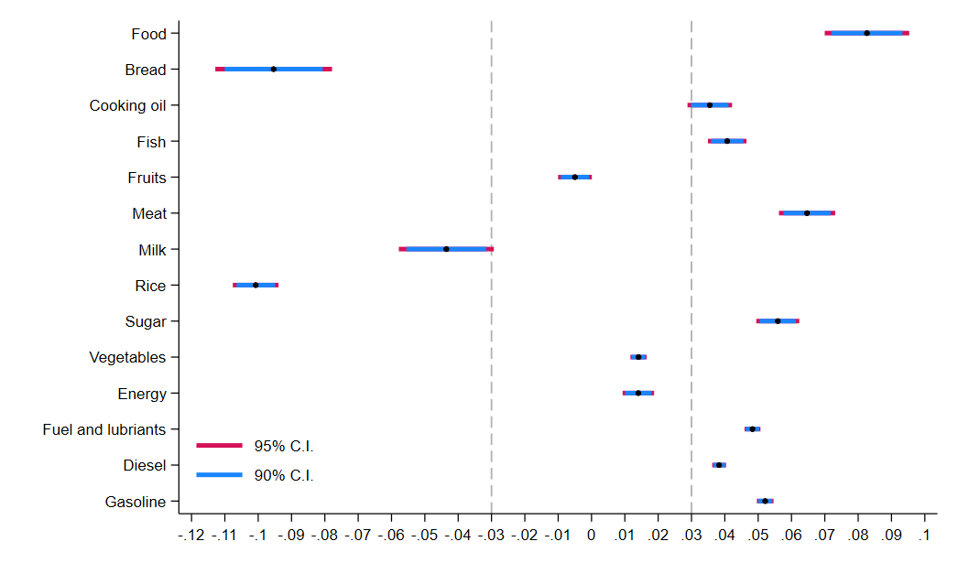
(b) ROPE = 0.04
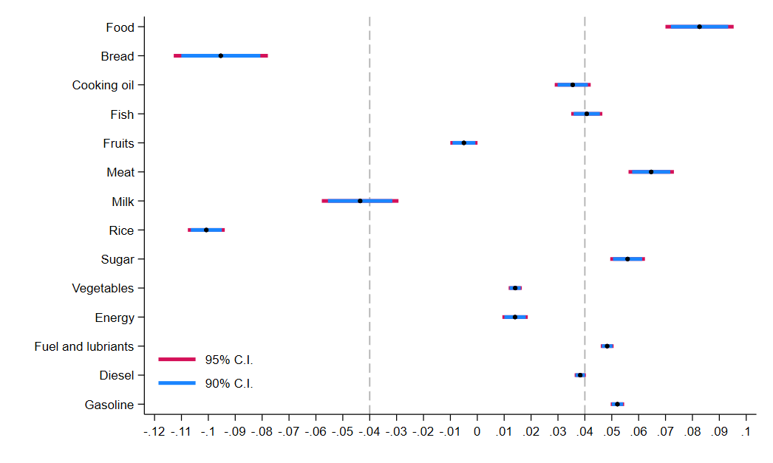
5.5 Revisions model estimation results for the U.S.

Table 5 and Figure 5 show the results of group-based and panel-based regressions for the United States Similar to the Philippine findings, the group-based estimated coefficients on the effects of prices of overall food, fuel, and other fuel items are also positive and significant. Results of the panel-based estimate also obtain the expected positive sign. To be specific, the coefficient $β_{1}^{c}$on $π_{p, t}^{food}$ is 0.072, indicating that a 1.0-percent change in food prices increases forecast revision by 0.072 percent. This coefficient is much smaller compared with the estimated sensitivity of forecast revision to a change in aggregate food price reported in this paper and in Kikuchi and Nakazono’s (2023) investigation of inflation forecast revision among Japanese consumers.

It is also clear from Table 5 that the group-based coefficient $β_{2}^{c}$ of 0.028 on fuel is highly statistically significant. This estimate is 1.75 times larger than the gas price coefficient of 0.016 that Binder (2018) has reported for the US households’ inflation expectations revision. Perhaps such a difference can be attributed to the difference in the sample period used in our study (January 2010–June 2024) and Binder’s (April 2006–August 2014). This explanation may also be at play when comparing at a much higher coefficient $β_{3}^{c}$ of 0.055 for a change in price of other fuel items.

Interestingly, a clear pattern of similarities emerges between the group-based coefficients $β_{j}^{c}$ and the alternative rotating panel-based coefficients $β_{j}^{r}$. This pattern means that according to our Definition 2 for checking the validity of the group-based approach, we reject the null hypothesis $H_{0}^{TOST}: {\hat{δ}}_{2}<ϵ_{-}$ or $H_{0}^{TOST}: {\hat{δ}}_{2}>ϵ_{+}$. Indeed, the equivalence testing shows significant z-statistic for food and energy goods in most of the ROPE values between 0.03 and 0.07.

5.6 Impact of firms’ price adjustments on consumer forecast revisions

The previous section discussed how expectations are updated using the changes in food and energy prices to demonstrate household attentiveness to these prices. Another way of illustrating consumers’ inattention is to assess how their beliefs change with respect to prices set by firms in the market. This assumes that firms have some market power and therefore are price setters.

To capture different dimensions of firm pricing behavior, we construct quarterly pricing metrics for each of the aggregated regions in the Philippines using the BES. Like the CES, the BES collects information about firms’ outlook on their own operations, inflation expectations, and other economic indicators every quarter. This has been conducted by the BSP since 2003 and contains about 1,000 firms in each wave. The survey captures firm pricing behavior through the question: “What is generally your company’s expectation with respect to the following variables [for the current quarter]: Average selling price?” Respondents are given the options: “Prices will go up”, “Prices will go down”, or “Prices will stay the same”.

Using this information, we follow Buckle and Carlson (2000) in calculating the proportion of firms that reported price increases ($p_{up}$), price decreases ($p_{down}$), changing prices in either direction ($p_{up}+p_{down}$) across the 17 regions of the Philippines. In contrast to Valera and Galang (2025) who use an aggregated seven regions in the Philippines in measuring pricing metrics, we focus on all the 17 regions of the country.
Table 6 reports the estimates for the effects of commodity prices and firm pricing metrics on inflation forecast revisions and the results of the equivalence testing for ROPE = 0.03. The group-based methodology generates more intuitive results. When firms change their prices in general, most consumers have upward revisions in their inflation expectations. The results become clearer when we check the unidirectional price changes of firms, where expectations are revised upward with reported price increases among firms and downward with reported price decreases. These results contrast with the estimates from the mean-based method, where the regression runs give the opposite signs from what is the expected response of households given a price change.

Table 5. Impacts of price changes in food and energy goods on inflation expectations revisions in the U.S.
 | Coefficients |  |  | z-statistic [p-value] for each ROPE
 | Group-based $β_{j}^{c}$ | Panel-based $β_{j}^{r}$ |  | 0.02 | 0.03 | 0.04 | 0.05 | 0.06 | 0.07
$$β_{1}:π_{p, t}^{food}$$ | 0.072*** | 0.062*** |  | 0.055[0.956] | -0.355[0.361] | -1.874**[0.030] | -2.369***[0.009] | -2.994***[0.001] | -3.62***[0.000]
 | (0.011) | (0.012) |  | Inconclusive | Inconclusive | Bounded within | Bounded within | Bounded within | Bounded within
$$β_{2}:π_{p, t}^{fuel}$$ | 0.028*** | 0.029*** |  | 8.389***[0.000] | 16.785***[0.000] | 17.965***[0.000] | 28.818***[0.000] | 34.799***[0.000] | 40.781***[0.000]
 | (0.001) | (0.001) |  | Bounded within | Bounded within | Bounded within | Bounded within | Bounded within | Bounded within
$$β_{3}:π_{p, t}^{othfuel}$$ | 0.055*** | 0.050*** |  | 1.253[0.105] | -3.529***[0.000] | 2.807***[0.002] | -6.517***[0.000] | -7.969***[0.000] | -9.42***[0.000]
 | (0.006) | (0.004) |  | Inconclusive | Bounded within | Bounded within | Bounded within | Bounded within | Bounded within
All regressions:
Fixed effects | Yes | Yes
Tenure effects | Yes | Yes
Observations | 145,366 | 75,185
Notes: Clustered standard errors in parentheses. Significance codes: ***: 0.01, **: 0.05, *: 0.10. ROPE is region of practical equivalence.
Figure 5. Results of equivalence testing for the U.S.
- ROPE = 0.03
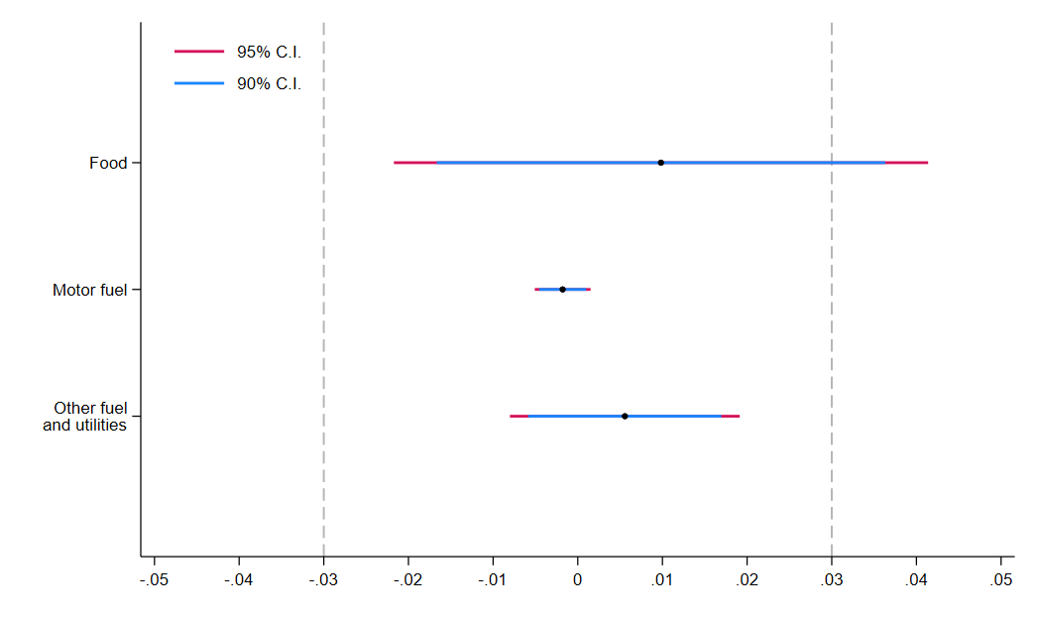
- ROPE = 0.04
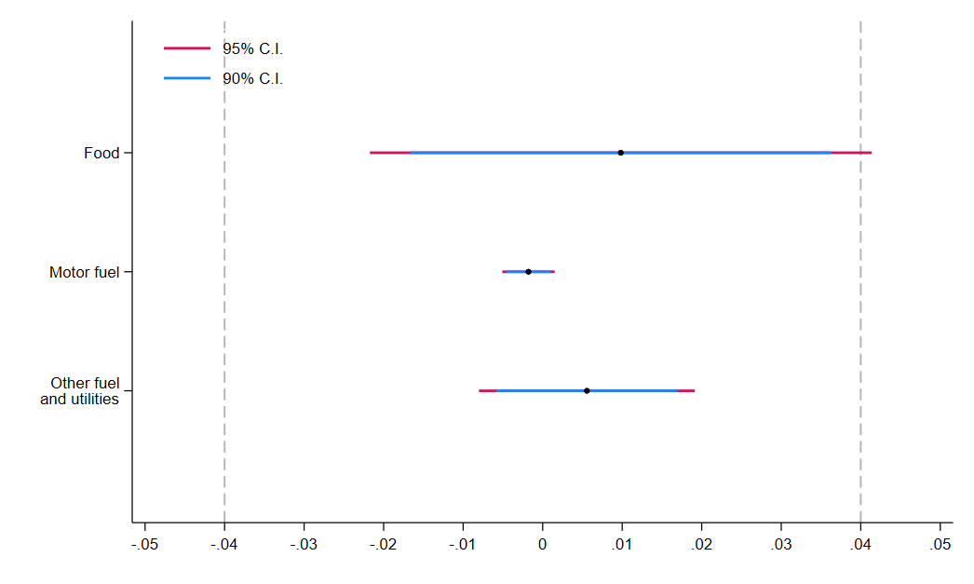

Table 6. Impact of firms’ price adjustment on household inflation expectations revisions in the Philippines.
 | Firms changing prices |  |  | Firms increasing prices |  |  | Firms decreasing prices
 | Group-based $β_{j}^{c}$ | Mean-based $β_{j}^{m}$ |  | Group-based $β_{j}^{c}$ | Mean-based $β_{j}^{m}$ |  | Group-based $β_{j}^{c}$ | Mean-based $β_{j}^{m}$
$$β_{1}:π_{p, t}^{food}$$ | 0.215*** | 0.155*** |  | 0.214*** | 0.127*** |  | 0.208*** | 0.070***
 | (0.005) | (0.004) |  | (0.006) | (0.004) |  | (0.006) | (0.004)
Price adjustment | 0.001** | -0.016*** |  | 0.005*** | 0.001*** |  | -0.016*** | -0.055***
 | (0.001) | (0.001) |  | (0.001) | (0.000) |  | (0.001) | (0.001)
ROPE = 0.03 | 4.621***[0.000] |  |  | 7.828***[0.000] |  |  | 15.061***[0.000]
 | Bounded above |  |  | Bounded above |  |  | Bounded above
$$β_{2}:π_{p, t}^{bread}$$ | 0.171*** | 0.301*** |  | 0.164*** | 0.271*** |  | 0.153*** | 0.169***
 | (0.007) | (0.006) |  | (0.008) | (0.006) |  | (0.008) | (0.006)
Price adjustment | 0.003*** | -0.018*** |  | 0.007*** | -0.002*** |  | -0.021*** | -0.051***
 | (0.001) | (0.001) |  | (0.001) | (0.000) |  | (0.001) | (0.001)
ROPE = 0.03 | -10.864***[0.000] |  |  | -7.545***[0.000] |  |  | 1.480*[0.069]
 | Bounded below |  |  | Bounded below |  |  | Inconclusive
$$β_{3}:π_{p, t}^{cookoil}$$ | 0.097*** | 0.052*** |  | 0.100*** | 0.058*** |  | 0.089*** | 0.033***
 | (0.003) | (0.002) |  | (0.003) | (0.002) |  | (0.003) | (0.002)
Price adjustment | 0.009*** | -0.011*** |  | 0.012*** | 0.005*** |  | -0.020*** | -0.055***
 | (0.001) | (0.001) |  | (0.000) | (0.000) |  | (0.001) | (0.001)
ROPE = 0.03 | 4.238***[0.000] |  |  | 3.531***[0.000] |  |  | 7.227***[0.000]
 | Bounded above |  |  | Bounded above |  |  | Bounded above
$$β_{4}:π_{p, t}^{fish}$$ | 0.060*** | -0.019*** |  | 0.058*** | -0.025*** |  | 0.053*** | -0.062***
 | (0.002) | (0.002) |  | (0.003) | (0.002) |  | (0.003) | (0.002)
Price adjustment | 0.006*** | -0.013*** |  | 0.011*** | 0.006*** |  | -0.023*** | -0.066***
 | (0.001) | (0.001) |  | (0.001) | (0.000) |  | (0.001) | (0.001)
ROPE = 0.03 | 3.490***[0.000] |  |  | 0.866[0.387] |  |  | 6.317***[0.000]
 | Bounded above |  |  | Inconclusive |  |  | Bounded within
$$β_{5}:π_{p, t}^{fruit}$$ | 0.012*** | 0.026*** |  | 0.010*** | 0.019*** |  | 0.019*** | 0.013***
 | (0.002) | (0.002) |  | (0.002) | (0.002) |  | (0.002) | (0.002)
Price adjustment | 0.005*** | -0.014*** |  | 0.012*** | 0.004*** |  | -0.030*** | -0.058***
 | (0.001) | (0.001) |  | (0.001) | (0.000) |  | (0.001) | (0.001)
ROPE = 0.03 | 6.232***[0.000] |  |  | 7.774***[0.000] |  |  | -8.801***[0.000]
 | Bounded within |  |  | Bounded within |  |  | Bounded within
Notes: Clustered standard errors in parentheses. Significance codes: ***: 0.01, **: 0.05, *: 0.10. ROPE is region of practical equivalence.

Table 6. Continuation.
 | Firms changing prices |  |  | Firms increasing prices |  |  | Firms decreasing prices
 | Group-based $β_{j}^{c}$ | Mean-based $β_{j}^{m}$ |  | Group-based $β_{j}^{c}$ | Mean-based $β_{j}^{m}$ |  | Group-based $β_{j}^{c}$ |  | Mean-based $β_{j}^{m}$
$$β_{6}:π_{p, t}^{meat}$$ | 0.118*** | -0.050*** |  | 0.112*** | -0.063*** |  | 0.119*** | -0.049***
 | (0.003) | (0.003) |  | (0.004) | (0.003) |  | (0.004) | (0.003)
Price adjustment | 0.004*** | -0.013*** |  | 0.010*** | 0.006*** |  | -0.029*** | -0.057***
 | (0.001) | (0.001) |  | (0.001) | (0.000) |  | (0.001) | (0.001)
ROPE = 0.03 | 8.796***[0.000] |  |  | 4.232***[0.000] |  |  | 8.946***[0.000]
 | Bounded above |  |  | Bounded above |  |  | Bounded above
$$β_{7}:π_{p, t}^{milk}$$ | 0.077*** | 0.160*** |  | 0.060*** | 0.120*** |  | 0.057*** | 0.056***
 | (0.006) | (0.004) |  | (0.007) | (0.005) |  | (0.006) | (0.005)
Price adjustment | 0.004*** | -0.017*** |  | 0.010*** | 0.001*** |  | -0.028*** | -0.056***
 | (0.001) | (0.001) |  | (0.001) | (0.000) |  | (0.001) | (0.001)
ROPE = 0.03 | -7.070***[0.000] |  |  | -3.659***[0.000] |  |  | -3.696***[0.000]
 | Bounded below |  |  | Bounded below |  |  | Bounded within
$$β_{8}:π_{p, t}^{rice}$$ | 0.015*** | 0.120*** |  | 0.012*** | 0.118*** |  | 0.004 | 0.105***
 | (0.003) | (0.002) |  | (0.003) | (0.002) |  | (0.003) | (0.002)
Price adjustment | 0.005*** | -0.015*** |  | 0.012*** | 0.002*** |  | -0.030*** | -0.053***
 | (0.001) | (0.001) |  | (0.001) | (0.000) |  | (0.001) | (0.001)
ROPE = 0.03 | -21.635***[0.000] |  |  | -20.326***[0.000] |  |  | -18.481***[0.000]
 | Bounded below |  |  | Bounded below |  |  | Bounded below
$$β_{9}:π_{p, t}^{sugar}$$ | 0.091*** | 0.043*** |  | 0.087*** | 0.030*** |  | 0.088*** | 0.011***
 | (0.003) | (0.002) |  | (0.003) | (0.002) |  | (0.003) | (0.002)
Price adjustment | 0.001 | -0.016*** |  | 0.006*** | 0.003*** |  | -0.021*** | -0.058***
 | (0.001) | (0.001) |  | (0.001) | (0.000) |  | (0.001) | (0.001)
ROPE = 0.03 | 5.297***[0.000] |  |  | 7.582***[0.000] |  |  | 12.948***[0.000]
 | Bounded above |  |  | Bounded above |  |  | Bounded above
$$β_{10}:π_{p, t}^{vegies}$$ | 0.021*** | 0.009*** |  | 0.019*** | 0.007*** |  | 0.018*** | 0.001*
 | (0.001) | (0.001) |  | (0.001) | (0.001) |  | (0.001) | (0.001)
Price adjustment | 0.005*** | -0.014*** |  | 0.010*** | 0.005*** |  | -0.026*** | -0.058***
 | (0.001) | (0.001) |  | (0.001) | (0.000) |  | (0.001) | (0.001)
ROPE = 0.03 | -14.640***[0.000] |  |  | -13.625***[0.000] |  |  | -10.116***[0.000]
 | Bounded within |  |  | Bounded within |  |  | Bounded within
Notes: Clustered standard errors in parentheses. Significance codes: ***: 0.01, **: 0.05, *: 0.10. ROPE is region of practical equivalence.

Table 6. Continuation.
 | Firms changing prices |  |  | Firms increasing prices |  |  |  | Firms decreasing prices
 | Group-based $β_{j}^{c}$ | Mean-based $β_{j}^{m}$ |  | Group-based $β_{j}^{c}$ | Mean-based $β_{j}^{m}$ |  |  | Group-based $β_{j}^{c}$ | Mean-based $β_{j}^{m}$
$$β_{11}:π_{p, t}^{energy}$$ | 0.062*** | 0.045*** |  | 0.056*** | 0.044*** |  | 0.052*** |  | 0.012***
 | (0.002) | (0.001) |  | (0.002) | (0.002) |  | (0.002) |  | (0.002)
Price adjustment | 0.007*** | -0.012*** |  | 0.010*** | 0.004*** |  | -0.017*** |  | -0.056***
 | (0.001) | (0.001) |  | (0.001) | (0.000) |  | (0.001) |  | (0.001)
ROPE = 0.03 | -5.353***[0.000] |  |  | -7.316***[0.000] |  |  | 3.483***[0.000]
 | Bounded within |  |  | Bounded within |  |  | Bounded above
$$β_{12}:π_{p, t}^{fuel}$$ | 0.052*** | -0.004*** |  | 0.050*** | 0.001 |  | 0.045*** |  | -0.011***
 | (0.001) | (0.001) |  | (0.001) | (0.001) |  | (0.001) |  | (0.001)
Price adjustment | 0.011*** | -0.014*** |  | 0.013*** | 0.005*** |  | -0.016*** |  | -0.061***
 | (0.001) | (0.001) |  | (0.000) | (0.000) |  | (0.001) |  | (0.001)
ROPE = 0.03 | 14.622***[0.000] |  |  | 15.195***[0.000] |  |  | 2.587***[0.010]
 | Bounded above |  |  | Bounded above |  |  | Bounded above
$$β_{13}:π_{p, t}^{diesel}$$ | 0.041*** | -0.003*** |  | 0.039*** | 0.001 |  | 0.035*** |  | -0.010***
 | (0.001) | (0.001) |  | (0.001) | (0.001) |  | (0.001) |  | (0.001)
Price adjustment | 0.010*** | -0.014*** |  | 0.012*** | 0.005*** |  | -0.017*** |  | -0.061***
 | (0.001) | (0.001) |  | (0.001) | (0.000) |  | (0.001) |  | (0.001)
ROPE = 0.03 | 7.371***[0.000] |  |  | 7.693***[0.000] |  |  | -4.918***[0.000]
 | Bounded above |  |  | Bounded above |  |  | Bounded within
$$β_{14}:π_{p, t}^{gas}$$ | 0.057*** | -0.005*** |  | 0.054*** | 0.001 |  | 0.049*** |  | -0.010***
 | (0.001) | (0.001) |  | (0.001) | (0.001) |  | (0.001) |  | (0.001)
Price adjustment | 0.011*** | -0.014*** |  | 0.013*** | 0.005*** |  | -0.016*** |  | -0.060***
 | (0.001) | (0.001) |  | (0.000) | (0.000) |  | (0.001) |  | (0.001)
ROPE = 0.03 | 16.926***[0.000] |  |  | 17.781***[0.000] |  |  | 6.245***[0.000]
 | Bounded above |  |  | Bounded above |  |  | Bounded above
All regressions:
Fixed effects | Yes | Yes |  | Yes | Yes |  | Yes |  | Yes
Observation | 218,033 | 262,188 |  | 208,379 | 248,204 |  | 204,384 |  | 241,725
Notes: Clustered standard errors in parentheses. Significance codes: ***: 0.01, **: 0.05, *: 0.10. ROPE is region of practical equivalence.

5.7 Robustness analyses

We perform two experiments in this section to see whether our results in the previous section are robust to the change in demographic groups for estimating expectations revision and horizon k for prior expectations. First, we consider an alternative classification of demographic groups by excluding the age attribute and crossing only gender, education, and income in line with Patzelt and Reis (2024). In doing so, we classify 18 demographic groups within which to calculate averages for inflation expectations and then re-estimate Eq. (3). The estimation and equivalence testing results are collected in Table 7 for the Philippines and Table 8 for the US.

Once again, the group-based coefficients $β_{j}^{c}$ shown in Table 7 are all positive and highly statistically significant. The magnitude of these coefficients also seems similar to coefficients from our benchmark regressions. In fact, the mean-based coefficients on fish, meat, fuel, diesel, and gas have counterintuitive results as these have negative signs. Furthermore, six out of the 14 commodities pass the equivalence testing across all ROPE values. These include fish, bread, meat, rice, sugar, fuel, and gas. We also conduct a similar assessment in Table 8 for the US. Both the group- and panel-based estimated coefficients show intuitive results, where a positive relationship is seen between inflation expectations revision and changes in goods prices. More importantly, the equivalence testing shows that the estimates for the group- and panel-based methods are similar.

In the second experiment, we carry out all the forecast revision estimations using different values of $k=1, 3, 4$ quarters. Note that our benchmark regression used $k=2$ quarters.

As shown in Table 9 that reports qualitative results, the main findings in Section 5.4 do not change. These are summarized as follows. First, the impacts of price changes on specific food and energy goods are still positive throughout $k=1, 3, 4$ quarters. Second, the validity of the group-based approach is confirmed by the equivalence testing in most of the regressions. Indeed, such validity confirmation has slightly improved from nine to 10 of the cases with $k=3$ quarters and to 11 of the cases with $k=4$ quarters. The results of utilizing longer $k$ horizons reaffirm the argument by Patzelt and Reis (2024) that such horizon for estimating the change in inflation expectations yields less noise. Finally, the alternative mean-based method produces counterintuitive, reverse signs for several goods like fish, meat, diesel, gasoline, and overall fuel items.

6. Conclusion

This paper addresses the challenge of estimating revisions to consumer inflation expectations when only repeated cross-section microdata is available, a setting where individual continuity is absent. We introduce and validate a novel group-based methodology that utilizes demographic factors—such as gender, age, income, and education—to proxy prior expectations. This methodological contribution is significant for broadening the scope of inflation expectation research beyond the traditional requirement of rotating panel data.

The validity and robustness of our group-based method is confirmed through a two-way equivalence-testing procedure. The testing demonstrated that the estimates derived from the group-based method differ significantly from results obtained using a simpler overall sample average approach. Crucially, when compared against the established gold standard, the group-based coefficients are found to resemble results derived from the rotating panel data of the Michigan Survey of US households. This validated our approach, demonstrating that it can mimic the rotating panel’s ability to capture consumer forecast revisions, thus addressing a longstanding question concerning the measurement of inflation expectations where panel data is scarce.

Furthermore, our empirical analysis of the Philippine household data generated several important insights into consumer behavior. Revisions to inflation expectations are found to be sensitive to changes in the prices of specific food and energy goods, supporting the idea that consumers employ a heuristic in which "bad news" (price increases) prompts an upward revision in expectations. A key improvement offered by our technique is that the group-based method consistently yielded the intuitive positive signs for the impact of these price changes, while alternative methods often produced counterintuitive, reverse signs for several commodities.

Finally, by linking consumer data with firm-level information from the BES, we documented new evidence that the frequency of price changes among firms tends to induce upward revisions of consumer inflation expectations. This suggests that consumer belief formation is not just shaped by observed commodity price changes, but that households may also utilize firms’ pricing adjustments as a signal of changes in the overall headline inflation rate.

In summary, this paper offers a novel, robust, and validated methodology for estimating revisions to inflation expectations using repeated cross-sections, providing a powerful analytical tool for researchers, and contributing to a deeper understanding of the formation and revision process of consumer expectations.

Table 7. Impacts of changes in food and energy prices in the Philippines using alternative demographic groups: Robustness check.
 | Coefficients |  |  |  | z-statistic [p-value] for each ROPE
 | Group-based $β_{j}^{c}$ |  | Mean-based $β_{j}^{m}$ |  | 0.02 | 0.03 | 0.04 | 0.05 | 0.06 | 0.07
$$β_{1}:π_{p, t}^{food}$$ | 0.213*** |  | 0.134*** |  | 9.89*** [0.000] | 8.189*** [0.000] | 6.488*** [0.000] | 4.788*** [0.000] | 3.087*** [0.002] | 1.386 [0.166]
 | (0.004) |  | (0.004) |  | Bounded above | Bounded above | Bounded above | Bounded above | Bounded above | Inconclusive
$$β_{2}:π_{p, t}^{bread}$$ | 0.166*** |  | 0.272*** |  | -10.531*** [0.000] | -9.3*** [0.000] | -8.069*** [0.000] | -6.839*** [0.000] | -5.608*** [0.000] | -4.377*** [0.000]
 | (0.006) |  | (0.005) |  | Bounded below | Bounded below | Bounded below | Bounded below | Bounded below | Bounded below
$$β_{3}:π_{p, t}^{cookoil}$$ | 0.089*** |  | 0.057*** |  | 3.719*** [0.000] | 0.503 [0.615] | -2.712*** [0.003] | -5.927*** [0.000] | -9.142*** [0.000] | -12.358*** [0.000]
 | (0.002) |  | (0.002) |  | Bounded above | Inconclusive | Bounded within | Bounded within | Bounded within | Bounded within
$$β_{4}:π_{p, t}^{fish}$$ | 0.055*** |  | -0.018*** |  | 6.404*** [0.000] | 2.639*** [0.008] | -1.125 [0.130] | -4.890*** [0.000] | -8.654*** [0.000] | -12.419*** [0.000]
 | (0.002) |  | (0.002) |  | Bounded above | Bounded above | Inconclusive | Bounded within | Bounded within | Bounded within
$$β_{5}:π_{p, t}^{fruit}$$ | 0.011*** |  | 0.020*** |  | 4.592*** [0.000] | 8.818*** [0.000] | 13.044*** [0.000] | 17.270*** [0.000] | 21.496*** [0.000] | 25.722*** [0.000]
 | (0.002) |  | (0.002) |  | Bounded within | Bounded within | Bounded within | Bounded within | Bounded within | Bounded within
$$β_{6}:π_{p, t}^{meat}$$ | 0.121*** |  | -0.056*** |  | 11.526*** [0.000] | 8.966*** [0.000] | 6.406*** [0.000] | 3.846*** [0.000] | 1.286 [0.199] | -1.274 [0.101]
 | (0.003) |  | (0.003) |  | Bounded above | Bounded above | Bounded above | Bounded above | Inconclusive | Inconclusive
$$β_{7}:π_{p, t}^{milk}$$ | 0.082*** |  | 0.128*** |  | -3.984*** [0.000] | -2.475** [0.013] | -0.967 [0.334] | 0.542 [0.294] | 2.050** [0.020] | 3.559*** [0.000]
 | (0.005) |  | (0.004) |  | Bounded below | Bounded below | Inconclusive | Inconclusive | Bounded within | Bounded within
$$β_{8}:π_{p, t}^{rice}$$ | 0.013*** |  | 0.117*** |  | -26.813*** [0.000] | -23.615*** [0.000] | -20.417*** [0.000] | -17.219*** [0.000] | -14.021*** [0.000] | -10.824*** [0.000]
 | (0.002) |  | (0.002) |  | Bounded below | Bounded below | Bounded below | Bounded below | Bounded below | Bounded below
$$β_{9}:π_{p, t}^{sugar}$$ | 0.087*** |  | 0.035*** |  | 10.874*** [0.000] | 7.453*** [0.000] | 4.031*** [0.000] | 0.610 [0.542] | -2.811*** [0.002] | -6.233*** [0.000]
 | (0.002) |  | (0.002) |  | Bounded above | Bounded above | Bounded above | Inconclusive | Bounded within | Bounded within
$$β_{10}:π_{p, t-2→t}^{vegies}$$ | 0.023*** |  | 0.007*** |  | -3.863*** [0.000] | -12.594*** [0.000] | -21.325*** [0.000] | -30.055*** [0.000] | -38.786*** [0.000] | -47.517*** [0.000]
 | (0.001) |  | (0.001) |  | Bounded within | Bounded within | Bounded within | Bounded within | Bounded within | Bounded within
$$β_{11}:π_{p, t}^{energy}$$ | 0.059*** |  | 0.047*** |  | -3.368*** [0.000] | -7.874*** [0.000] | -12.381*** [0.000] | -16.887*** [0.000] | -21.394*** [0.000] | -25.901*** [0.000]
 | (0.002) |  | (0.001) |  | Bounded within | Bounded within | Bounded within | Bounded within | Bounded within | Bounded within
$$β_{12}:π_{p, t}^{fuel }$$ | 0.052*** |  | -0.001 |  | 27.238*** [0.000] | 18.406*** [0.000] | 9.574*** [0.000] | 0.742 [0.458] | -8.090*** [0.000] | -16.922*** [0.000]
 | (0.001) |  | (0.001) |  | Bounded above | Bounded above | Bounded above | Inconclusive | Bounded within | Bounded within
$$β_{13}:π_{p, t}^{diesel}$$ | 0.041*** |  | 0.0004 |  | 20.611*** [0.000] | 10.467*** [0.000] | 0.322 [0.748] | -9.823*** [0.000] | -19.968*** [0.000] | -30.113*** [0.000]
 | (0.001) |  | (0.001) |  | Bounded above | Bounded above | Inconclusive | Bounded within | Bounded within | Bounded within
$$β_{14}:π_{p, t}^{gas}$$ | 0.055*** |  | -0.001 |  | 29.089*** [0.000] | 20.653*** [0.000] | 12.217*** [0.000] | 3.781*** [0.000] | -4.655*** [0.000] | -13.091*** [0.000]
 | (0.001) |  | (0.001) |  | Bounded above | Bounded above | Bounded above | Bounded above | Bounded above | Bounded within
All regressions:
Fixed effects | Yes |  | Yes
Observations | 247751 |  | 262,189
Notes: Clustered standard errors in parentheses. Significance codes: ***: 0.01, **: 0.05, *: 0.10. ROPE is region of practical equivalence.

Table 8. Impacts of changes in food and energy prices in the U.S. using alternative demographic groups: Robustness check.
 | Coefficients |  | z-statistic [p-value] for each ROPE
 | Group-based $β_{j}^{c}$ | Panel-based $β_{j}^{r}$ |  | 0.02 | 0.03 | 0.04 | 0.05 | 0.06 | 0.07
$$β_{1}:π_{p, t}^{food}$$ | 0.067*** | 0.060*** |  | -0.984 [0.163] | -1.749** [0.040] | -2.514*** [0.006] | -3.279*** [0.001] | -4.043*** [0.000] | -4.808*** [0.000]
 | (0.005) | (0.012) |  | Inconclusive | Bounded within | Bounded within | Bounded within | Bounded within | Bounded within
$$β_{2}:π_{p, t}^{fuel}$$ | 0.028*** | 0.029*** |  | 12.485*** [0.000] | 19.378*** [0.000] | 26.271*** [0.000] | 33.165*** [0.000] | 40.058*** [0.000] | 46.951*** [0.000]
 | (0.001) | (0.001) |  | Bounded within | Bounded within | Bounded within | Bounded within | Bounded within | Bounded within
$$β_{3}:π_{p, t}^{othfuel}$$ | 0.051*** | 0.050*** |  | -3.179*** [0.001] | -4.855*** [0.000] | -6.531*** [0.000] | -8.207*** [0.000] | -9.883*** [0.000] | -11.559*** [0.000]
 | (0.005) | (0.004) |  | Bounded within | Bounded within | Bounded within | Bounded within | Bounded within | Bounded within
All regressions:
Fixed effects | Yes | Yes
Observations | 199,707 | 78,042
Notes: Clustered standard errors in parentheses. Significance codes: ***: 0.01, **: 0.05, *: 0.10. ROPE is region of practical equivalence.
Table 9. Impacts of changes in food and energy prices in the Philippines using different $k$ horizons: Robustness check.
 | Coefficients |  |  | Equivalence testing for each ROPE
 | Group-based $β_{j}^{c}$ | Mean-based $β_{j}^{m}$ |  | 0.02 | 0.03 | 0.04
$k=1$
Food | + | + |  | Bounded within | Bounded within | Bounded within
Bread | + | + |  | Bounded below | Bounded below | Bounded below
Cooking oil | + | + |  | Inconclusive | Bounded within | Bounded within
Fish | + | - |  | Inconclusive | Bounded within | Bounded within
Fruits | + | + |  | Bounded within | Bounded within | Bounded within
Meat | + | - |  | Bounded within | Bounded within | Bounded within
Milk | + | + |  | Bounded below | Bounded below | Bounded below
Rice | + | + |  | Bounded below | Bounded below | Bounded below
Sugar | + | + |  | Bounded above | Inconclusive | Bounded within
Vegetables | + | + |  | Bounded within | Bounded within | Bounded within
Energy | + | - |  | Inconclusive | Bounded within | Bounded within
Fuel and lubricants | + | - |  | Inconclusive | Bounded within | Bounded within
Diesel | + | - |  | Bounded within | Bounded within | Bounded within
Gasoline | + | - |  | Inconclusive | Bounded within | Bounded within
$k=3$
Food | + | + |  | Bounded above | Bounded above | Bounded above
Bread | + | + |  | Inconclusive | Bounded within | Bounded within
Cooking oil | + | + |  | Bounded above | Bounded above | Bounded above
Fish | + | - |  | Bounded above | Bounded above | Bounded above
Fruits | + | + |  | Bounded within | Bounded within | Bounded within
Meat | + | - |  | Bounded above | Bounded above | Bounded above
Milk | + | + |  | Bounded within | Bounded within | Bounded within
Rice | + | + |  | Bounded below | Bounded below | Bounded below
Sugar | + | + |  | Bounded above | Bounded above | Bounded above
Vegetables | + | + |  | Bounded within | Bounded within | Bounded within
Energy | + | + |  | Bounded above | Bounded above | Bounded above
Fuel and lubricants | + | - |  | Bounded above | Bounded above | Bounded above
Diesel | + | - |  | Bounded above | Bounded above | Bounded above
Gasoline | + | - |  | Bounded above | Bounded above | Bounded above
$k=4$
Food | + | + |  | Bounded above | Bounded above | Bounded above
Bread | + | + |  | Bounded above | Bounded above | Bounded above
Cooking oil | + | + |  | Bounded above | Bounded above | Bounded above
Fish | + | - |  | Bounded above | Bounded above | Bounded above
Fruits | + | + |  | Bounded within | Bounded within | Bounded within
Meat | + | - |  | Bounded above | Bounded above | Bounded above
Milk | + | + |  | Inconclusive | Inconclusive | Inconclusive
Rice | + | + |  | Bounded below | Bounded below | Bounded below
Sugar | + | + |  | Bounded above | Bounded above | Bounded above
Vegetables | + | + |  | Bounded above | Bounded within | Bounded within
Energy | + | + |  | Bounded above | Bounded above | Bounded above
Fuel and lubricants | + | - |  | Bounded above | Bounded above | Bounded above
Diesel | + | - |  | Bounded above | Bounded above | Bounded above
Gasoline | + | - |  | Bounded above | Bounded above | Bounded above

References

Armantier, O., Bruine de Bruin, W., Potter, S., Topa, G., Van Der Klaauw, W., & Zafar, B. (2013). Measuring inflation expectations. Annual Review of Economics, 5(1), 273–301. https://doi.org/10.1146/annurev-economics-081512-141510
Armantier, O., Bruine de Bruin, W., Topa, G., Van Der Klaauw, W., & Zafar, B. (2015). Inflation expectations and behavior: Do survey respondents act on their beliefs? International Economic Review, 56(2), 505–536. https://doi.org/10.1111/iere.12113
Bachmann, R., Berg, T., & Sims, E. (2015). Inflation expectations and readiness to spend: Cross-sectional evidence. American Economic Journal: Economic Policy, 7(1), 1–35. http://doi.org/10.1257/pol.20130292
Becker, C., Dürsch, P., & Eife, T.A. (2023). Measuring inflation expectations: How the response scale shapes density forecasts. [University of Heidelberg, Department of Economics AWI Discussion Paper Series No. 727].
Binder, C. (2017). Measuring uncertainty based on rounding: New method and application to inflation expectations. Journal of Monetary Economics, 90(October), 1–12. https://doi.org/10.1016/j.jmoneco.2017.06.001
Binder, C. (2018). Inflation expectations and the price at the pump. Journal of Macroeconomics, 58(December), 1–18. https://doi.org/10.1016/j.jmacro.2018.08.006
Binder, C.C., Campbell, J.R., & Ryngaert, J.M. (2024). Consumer inflation expectations: Daily dynamics. Journal of Monetary Economics, 145(Supplement), 103613. https://doi.org/10.1016/j.jmoneco.2024.103613
Bruine de Bruin, W. B., Van der Klaauw, W., & Topa, G. (2011). Expectations of inflation: The biasing effect of thoughts about specific prices. Journal of Economic Psychology, 32(5), 834–845. https://doi.org/10.1016/j.joep.2011.07.002
Bruine de Bruin, W. B., Van der Klaauw, W., Topa, G., Downs, J. S., Fischhoff, B., & Armantier, O. (2012). The effect of question wording on consumers’ reported inflation expectations. Journal of Economic Psychology, 33(4), 749–757. https://doi.org/10.1016/j.joep.2012.02.001
Buckle, R. A. & Carlson, J. A. (2000). Inflation and symmetric price adjustment. Review of Economics and Statistics, 82(1), 157–160. https://doi.org/10.1162/rest.2000.82.1.157
Buckle, R. A., Ryan, M., & Song, Z. (2025). Inflation and the changing nature of firm price adjustment: Six decades worth of evidence. Department of Economics Working Paper in Economics 6/25. University of Waikato, Hamilton, New Zealand. https://repec.its.waikato.ac.nz/wai/econwp/2506.pdf
Cacnio, F. & Basilio, J. (2022). Insights on inflation expectations in the Philippines from a household survey. Philippine Review of Economics, 59(2), 81–110. https://doi.org/10.37907/3ERP2202D
Carroll, C. (2003). Macroeconomic expectations of households and professional forecasters. The Quarterly Journal of Economics, 118(1), 269-298. https://doi.org/10.1162/00335530360535207
Coibion, O. & Gorodnichenko, Y. (2015). Information rigidity and the expectations formation process: A simple framework and new Facts. American Economic Review, 105(8), 2644–2678. http://doi.org/10.1257/aer.20110306
Coibion, O., Gorodnichenko, Y., & Ropele, T. (2019). Inflation expectations and firm decisions: New causal evidence. The Quarterly Journal of Economics, 135(1), 165–219. https://doi.org/10.1093/qje/qjz029
Coibion, O., Gorodnichenko, Y., & Weber, M. (2022). Monetary policy communications and their effects on household inflation expectations. Journal of Political Economy, 130(6), 1537–1584. https://doi.org/10.1086/718982
D’Acunto, F., Malmendier, U., & Weber, M. (2021). Gender roles produce divergent economic expectations. Proceedings of the National Academy of Sciences, 118(21), e2008534118.
https://doi.org/10.1073/pnas.200853411
Drager, L. & Lamla, M. (2012). Updating inflation expectations: evidence from micro-data. Economics Letters, 117(3), 807–810. https://doi.org/10.1016/j.econlet.2012.08.033
Drager, L. & Lamla, M. (2017). Imperfect information and consumer inflation expectations: Evidence from microdata. Oxford Bulletin of Economics and Statistics, 79(6), 933–968. https://doi.org/10.1111/obes.12189
Easaw, J., Golinelli R., & Malgarini, M. (2013). What determines household inflation expectations? Theory and evidence from a household survey. European Economic Review, 61(July), 1–13. https://doi.org/10.1016/j.euroecorev.2013.02.009
Ehrmann, M., Pfajfar, D., & Santoro, E. (2017). Consumers' attitudes and their inflation expectations. International Journal of Central Banking, 47, 1–30. https://doi.org/10.2139/ssrn.2595719
Fitzgerald, J. (2025). The need for equivalence testing in economics. MetaArXiv, https://doi.org/10.31222/osf.io/d7sqr_v1
Goeman, J.J., Solari, A., & Stijnen, T. (2010). Three-sided hypothesis testing: Simultaneous testing of superiority, equivalence, and inferiority. Statistics in Medicine, 29(20), 2117–2125. https://doi.org/10.1002/sim.4002
Goodspeed, T. (2025). Trust the experts? The performance of inflation expectations, 1960–2023. International Journal of Forecasting, 41(3), 863-876. https://doi.org/10.1016/j.ijforecast.2024.06.006
Guillochon, J. & ter Ellen, S. (2025). Inflation concern, attention, and central bank trust. Journal of Economic Behavior and Organization, 239(November), 107268. https://doi.org/10.1016/j.jebo.2025.107268
Kikuchi, J. & Nakazono, Y. (2023). The formation of inflation expectations: Microdata evidence from Japan. Journal of Money, Credit and Banking, 55(6), 1609–1632. http://doi.org/10.1111/jmcb.12944
Kim, G. & Binder, C. (2023). Learning-through-survey in inflation expectations. American Economic Journal: Macroeconomics, 15(2), 254–278. http://doi.org/10.1257/mac.20200387
Lanne, M., Luoma, A., & Luoto, J. (2009). A naïve sticky information model of households’ inflation expectations. Journal of Economic Dynamics and Control, 33(6), 1332–1344.
https://doi.org/10.1016/j.jedc.2009.01.004
Madeira, C. & Zafar, B. (2015). Heterogeneous inflation expectations and learning. Journal of Money, Credit and Banking, 47(5), 867–896. https://doi.org/10.1111/jmcb.12230
Malmendier, U. & Nagel, S. (2016). Learning from inflation experiences. The Quarterly Journal of Economics, 131(1), 53–88. https://doi.org/10.1093/qje/qjv037
Mankiw, N. G. & Reis, R. (2002). Sticky information versus sticky prices: A proposal to replace the New Keynesian Phillips Curve. The Quarterly Journal of Economics 117(4), 1295–1328. https://doi.org/10.1162/003355302320935034
Mankiw, N. G., Reis, R., & Wolfers, J. (2004). Disagreement about inflation expectations. NBER macroeconomics annual 18, 209–248.
Morewedge, C. K., Gilbert, D. T., & Wilson, T. D. (2005). The least likely of times: How remembering the past biases forecasts of the future. Psychological Science, 16(8), 626–630.
https://doi.org/10.1111/j.1467-9280.2005.01585.x
Patzelt, P. & Reis, R. (2024). Estimating the rise in expected inflation from higher energy prices. CEPR Discussion Paper No. 18907. CEPR Press, Paris & London. https://cepr.org/publications/dp18907
Pfajfar, D. (2013). Formation of rationally heterogeneous expectations. Journal of Economic Dynamics and Control, 37(8), 1434–1452. https://doi.org/10.1016/j.jedc.2013.03.012
Pfajfar, D. & Santoro, E. (2013). News on inflation and epidemiology of inflation expectations. Journal of Money, Credit and Banking, 45(6), 1045–1067. http://doi.org/10.1111/jmcb.12043
Reis, R. (2006). Inattentive consumers. Journal of Monetary Economics, 53(8), 1761–1800. https://doi.org/10.1016/j.jmoneco.2006.03.001
Savignac, F., Gautier, E., Gorodnichenko, Y., & Coibion, O. (2024). Firms’ inflation expectations: New evidence from France. Journal of the European Economic Association, 22(6), 2748–2781. https://doi.org/10.1093/jeea/jvae015
Sheen, J. & Wang, B. (2023). Do monetary condition news at the zero lower bound influence households’ expectations and readiness to spend? European Economic Review 152(February), 104345. https://doi.org/10.1016/j.euroecorev.2022.104345
Sims, C. A. (2003). Implications of rational inattention. Journal of Monetary Economics 50(3), 665–690. https://doi.org/10.1016/S0304-3932(03)00029-1
Valera, H. G. A. & Galang, I. M. (2025). Asymmetric price adjustment: The role of consumer inattention, mimeo. Bangko Sentral ng Pilipinas.
Woodford, M. (2003). Imperfect common knowledge and the effects of monetary policy. Knowledge, information, and expectations in modern macroeconomics: In honor of Edmund S. Phelps, 25(1), 4.
Xu, Y., Chang, H. L., Lobonţ, O. R., & Su, C. W. (2016). Modeling heterogeneous inflation expectations: empirical evidence from demographic data? Economic Modelling, 57(September), 153–163. https://doi.org/10.1016/j.econmod.2016.04.017
Zhao, Y. (2019). Updates to inflation expectations: signal or noise? Economics Letters 181(August), 95–98. https://doi.org/10.1016/j.econlet.2019.05.017

These commodities include rice, bread and cereals, meat, fish/seafood, fruits, vegetables, milk, oil and fats, sugar, non-alcoholic beverages, alcoholic beverages and tobacco, clothing, house rent, water, light/electricity, gas and solid fuels, health, transport, communication, education, recreation and culture, personal care, restaurants and cafes, and other food, n.e.c.
We also estimate the forecast revision model as function of the biannual changes in the level of rice prices rather than rice price inflation. Results, not reported here to conserve space but available upon request, yield a larger coefficient on rice with $β_{18}^{c}=0.12$.

