UNIVERSITY OF WAIKATO

Hamilton
New Zealand

Slippery Up and Sticky Down?
An Analysis of the Auckland Regional Fuel Tax
Joshua McNamara

Department of Economics
Working Paper in Economics 1/26
February 2026

Joshua McNamara
Waikato Management School
University of Waikato
Hamilton, 3240
New Zealand
Email: Joshmcnamara_nz@yahoo.com

Abstract

This paper examines whether retail fuel prices in New Zealand adjust asymmetrically to cost shocks, using the introduction and repeal of the Auckland Regional Fuel Tax (ARFT) as a natural experiment. The ARFT imposed a 10 cents-per-litre levy on fuel sold in Auckland from July 2018 to June 2024, while neighbouring regions remained untaxed. Exploiting these sharp and opposite policy changes, the analysis employs a difference-in-differences framework using daily, station-level fuel price data from Auckland, Northland, and Waikato. At the aggregate level, fuel prices increased by 10.8 cents per litre following the tax introduction and fell by 11.6 cents per litre after its repeal, indicating near-complete and symmetric pass-through on average. However, substantial spatial heterogeneity emerges when local competitive conditions are considered. Among stations located close to competitors operating under a different tax regime, prices rose almost fully after the tax was introduced but fell by only around three-quarters as much following its removal. Distance-based interaction estimates confirm that pass-through varies systematically with proximity to oppositely treated competitors, consistent with localised asymmetric price transmission driven by spatial competition. These findings show that while fuel prices may adjust symmetrically on average, asymmetric adjustment can persist in local markets, with important implications for the incidence of regional fuel taxes and their repeal.

Key words
Asymmetric price transmission
Price transmission
Fuel Taxation
Spatial Competition
Difference-in-differences
Retail fuel prices

JEL Classification
L11 H22 Q41 R12

Acknowledgements
I am grateful to John Gibson for suggesting I continue this project and providing in-depth comments on the first version of this paper. I would also like to thank Susan Olivia and Michael Cameron for their advice.

1. Introduction
Fuel prices are among the most visible and politically sensitive prices in the economy. When they rise, consumers and policymakers react quickly. When they fall, complaints often persist that prices are “sticky” on the way down. These perceptions reflect a well-documented empirical regularity known as asymmetric price transmission (APT), the tendency for retail prices to respond faster to cost increases than to cost decreases. This paper asks whether retail fuel prices in New Zealand exhibit asymmetric adjustment to cost shocks, using the Auckland Regional Fuel Tax (ARFT) as a natural experiment. The ARFT, introduced in July 2018 and repealed in June 2024, imposed and later removed a 10 cents-per-litre (cpl) levy on fuel sold within Auckland. Because the tax applied abruptly and exclusively to one region, while neighbouring Northland and Waikato were unaffected, these two events provide an ideal setting to test whether fuel prices rise faster than they fall in response to equivalent cost shocks of opposite direction.
To identify the causal effect of the ARFT, the paper employs a difference-in-differences (DiD) framework using daily, station-level fuel price data from Gaspy across Auckland, Northland, and Waikato. Separate DiD regressions estimate the effects of the 2018 introduction and 2024 repeal. To examine spatial heterogeneity in pass-through, the analysis further interacts treatment with the road distance to the nearest fuel station facing the opposite tax regime. The assumption is that, absent the ARFT, price trends in Auckland would have evolved in parallel with those in the control regions, a condition supported by pre-trend graphs and placebo tests.
The results show that Auckland fuel prices increased by 10.8 cents per litre following the introduction of the ARFT and decreased by 11.6 cents per litre after its repeal, suggesting near-complete and symmetric pass-through at the aggregate level. However, heterogeneity analysis reveals evidence of localised asymmetry. Among stations located within 10 kilometres of an oppositely treated competitor, prices rose by a similar magnitude after the tax was introduced but fell by only around three quarters as much following its removal. Consistent with this pattern, estimates from the interaction specification indicate that price responses vary systematically with competitive proximity: pass-through is stronger for stations farther from an oppositely treated competitor, suggesting that local cross-regime competition constrains price adjustment.
This paper makes two contributions. First, it provides causal evidence that asymmetric price transmission can arise in New Zealand’s fuel market, even when aggregate pass-through appears symmetric. Second, it extends the APT literature by demonstrating how local spatial competition, measured using station-to-station proximity, influences fuel tax pass-through. The remainder of the paper proceeds as follows. Section 2 reviews the related literature. Section 3 describes the data and empirical strategy. Section 4 presents the main results and robustness checks, and Section 5 concludes.
2. Literature Review
The study of APT, the tendency for retail prices to respond more quickly to cost increases than to cost decreases, has a long history in the economics literature. Bacon (1991) first coined the term “rockets and feathers” to describe UK petrol prices between 1982 and 1989, which rose rapidly following wholesale price increases but fell more slowly after price declines, attributing this pattern to imperfect competition among retail fuel suppliers. This early time-series evidence suggested that market structure, in addition to cost shocks, plays a central role in generating APT. Building on this insight, Borenstein et al. (1997) developed a more rigorous econometric framework using error-correction and distributed-lag models applied to U.S. city-level fuel data from 1986 to 1992, confirming that retail fuel prices rise faster than they fall. These findings gave rise to a large empirical literature linking APT to oligopolistic pricing, search frictions, and firm behaviour. In markets where APT occurs, firms may increase prices quickly to protect margins while delaying price decreases to avoid price wars or exploit consumer inattention.
Peltzman (2000) provides one of the most comprehensive studies of asymmetric price transmission. Using U.S. producer, consumer, and supermarket price data across a wide range of goods, he finds that approximately two-thirds of markets exhibit positive price asymmetry (“rockets and feathers”). After examining several potential explanations, Peltzman documents a negative correlation between APT and input price volatility and finds little evidence that APT is systematically related to inventory costs, asymmetric menu costs, or broad measures of imperfect competition. These results suggest that while broad market structure may not fully explain price asymmetries, scope remains for heterogeneity driven by more localised competitive conditions.
More recent work has shifted towards exploiting tax and policy shocks as natural experiments to identify asymmetric price transmission in a causal framework. Doyle and Samphantharak (2007), for example, study the temporary suspension of a 5 percent fuel sales tax in the U.S. state of Indiana in 2000. They find that the tax cut was passed through almost completely to consumers, but that prices increased more rapidly when the tax was reintroduced than they fell when it was suspended. This asymmetric response to policy-induced cost changes closely parallels the setting examined in this paper.
In New Zealand, there is little published evidence on asymmetric price transmission in retail fuel markets. The Commerce Commission’s fuel market study (2019) highlighted weak retail competition in fuel retailing, suggesting conditions under which APT could arise, particularly in local markets. Hyslop et al. (2023) use the introduction of the ARFT as a policy shock to estimate fuel price elasticities and find a short-run elasticity of approximately −0.2, driven largely by consumers shifting fuel purchases from Auckland to neighbouring regions such as Waikato and Northland. This evidence points to the importance of cross-region substitution and competitive interactions across tax regimes. The Commerce Commission’s (2024) report on the repeal of the ARFT similarly finds that cost savings were passed on to consumers, but does not formally test for asymmetry between the introduction and repeal, nor does it examine how pass-through varies with local competitive conditions.
This paper contributes to the literature in two ways. First, by directly comparing the introduction and repeal of the ARFT, it provides a clear test of asymmetric price transmission in the New Zealand fuel market. Second, it shows how local spatial competition, measured using station-to-station proximity to retailers facing different tax regimes, shapes fuel tax pass-through.
3. Data and Empirical Strategy
This analysis uses daily, geo-coded, station-level fuel prices from Auckland, Northland, and Waikato. The data is obtained from Gaspy, a crowdsourced fuel price monitoring platform that reports petrol and diesel prices across New Zealand. Gaspy users submit price observations from local fuel stations via a mobile application, and the dataset consists of average daily station-level prices constructed from these submissions over the sample period. At the time of writing, Gaspy reports approximately 1.8 million users, providing broad coverage of retail fuel markets. Although the data are user-reported rather than collected directly from retailers, aggregation across multiple submissions per station and day helps mitigate measurement error. The same data source is used by the Commerce Commission (2024), and crowdsourced fuel price data has become an accepted data source in the literature (e.g., Byrne et al., 2014).
The analysis focuses on two distinct policy events: the introduction of the ARFT on 1 July 2018 and its repeal on 30 June 2024. To capture short-run price dynamics around each event, the sample includes three months of daily observations before and after each policy change (1 April 2018 to 30 September 2018 and 1 April 2024 to 30 September 2024, respectively). Each observation is classified as belonging to either the treatment region, Auckland (excluding Waiheke Island), where the ARFT applied, or the control region, comprising Northland and Waikato, where the tax was not in effect. Treatment status is assigned using official regional council boundaries.
To capture spatial variation in competitive pressure, the analysis constructs a station-level measure of competitive proximity based on distance to the nearest fuel station facing the opposite tax regime. For stations located in Auckland, this measure is defined as the road network distance to the nearest station in Northland or Waikato; for stations in the control regions, it is defined symmetrically as the distance to the nearest Auckland station. Distances are calculated using the road network rather than straight-line distance to better reflect the relevant competitive environment faced by retailers and consumers. Unlike distance to an administrative boundary, which may not correspond to actual competitive interactions, distance to the nearest oppositely treated station provides a market-based proxy for local cross-regime competition. The measure is used both as a continuous variable, interacted with treatment timing, and to define subsamples of stations facing particularly strong competitive pressure, such as those located within 10 kilometres of an oppositely treated competitor.

3.1 Variable Description and Summary Statistics
Table 1 reports summary statistics for average daily retail fuel prices across treatment and control regions, before and after each policy event. Average prices for 91-octane petrol were 209.4 cents per litre in the control regions and 208.8 cents per litre in Auckland prior to the ARFT’s introduction, rising to 226.6 cents per litre afterwards, an increase consistent with full pass-through of the 10 cpl (plus GST) tax. Following the repeal, Auckland prices fell from 290.7 to 266.1 cents per litre, again suggesting near-complete pass-through. Higher-grade fuels exhibit similar patterns, with 95- and 98-octane petrol maintaining stable price premia of roughly 13 to 20 cents per litre relative to 91-octane, and diesel prices remaining approximately 65 to 70 cents per litre lower.

Table 1: Descriptive Statistics
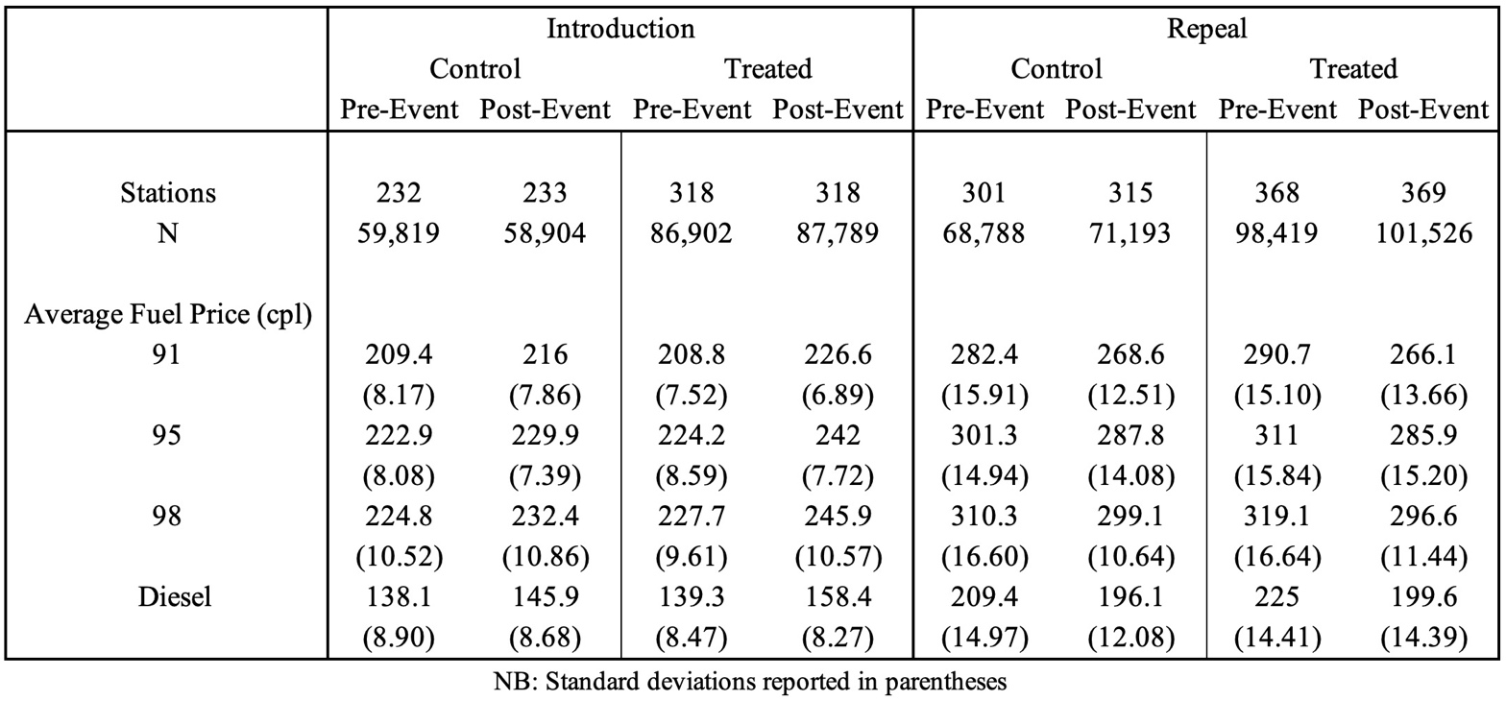

3.2 Methodological Approach
A difference-in-differences (DiD) approach is used to estimate the causal effect of the introduction and repeal of the ARFT on retail fuel prices. The baseline specification is given by:

$$P_{igt}=α+β\left(Auckland_{i}×Post_{t}\right)+φ_{g}+γ_{i}+δ_{t}+ϵ_{igt}$$

where $P_{igt}$ denotes the pump price of fuel grade $g$ at station $i$ on day $t$. $Auckland_{i}$ equals one for stations located in Auckland and zero otherwise, while $Post_{t}$ equals one for observations after the relevant policy change and zero otherwise. The term $ϕ_{g}$ captures fuel-grade fixed effects, $γ_{i}$ denotes station fixed effects controlling for time-invariant characteristics such as brand and location, and $δ_{t}$ denotes day fixed effects. The coefficient $β$ measures the average effect of the ARFT on retail fuel prices in Auckland relative to the control regions. Separate regressions are estimated for the 2018 introduction and the 2024 repeal of the tax.
Furthermore, subgroup regressions are estimated for stations located within 10 kilometres of an oppositely treated competitor. This restriction isolates stations facing strong cross-regime competitive pressure and allows the response to the introduction and repeal of the ARFT to be compared in settings where substitution across tax regimes is most plausible. Comparing the magnitude of the estimated treatment effects across the introduction and repeal provides a direct test for asymmetric price transmission. If prices rise more rapidly following the tax introduction than they fall after its repeal, this constitutes evidence of the “rockets and feathers” phenomenon.
To further examine how competitive pressure shapes pass-through, an interaction specification is estimated of the form:

$$P_{igt}=α+β_{1}(Auckland_{i}×Post_{t})+β_{2}(Auckland_{i}×Post_{t}×Distance_{i})+ϕ_{g}+γ_{i}+δ_{t}+ε_{igt}$$

where $Distance_{i}$ denotes the distance from station $i$ to the nearest fuel station facing the opposite tax regime. The coefficient $β_{1}$ captures the estimated treatment effect for stations located in close proximity to an oppositely treated competitor, while $β_{2}$ measures how pass-through varies with competitive proximity. A significant $β_{2}$ indicates that the incidence of the ARFT depends on the intensity of local spatial competition rather than solely on regional tax status.

3.3 Identification and Estimation
For a DiD analysis to identify causal effects, the parallel trends assumption must hold. In the absence of the ARFT, retail fuel prices in Auckland would be expected to evolve similarly to prices in the control regions of Northland and Waikato. In addition, the heterogeneity analyses assume that, absent the policy change, price trends would not differ systematically across stations facing different degrees of competitive proximity to oppositely treated retailers. These assumptions are assessed by visually inspecting pre-treatment price trends. As shown in Figure 1, average prices for treated and control stations move in parallel prior to both the introduction and repeal of the ARFT. Similar pre-trend patterns are observed across fuel grades and across the subsamples used in the analysis. As a robustness check, in-time placebo regressions are estimated by examining the periods before each policy change and assigning a false introduction and repeal date on the 15th of May 2018 and 2024.
Figure 1: Fuel price trends around the ARFT introduction and repeal
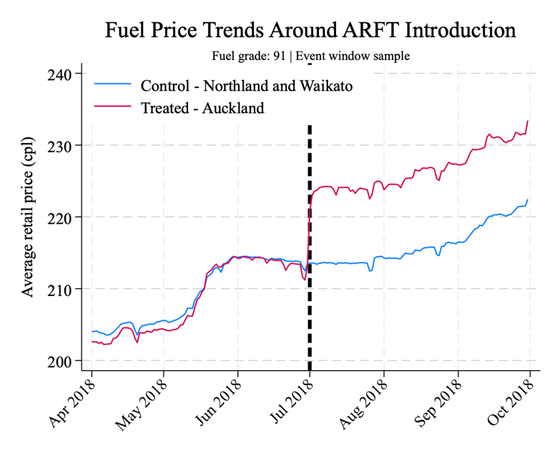 | 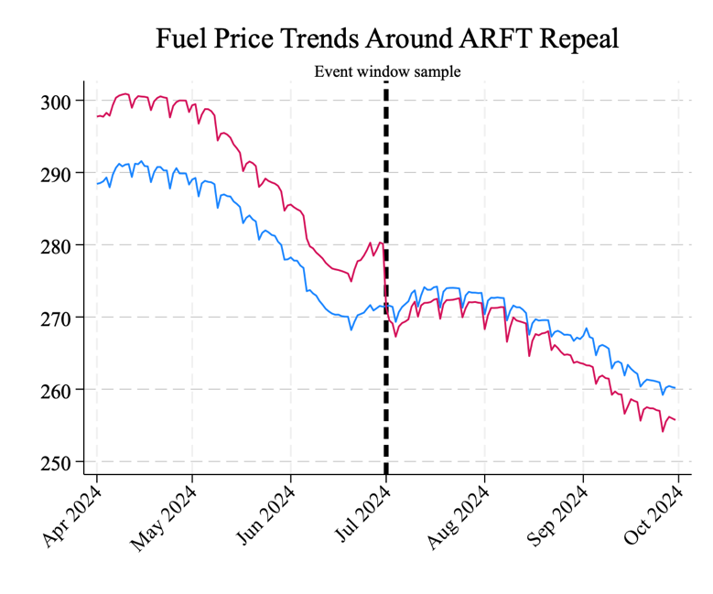
4. Results
Table 2 presents the main results from the DiD estimations. Column (1) reports the effects of the 2018 introduction of the ARFT using the full sample, while Column (2) reports the corresponding estimates for the 2024 repeal. The coefficient on the Treated × Post term captures the causal effect of the ARFT on retail fuel prices in Auckland relative to the Northland and Waikato control regions. Following the introduction of the tax, Auckland fuel prices increased by 10.8 cents per litre (p < 0.01), closely matching the 10 cpl (plus GST) levy and indicating near-complete pass-through to consumers. When the ARFT was repealed, prices fell by 11.7 cents per litre (p < 0.01). The similarity in magnitude between the introduction and repeal effects suggests symmetric pass-through at the aggregate level.

Table 2: Main Results
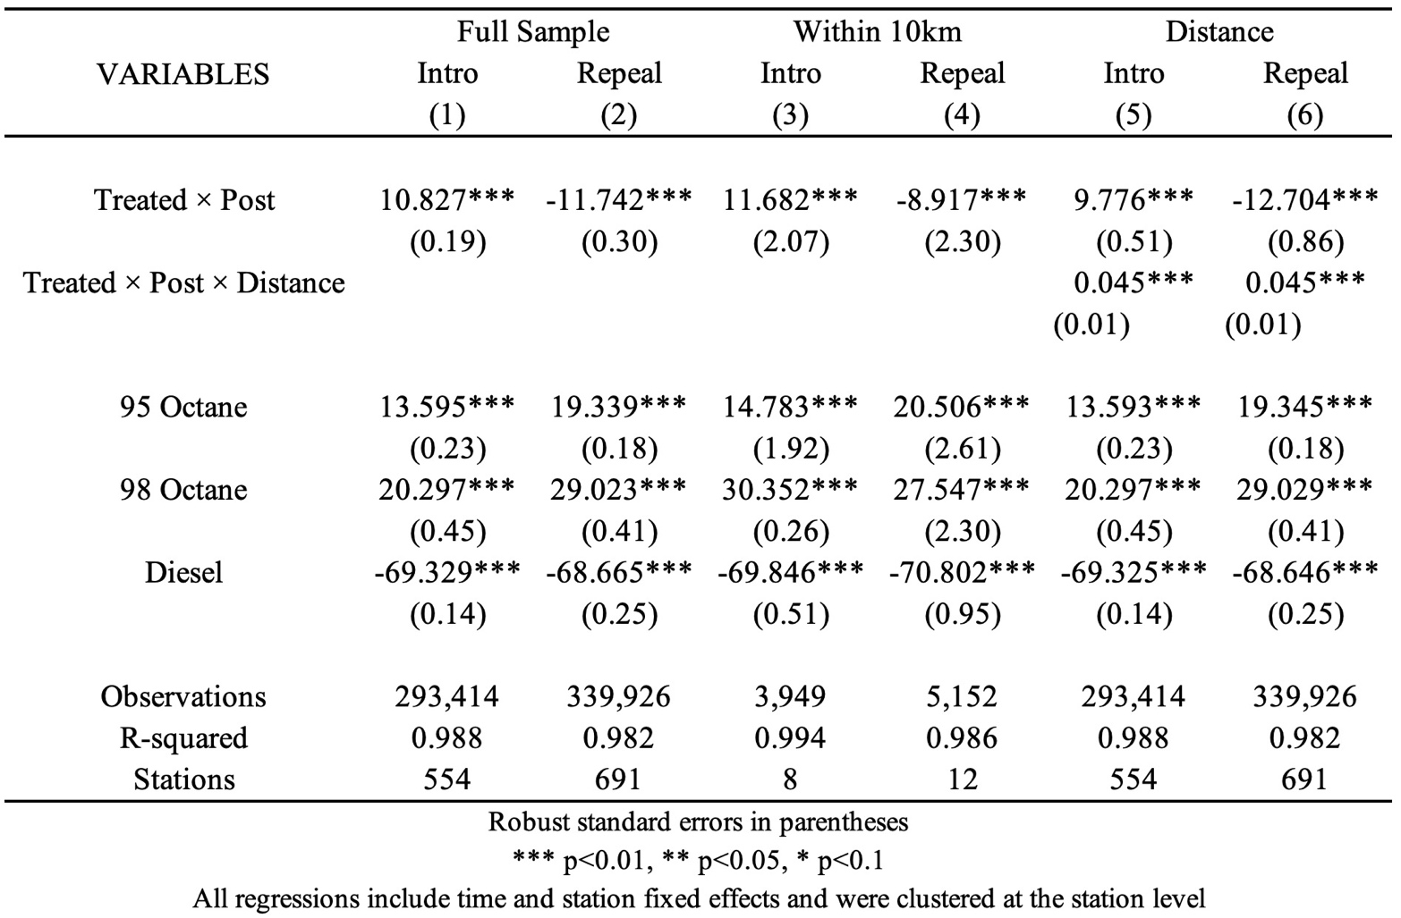

4.1 Border Estimates
Columns (3) and (4) restrict the sample to stations located within 10 kilometres of an oppositely treated competitor, capturing settings in which cross-regime competitive pressure is most pronounced. For these stations, the estimated price increase following the introduction of the ARFT was 11.7 cents per litre, similar in magnitude to the full-sample estimate. In contrast, the estimated price decline following the repeal was only 8.9 cents per litre, only approximately 75% of the initial increase.
This difference is both statistically and economically significant, indicating the presence of localised APT. Stations facing nearby competitors operating under a different tax regime appear to pass through the tax increase almost fully when it is imposed, but only partially transmit the benefits of its removal. This pattern is consistent with the “rockets and feathers” phenomenon documented in international fuel markets and suggests that downward price rigidity can persist even in settings with strong local competitive pressure.

4.2 Distance-Based Estimates
Columns (5) and (6) incorporate the continuous measure of competitive proximity, defined as the distance to the nearest fuel station facing the opposite tax regime. In this specification, the coefficient on Treated × Post captures the estimated effect of the ARFT for stations located in close proximity to an oppositely treated competitor, while the interaction term Treated × Post × Distance measures how the treatment effect varies with competitive proximity. Following the introduction of the ARFT, the baseline treatment effect is estimated at 9.8 cents per litre, increasing by approximately 0.045 cpl for each additional kilometre from the nearest oppositely treated station (both p < 0.01). For the repeal, the corresponding estimates are a price decrease of 12.7 cents per litre at close proximity, with the magnitude attenuating by around 0.045 cpl per kilometre (both p < 0.01).
The positive interaction terms indicate that pass-through increases as stations face weaker local competitive pressure from oppositely taxed rivals. Stations located further from an oppositely treated competitor are therefore able to pass through the tax more fully upon introduction and retain a larger share of the surplus following repeal. By contrast, stations operating in close proximity to competitors under a different tax regime face stronger competitive constraints, limiting both upward and downward price adjustment.

4.3 Placebo Results
To assess whether the estimated treatment effects reflect genuine responses to the ARFT rather than coincidental timing or underlying price dynamics, a set of in-time placebo regressions is conducted. The true policy dates are replaced with false introduction and repeal dates, and the baseline DiD and distance-interaction specifications are re-estimated using these placebo treatment dates.
The placebo results show no evidence of economically meaningful treatment effects. Although some coefficients are statistically significant due to the large sample size, their magnitudes are small relative to the true ARFT effects and display no systematic structure across specifications. In particular, the placebo estimates do not replicate the asymmetry between introduction and repeal, nor do they reproduce the spatial gradient in pass-through observed in the main results. The distance-interaction terms are small and unstable, and do not generate a coherent pattern of competitive heterogeneity.
These findings indicate that the main results are not driven by arbitrary timing, seasonal price movements, or spurious temporal correlations. Instead, the placebo analysis supports the interpretation that the observed price responses and spatial heterogeneity are causally attributable to the introduction and repeal of the ARFT. The in-time placebo therefore provides a meaningful internal validity check on the identification strategy.
Table 3: Placebo Results
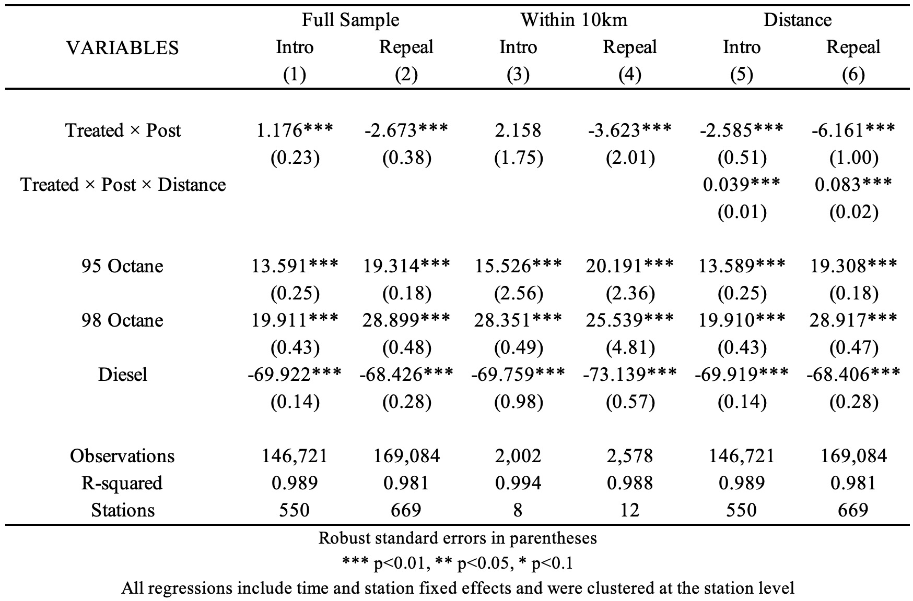
5. Discussion and Conclusion
This paper examines if APT occurred in fuel prices in response to the introduction and repeal of the ARFT. Using high-frequency station-level data and a DiD framework, it finds that fuel prices in Auckland increased by approximately 10.8 cents per litre following the introduction of the tax and decreased by around 11.6 cents per litre after its repeal. Taken together, these estimates indicate near-complete and symmetric pass-through at the aggregate level.
However, further analysis reveals substantial spatial heterogeneity in the adjustment process. Among stations facing close proximity to competitors operating under a different tax regime, prices fell by only around 75% as much following the repeal as they had risen after the introduction. The distance-interaction estimates confirm that pass-through varies systematically with competitive proximity, increasing as stations are located further from an oppositely treated competitor. This pattern suggests that while retail fuel prices adjust symmetrically on average, localised APT persists in markets characterised by strong cross-regime competitive pressure.
The results have two main implications. First, local spatial competition plays a critical role in shaping the incidence of regional fuel taxes and their subsequent removal. Second, APT can arise in local markets even in the presence of strong competitive pressure from nearby retailers operating under different tax regimes. Policymakers should therefore be cautious in assuming that tax repeals will be fully and immediately passed on to consumers. Finally, while this paper provides causal evidence on the presence and spatial variation of asymmetric price transmission in New Zealand’s retail fuel market, it does not identify the underlying mechanisms driving this behaviour. Future research could build on these findings by examining the sources of APT in greater detail.
References
Auckland Transport. (n.d.). Regional fuel tax. https://at.govt.nz/projects-initiatives/past-auckland-projects-and-initiatives/regional-fuel-tax
Bacon, R. W. (1991). Rockets and feathers: the asymmetric speed of adjustment of UK retail gasoline prices to cost changes. Energy Economics, 13(3), 211–218.
Borenstein, S., Cameron, A. C., & Gilbert, R. (1997). Do gasoline prices respond asymmetrically to crude oil price changes? Quarterly Journal of Economics, 112(1), 305–339.
Byrne, D. P., Leslie, G. W., & Ware, R. (2014). How do Consumers Respond to Gasoline Price Cycles? The Energy Journal, 36(1), 115–148.
Doyle, J. J., & Samphantharak, K. (2007). $2.00 Gas! Studying the effects of a gas tax moratorium. Journal of Public Economics, 92(3–4), 869– 884.
Hyslop, D., Le, T., Maré, D., Riggs, L., & Watson, N. (2023). Domestic Transport Charges: Estimation of transport-related elasticities. In Motu Working Paper. https://doi.org/10.29310/wp.2023.10
Land Transport Management (Regional Fuel Tax Scheme—Auckland) Order 2018 (LI 2018/103) (as at 01 July 2024) Contents – New Zealand Legislation. (2024, July 12). https://www.legislation.govt.nz/regulation/public/2018/0103/latest/LMS52616.html#LMS52615
Land Transport Management (Repeal of Regional Fuel Tax) Amendment Act 2024 No 9, Public Act – New Zealand Legislation. (2024, March 7) https://www.legislation.govt.nz/act/public/2024/0009/latest/whole.html#LMS932377
Market study into the retail fuel sector: Final Report, 5 December 2019. (2019).
Peltzman, S. (2000). Prices Rise Faster than They Fall. Journal of Political Economy, 108(3), 466–502.
Removal of Auckland Regional Fuel Tax. (2024). In www.comcom.govt.nz. Commerce Commission. Retrieved July 14, 2025, from https://comcom.govt.nz/__data/assets/pdf_file/0024/361356/Removal-of-Auckland-Regional-Fuel-Tax.pdf
Appendix
Data Sources and Code
Two datasets are used in this analysis. The first consists of daily, geocoded, station-level fuel price data for all fuel stations in Northland, Auckland, and Waikato from 1 April 2018 to 30 September 2018, and from 1 April 2024 to 30 September 2024. These data were obtained from Gaspy, a crowdsourced fuel price platform, via its data agent Datamine Ltd. Due to confidentiality restrictions under a data-sharing agreement, the fuel price data cannot be publicly released. Researchers wishing to reproduce the analysis must request access to the Gaspy dataset directly from Datamine Ltd under their own data-sharing agreement using the reference “Josh McNamara 20250925”.
Treatment status is assigned using official New Zealand Regional Council boundaries obtained from the Statistics New Zealand DataFinder website. Stations located in Auckland (excluding Waiheke Island) are classified as treated, while stations located in Northland and Waikato are classified as controls. Shapefiles are used solely for treatment classification and are not used to construct distance measures.
Competitive proximity is measured using road-network travel distance to the nearest oppositely treated station. Distances are computed using a locally hosted instance of the Open Source Routing Machine (OSRM) (version v5.27) and implemented programmatically in Stata using the user-written osrmtime command. This approach calculates shortest-path travel distances over the New Zealand road network rather than straight-line (Euclidean) distances. The OSRM routing graph is built using New Zealand road network data extracted from OpenStreetMap, obtained via the Geofabrik New Zealand map extract (PBF format), and processed using the standard OSRM preprocessing pipeline.
Distances are constructed only between stations facing different tax regimes. For each Auckland station, road-network distances are calculated to all control-region stations (Northland and Waikato), and for each control-region station, distances are calculated to all Auckland stations. For each station, the minimum road-network distance to an oppositely treated station is retained, yielding a station-level, time-invariant measure of competitive proximity. This variable is merged into the daily station-level price panel prior to estimation and is used to define both continuous distance interactions and the ≤10 km high-proximity subsample.

A full replication package for this paper is available at:
https://drive.google.com/drive/folders/1fe7jM2zhvYHJFcD0hAuunnzqENL_N-O9?usp=share_link

All data cleaning, transformation, distance construction, and econometric analysis were performed in Stata 18.0. Road-network distance calculations are implemented internally within Stata using the manually installed osrmtime command interfaced with a local OSRM backend.

To replicate the results:
- Obtain the fuel price data from Datamine Ltd.
- Download the replication package titled “ARFT_Replication”.
- Place the raw fuel price data file in the data_raw subfolder.
- Install and configure OSRM v5.27 and build the New Zealand routing graph using the OpenStreetMap Geofabrik extract.
- Manually install the osrmtime Stata command in the local ado path.
- Open Stata, set the working directory to the “ARFT_Replication” folder, and run the “ARFT_Master”.do file located in the code subfolder.

The master do-file automatically executes all scripts in sequence to reproduce the cleaned datasets, competitive-proximity construction, econometric analysis, and tables and figures reported in this study.

