UNIVERSITY OF WAIKATO

Hamilton
New Zealand

What Influences Managerial Use of Business Analytic Systems?
A Theory of Performance-Driven Search

Abhijith Anand, Rajeev Sharma and Rajiv Kohli

Department of Economics
Working Paper in Economics 12/17
May 2017

Corresponding Author

Abhijith Anand
Waikato Management School
University of Waikato
Hamilton 3240
New Zealand

Email: aas188@uowmail.edu.au

Rajeev Sharma  Waikato Management School  University of Waikato  Hamilton 3240  New Zealand  Email: rajeev.sharma@waikato.ac.nz | Rajiv Kohli  Mason School of Business  The College of William & Mary  Williamsburg  Virginia, USA  Email: rajiv.kohli@mason.wm.edu

Abstract

Managers use business analytic systems to search for solutions to improve future performance. However, how past performance motivates managers to undertake search for solutions is not well understood. The Behavioral Theory of the Firm (BTF) proposed that managers gather information and engage in search for a solution when they encounter performance problems. We propose a Theory of Performance-driven Search (TPS) and argue that managerial search effort is a function of combined variations in unit-level performance and variations in organizational performance. We tested our theory with managerial use of business analytic systems and monthly performance data collected from seven hospitals over a period of four years.

Our findings indicate that after a decline in unit-level performance, managers’ search effort is shaped by patterns of organizational performance. We also find that managers’ search response to sustained decline is quicker when decline in organizational performance is steep and sustained. Consistent with hypotheses proposed by the TPS, our findings extend our understanding of managerial search behavior and have important implications for organizations’ efforts to create business value from the use of analytic technologies.

Keywords
managerial search
business analytics
aspirations
performance feedback
problemistic search

1. Introduction

Managers’ use of informating capabilities embedded in business analytic systems contributes to improved organizational performance (Burton-Jones 2014, Chen et al. 2012 and Straub et al. 1995). The promise of performance gains from analyzing historical data and devising performance improvement strategies is a key motivation for organizations to invest in systems with informating capabilities. These include business intelligence systems, data warehouses, and other systems with capabilities to integrate, analyze and visualize data, collectively referred to as business analytic systems (Chen et al. 2012, Gartner 2015, InformationWeek 2015 Kiron et al. 2014 and Watson 2014).

Two mechanisms underpin the relationship between the use of business analytic systems and performance improvements. First, managers use analytical capabilities to search available information to generate insights into the cause-effect relationship between past performance and factors that influence performance. Second, managers employ such insights to devise strategies and actions to improve future performance. Managerial search, defined as the effort spent by managers in acquiring and analyzing information to discover knowledge is a critical element in capturing value from investments in informating technologies (Li et al. 2013, Salge et al. 2015 and Vandenbosch and Huff 1997). Although scholars have accumulated a rich body of knowledge on managerial search (Baum and Dahlin 2007, Cyert and March 1963 and Madsen and Desai 2010), what motivates managers to undertake search is scarcely understood. Our objective in this paper is to supplement our understanding of the use – performance relationship by examining what motivates managers to use information systems, particularly business analytic systems. In doing so, we examine how past unit-level and organizational performance, relative to aspiration levels, influences managers’ use of analytic systems.

We draw on, and expand the Behavioral Theory of the Firm (BTF) by proposing a Theory of Performance-driven Search (TPS). BTF suggests that performance shortfalls trigger search for information to identify and address the causes of performance shortfalls, referred to as problemistic search (Cyert and March 1963 and Gavetti et al. 2012). Following this assertion, researchers found support for the causal chain in which past failures drive future performance. Although they argued that search is a mediator between failure and future performance (Baum and Dahlin 2007, Desai 2015, Haunschild and Rhee 2004, Haunschild and Sullivan 2002 and Madsen and Desai 2010), we found no study that theorized or empirically validated the relationship between performance feedback and managerial search. BTF does not offer guidance about whether the locus of failure motivates managerial search. Specifically, it does not distinguish between the effects of failure in unit-level performance and firm-level performance on managerial search. Failure in the performance of a unit is likely to influence search behavior of the unit manager in a different way than a decline in the organization’s overall performance. Although researchers have investigated the relationship between failure experiences and future organizational performance, they have not shed light on managerial search behaviors in response to concomitant variations in unit performance and organizational performance (Gavetti et al. 2012). In this paper, we expand upon the BTF and examine managers’ search behavior in light of the performance of the unit and the organization.

We review prior literature on BTF and problemistic search to develop a theory of managers’ search behavior. Our theory of performance-driven search, TPS, proposes that both unit performance and organizational performance exert contingent effects on managerial search. We identify patterns of combined unit and organizational performance under which managers are likely to engage in search. Our analysis of panel data models, based on data collected over four years from seven healthcare organizations supports our hypotheses. We conclude with a discussion of the implications of our findings for theory and practice.

2. Literature Review

Managerial search effort, the effort spent by managers in acquiring and analyzing information to discover knowledge, is a key predictor of organizational learning and future performance (Cyert and March 1963). Knowledge refers to managers’ understanding of cause-effect relationships between performance and factors that affect performance. The desire to understand and explain performance variation is an intrinsic motivation that underpins managerial efforts expended in search and learning (Desai 2015, Haunschild and Rhee 2004 and Haunschild and Sullivan 2002; March 1991).

The BTF argues that problemistic search, a form of search that 'is stimulated by a problem … and … directed toward finding a solution to that problem' is an important factor that drives organizational learning (Cyert and March 1963, p.121 and Salge et al. 2015). Consistent with this argument, researchers found that the effects of performance feedback on organizational learning are asymmetric and that organizations are more likely to learn from failures rather than from successes (Greve 2003b and Jordan and Audia 2012). This research stream proposes a sequence of ‘failure-search-learning-performance’ (Lant and Montgomery 1987, Haunschild and Sullivan 2002 and Lapré and Tsikriktsis 2006). Researchers also found that catastrophic failures motivate managers to invest extensively in search resources (Darr et al. 1995 and Madsen and Desai 2010). This pattern of the effect of performance feedback on future performance has been reported in multiple settings, including the gas industry, the railroad industry and hospitals (Baum and Dahlin 2007, Desai 2010a, Desai 2010b, Desai 2015, Salge et al. 2015 and Salge 2011).

Despite the extensive literature, it is unclear how the locus of failure influences managerial search. Previous studies do not distinguish between failure in the performance among units and failure in overall organizational performance. This distinction is important because organizational performance and the performance of organizational units are not perfectly correlated, particularly when organizational performance is measured as a profitability metric and unit performance is measured as a productivity metric. The performance of a unit, although influenced by factors common across units, is likely to be influenced by some unique factors, such as variability in demand of the unit’s products or services, the skills of unit members, and the efficacy of managerial oversight. As a result, at any given point in time, managers of some units may experience increased performance while others experience a decline in performance or stable performance. Managers of high-performing units are unlikely to be motivated to invest effort in additional search when they are confident that they have insights into what drives performance in their unit and are likely to attribute the causes of poor organizational performance to other units. Consequently, at any given point, the search behavior of managers within an organization could vary, irrespective of overall organizational performance. Given that unit managers are responsible for the operations and performance of their respective units, it is important to investigate how unit-level performance and organizational performance jointly influence the search behaviors of unit managers. We therefore seek an answer to the question:

Do managers engage in search in response to failure in unit performance or in response to failure in organizational performance, or to a combination of the two performances?

3. Theory of Performance-Driven Search (TPS)

Through our proposed TPS (Figure 1) we suggest that while managers’ search effort is likely to be influenced by the success or failure of their own unit, it is also likely to be influenced by success or failure of organizational performance, as well as by trends in organizational performance.

Our findings will inform managers about how organizations can effectively promote the use of analytic capabilities for better decision making. The use of analytic capabilities is likely to be affected by various contextual contingencies including patterns of past performance of organizational units as well as contemporary organizational performance. Recognizing that use of analytic capabilities is a form of managerial search, we argue that current and past performance feedback is important in the use of information systems, improved decision making and organizational learning.

Figure 1: The Theory of Performance-Driven Search (TPSP)

The BTF proposes that output controls align extrinsic motivation of managers with the interests and goals of the organization (Eisenhardt 1985, Flamholtz et al. 1985 and Snell 1992). Output controls involve setting performance goals for outcome metrics that managers are expected to achieve and offering rewards contingent on performance that exceeds target levels. These performance goals include financial and operational metrics (Chenhall 2003 and Gomez-Mejia et al. 2014). For instance, sales managers are rewarded for exceeding targets for new product sales and production managers are rewarded for not exceeding targets for days lost due to machine breakdown (Langfield-Smith 2009 and O’Connor et al. 2006). Since managers’ rewards are contingent on performance that meets or exceeds target goals, they are motivated to search for causes of poor operational performance and develop strategies to improve the performance of their unit in subsequent periods (Chenhall 2003, Eisenhardt 1985 and Flamholtz et al. 1985). However, when performance exceeds target levels, output controls do not create the same level of extrinsic motivation for managers to search for new knowledge. Researchers have found support for such asymmetric managerial responses to search that are proposed by BTF, lending support to the theory that managers’ search behavior is influenced by the control systems under which they operate (Anthony et al. 1989, Simons 1991 and Simons 2013).

4. Attribution Theory and Managerial Search

The asymmetric effects of performance feedback on managerial search have also been explained by attribution theory. Attribution theory draws on a different set of motivational mechanisms than those considered in the BTF and adds insights into the asymmetric search response of managers (Heider 1958 and Kelley 1971). While the BTF draws on extrinsic motivation in explaining the asymmetric response of managers to performance, attribution theory draws on intrinsic motivation. Attribution theory argues that managers have an ingrained need to understand their environment and to develop causal explanations for significant events (Vaara et al. 2014). Further, it proposes that managers are intrinsically motivated to protect their self-esteem, to show and maintain their sense of mastery over their environment, and to reduce cognitive dissonance on account of discrepancy between their expectations and outcomes (Bettman and Weitz 1983 and Staw et al. 1983). Based upon the above explanation, attribution theory proposes that managers tend to attribute failures to external causes over which they have little or no control. In contrast, managers attribute success to their own abilities and actions. Hence, attribution theory proposes that there is an enhanced intrinsic motivation to search externally for causes of failure than for causes of success. A number of studies found support for attribution effects and the asymmetric effects of success and failure on subsequent managerial responses (Billett and Qian 2008, Hayward 2002, Hayward et al. 2004, Lee and Robinson 2000, Lee and Tiedens 2001, Schlenker et al. 2001, Vaara 2002 and Vaara et al. 2014).

The asymmetric effects of success and failure on managerial search behavior have also been explained with cognitive biases, in particular the effect of recall bias. Managers recall events that occurred prior to positive outcomes differently than those that occurred prior to negative outcomes (Heider 1958 and Vaara 2002). When managers focus on improving performance, they plan a set of actions to attain objectives. If outcomes are as intended, and managers are asked to explain the reasons for successful outcomes, the explanation that they can most readily recall lies in the actions they took. However, if the outcomes are not as intended, they will rely on identifying external causes that might have undermined the intended effects of their actions.

Building upon the above theoretical tenets, we propose that managers’ search behavior is a function not only of overall organizational performance, but also of the performance of the units. Organizations develop unit-level performance metrics alongside firm-level metrics as a way for top management to manage overall organizational performance (Langfield-Smith 2009 and O’Connor et al. 2006). Unit managers are responsible for the performance of their respective units and are expected to respond to declines in their unit performance. Top management is likely to pay closer attention to overall organizational performance than to variations in the performance of individual units. Consequently, when overall organizational performance is unsatisfactory, top management is more likely to scrutinize the unit-level performance metrics and seek explanations from unit managers. In contrast, when organizational performance is satisfactory, top management is less likely to scrutinize the unit-level performance metrics, even of those units that are returning unsatisfactory performance. Ironically, under such conditions, unsatisfactory performance of units is viewed as ‘opportunities for learning’ and treated as a stepping stone for future success (Dillon and Tinsley 2008 and Morris and Moore 2000).

The control and attribution effects that are responsible for the asymmetric managerial responses to success and failure operate not only for unit managers but also for senior managers. Just as unit managers have targets, so do senior managers and CEOs. Similarly, just as unit managers exhibit attribution behavior, so do their managers and CEOs. As the search behavior of unit managers is conditioned by their own intrinsic and extrinsic motivations and also in response to the attention that top management is paying to the performance of their unit, they are more likely to engage in search in response to their own unsatisfactory performance only when overall organizational performance is also unsatisfactory. As shown in Figure 2, formally we hypothesize:

H1: A decline in unit-level performance is more likely to lead to increased managerial search effort when organizational performance also declines in the same period.

Figure 2: The Contingent Effects of Organizational Performance
and Aspiration Levels Proposed in Theory of Performance-Driven Search

5. Episodic vs. Sustained Performance

Extending the above theoretical arguments, we propose that unit managers’ response to an episode of decline in unit performance in a particular period is contingent on an episodic decline in organizational performance in the same period (H1) and on long term trends in organizational performance. Managers interpret stable and increasing organizational performance as evidence of their own success and deem further search for knowledge as unnecessary, even at the risk of ignoring contrary information (Hayward et al. 2004, Lant 1992 and Yadav et al. 2007). Hence, under stable or increasing organizational performance, it is less likely that an explanation for declining unit-level performance will be demanded. Episodic declines in unit performance under those conditions can be attributed by top management to external causes or one-time events and are often ignored as they do not have significant negative consequences on organizational performance. Consequently, unit managers are unlikely to increase their search efforts in subsequent periods following episodic declines in unit performance when organizational performance is stable or increasing.

In contrast, top management cannot ignore sustained performance decline in organizational performance and is likely to closely monitor unit performance to understand and reverse the declining trend in organizational performance. Following from the structure of goal and attribution effects discussed above, we propose that unit managers are more likely to engage in increased search in periods following an episodic decline in unit performance when overall organizational performance is in a sustained decline. As shown in Figure 2, we formally present our second hypothesis:

H2: A decline in unit-level performance is likely to lead to increased managerial search effort in subsequent periods only when the organization is experiencing a sustained failure in organizational performance, but not when it is experiencing episodic failure, or episodic success or sustained success in organizational performance.

Latency of Managerial Search Response

We proposed above that the extent of managerial search effort is contingent on patterns of failures or success in unit performance and organizational performance. Extending this theoretical argument, we propose that the latency of managerial search response between decline in unit-level performance and managerial search during sustained failures in organizational performance is a function of how rapidly organizational performance declines.

Large and sudden failures indicate significant gaps in managerial knowledge and the need to quickly search for causes of failure (Levinthal and March 1981). Organizational control systems are sensitive to large disruptions and react more quickly to avoid further declines. Damage control mechanisms are quickly activated such that the larger the magnitude and speed of failure, the faster the response. Performance control systems are commonly employed to assign accountability for failures. Therefore, unit managers calibrate their responses to the magnitude and speed of organizational failure. Specifically, the greater the magnitude and faster the failure, the greater is the sense of urgency to search for causes of failure and to respond effectively (Cameron 1984, Greve 2003b and Sitkin 1992).

Attribution theory also suggests that managers tend to proactively assume responsibilities for large failures, in order to avoid being perceived as 'deceptive, self-absorbed, and ineffectual...unreliable…' (Schlenker et al. 2001, p.15). Managers engage in substantive and visible search efforts to offer plausible explanations for failures in order to project that they are in control of the situation, that they can turn it around, and to justify their corrective response to failure (Lee and Robinson, 2000). Therefore, we propose that the latency of search response of the unit managers is contingent on the rate of decline in organizational performance. Formally, as shown in Figure 2, our third hypothesis is:

H3: The steeper the decline in organizational performance during sustained failure, the faster will be the search response of unit managers to decline in unit-level performance.

Aspiration Levels and Managerial Search

Managers’ assessment of organizational and unit performance as ‘success’ or ‘failure’ involves comparing performance feedback against their aspirational levels of performance (Cyert and March 1963, March 1994 and Montgomery 2008). Aspirations are 'the smallest outcome that would be deemed satisfactory by the decision maker [managers]' (Schneider 1992, p.1053){Schneider, 1992 #562;Schneider, 1992 #562}. Managers employ aspiration levels to simplify performance evaluations by transforming continuous outcome measures of performance into discrete measures of success and failures (Baum and Dahlin 2007). As success or failure categorizations depend on aspiration levels, managers’ search patterns are likely to be shaped by their aspiration levels. Failure assessments lead to problemistic search, while assessments of success do not. Empirical studies confirm the role of aspiration levels in influencing managerial search efforts in response to performance feedback (Baum and Dahlin 2007, Greve 1998, Greve 2003a, Lant 1992, Salge 2011 and Schneider 1992).

Managers’ aspiration levels are shaped by two different sets of information, historical aspiration levels and social aspiration levels (Baum et al. 2005, Cyert and March 1963 Kim et al. 2015 and Lant 1992). Historical aspiration levels are based on the firm’s performance history while social aspiration levels are drawn from the performance of a reference group of peers. The two aspirations vary in their origins and the information on which they are based and, consequently, influence managerial search behaviors differently (Audia et al. 2000, Gaba and Bhattacharya 2012, Gaba and Joseph 2013, Kacperczyk et al. 2015, Kim et al. 2015, Kuusela et al. 2016 and Park 2007).

As our proposed TPS distinguishes between the influence of unit-level performance and organizational performance on managerial search, it is important to understand how aspiration levels influence managerial search. Unit managers have access to organizational performance data that is also closely monitored by the top management. Given that top managers are more likely to scrutinize unit managers’ performance when there is a failure in organizational performance, unit managers’ form their aspirational levels based on historical organizational performance. Therefore, unit managers calibrate their search effort relative to such aspiration benchmarks. When organizational performance falls below historical aspirational levels and the unit-level performance is also in decline, a unit manager is more likely to search for the causes of failures in unit’s performance, to understanding the unit’s environment, develop reasonable explanations to report to top management and design strategic actions to reverse performance shortfall. We, therefore, propose that managers’ search effort in response to feedback on unit-level performance is shaped by historical aspirations of organizational performance. Formally, as shown in Figure 2, we propose a fourth hypothesis as:

H4: A decline in unit-level performance is more likely to lead to increased managerial search effort when organizational performance is below historical aspiration levels of organizational performance.

Similar to historical aspirations, social aspiration levels help managers to form a baseline performance level and enables them to reflect on how well they should perform (Washburn and Bromiley 2012). Unit managers closely monitor how well their peer organizations are performing. They recognize that the top management expects them to perform at least on par with their peers. However, the access to performance information of peers is limited to organizational performance because performance of units of peer organizations is likely to be private (Kim et al. 2015 and Kim and Miner 2007). Hence, social aspirational levels of organizational performance are likely to influence managerial search effort. As shown in Figure 2, our fifth and final hypothesis is:

H5: A decline in unit-level performance is more likely to lead to increased managerial search effort when organizational performance is below social aspiration levels of organizational performance.

6. Method, Operationalization and Analysis

Research Setting and Data

To examine the effects of performance on managerial search behaviors and to test our proposed TPS, we gathered longitudinal data on search, organizational performance and unit performance for 49 monthly periods from seven not-for-profit hospitals in the United States, resulting in a total of 280 data points. The hospitals operate in several geographic regions that also consist of smaller community health facilities. Hospitals are subject to similar regulations, reimbursement for services and to competitive market forces, regardless of the ownership status.

Our measure of search effort is operationalized as usage, or use, of a business analytic system by managers to generate ad hoc reports to monitor, analyze and diagnose performance. We excluded ‘standard reports’ that are automatically generated every month or quarter. Unit managers generate ad hoc reports to monitor and diagnose variance in performance. After reviewing findings from such analyses, and in declining performance, managers devise remedial actions to improve future performance, for example, by adjusting staffing levels, or by consolidating services.

Consider an example of the manager of pathology lab unit. The pathology lab manager views a decline in hospital’s profitability and also lower net patient revenue. This triggers a search through use of analytic system to track whether the pathology lab revenues have contributed to decline in hospital profitability. The pathology lab draws a sizable revenue from complete lipid panels, a blood test for cholesterol-related issues, so the pathology lab manager explores whether hospital charges are sufficient to cover the actual costs of labor and supplies in conducting the diagnostic test. The unit manager analyzes the payment terms of each contract with insurers to determine whether, and how much, the reimbursement for the complete lipid panel test contributes to pathology lab’s surplus. Should the surplus be below the aspiration level, say, three percent contribution margin, the pathology lab manager will generate ad hoc reports, such as ‘what-if’ price modeling, to devise actions to meet aspirational surplus levels. Such actions may include lowering of labor costs by redesigning the testing process, such as, by partnering with other diagnostic services to draw samples, or by investing in more efficient pathology equipment, or by renegotiating charges with insurance companies to raise revenue.

All seven hospitals in our sample belong to one parent corporate entity and utilize the same business analytic system developed and introduced by the corporate entity. The business analytic system is employed by managers in each hospital to monitor organizational and unit performance. In addition to hospital C-level top managers, corporate office top managers monitor performance of each hospital. Unit managers across hospitals utilize common system functionalities for reporting, analysis of costs, contract management, and for evaluating strategies to improve productivity and performance. The information system maintains a log of managerial usage of the analytic capabilities, in addition to periodic reporting of unit-level and organizational performance measures, including net patient revenue per day and net income. Monthly data on ad hoc usage was automatically captured by an in-built usage utility that recorded the number of analytical reports, the duration of computing, number of data records accessed, as well as the computing intensity consumed in the execution of the analysis.

Operationalization of Constructs

Managerial Search Effort: Managerial search effort reflects managers’ use of analytic capabilities embedded in business analytic system to monitor and diagnose organizational and unit performance. The analytic system is hosted on an IBM mainframe computer system. Built-in utilities of the mainframe capture usage data. We identified all reports executed by unit managers during the period of our data collection and collected usage data. Further, we reviewed each executed report and verified that the report was indeed an ad hoc report and that the manager entered one or more parameter required to execute the report. Our operationalization of managerial search effort is based on the aggregate usage of the analytic system for generating ad hoc reports by all unit managers in a hospital. It is represented by three system-captured measures (1) The number of ad hoc reports generated by unit managers (mean=280.14, max=2438, min=9), (2) the CPU time consumed in generating the reports (mean=8183.19, max=71365, min=80), and (3) the number of Disk Input/Output cycles consumed in generating the reports (mean=216447.23, max=1468907, min=6339). The ‘number’ of reports variable captures the frequency of search efforts, CPU time and Disk Input/Output cycles capture the depth or complexity and extent, respectively, of search efforts. Given the disparities in the scales of the three measures, we normalized the measures by rank ordering the responses on each of the three scales and sum of the ranks to create a composite measure of managerial search effort. Robustness check confirmed the reliability of the composite measure (Cronbach’s α = .782). These measures of system use were employed in prior research (Devaraj and Kohli 2000 and Devaraj and Kohli 2003) and are commonly used by organizations to report systems usage.

Unit Performance: Unit performance reflects the performance of business units for which the manager is responsible. Consistent with previous studies, we operationalize unit performance as net patient revenue per day (NPRDAY) (Gapenski et al. 1992; Langland-Orban et al. 1995). NPRDAY reflects the average revenue generated per day by all units in a hospital. It is based on net payments received from patients and insurance companies for services provided to patients. It is an important unit metric that is reported on standard reports that are regularly generated and monitored by unit managers as well as reported to corporate managers. A decline in NPRDAY is likely the result of underperformance of a number of units in a hospital. Standard reports also report unit-level revenue that managers review to assess whether their unit’s performance is in decline. TPS proposes that hospital unit managers whose unit performance is below expectations would further investigate the causes of decline by executing ad hoc reports, our measure of managerial search. The unit level of measurement of managerial search and unit performance are hence consistent as both are aggregated measures for each hospital.
Organizational Performance: Organizational performance is measured as the hospital’s financial performance. Consistent with previous studies, we operationalized organizational performance as a hospitals’ net income (NI) by month, a key performance metric monitored by top management (Baum and Dahlin 2007). It is reported on the income statement and available in the analytic systems.

Performance Trends

Trend in Organizational Performance: The trend in organizational performance of an organization refers to the direction of the slope of performance over a period of time. It is represented by the slope of the line of best fit for the time series performance data. For our study, we estimated the organizational performance trend for each hospital over 49 monthly periods (See Appendix 1, Table A1 for detailed results). We analyzed the time series data of monthly net income for each hospital and categorized the trend in organizational performance as ‘sustained success’, ‘sustained failure’, ‘episodic success’ or ‘episodic failure’ (Table 1).

Table 1: Analysis of Monthly Net Income Data
to Estimate Trend in Organizational Performance

Organization  (N=49 for Each Hospital) | B (Slope  of Time Series Regression Line) (NI) | p-value | Trend in Organizational Performance | Test of Difference in Slopes
O1 | -28650 | < 0.05 | Sustained Failure | SE = 7145.3  t = -3.07  p < 0.05
O2 | -7060.4 | < 0.05 | Sustained Failure | SE = 7145.3  t = -3.07  p < 0.05
O3 | -1135.3 | ns | Episodic Failure | SE = 5219.9;  t = 0.15;  p > 0.05
O4 | -1929.5 | ns | Episodic Failure | SE = 5219.9;  t = 0.15;  p > 0.05
O5 | 32541 | ns | Episodic Success | SE = 26755.3;  t = 1.094;  p > 0.05
O6 | 1934 | ns | Episodic Success | SE = 26755.3;  t = 1.094;  p > 0.05
O7 | 17274 | < 0.05 | Sustained Success

Hospitals returning a significant negative slope for organizational performance were categorized as experiencing ‘sustained failures’. Of the seven hospitals in the sample, two hospitals, Hospital O1 (B=-28650, p≤0.05) and Hospital O2 (B=-7060.4, p≤0.05) were categorized as experiencing ‘sustained failures’ (See Table 1).

Hospitals returning a non-significant negative slope for organizational performance were categorized as experiencing ‘episodic failures’. Of the seven hospitals in the sample, two hospitals, Hospital O3 (B=-1135.3, p>0.05) and Hospital O4 (B=-1929.5, p>0.05) were categorized as experiencing ‘episodic failures’ (See Table 1).
Hospitals returning a non-significant positive slope were categorized as experiencing ‘episodic success’. Of the seven hospitals in the sample, two hospitals, Hospital O5 (B=32541, p>0.05) and Hospital O6 (B=1934, p>0.05) were categorized as experiencing ‘episodic success’ (See Table 1).

Hospitals returning a significant positive slope were categorized as experiencing a ‘sustained success’. Of the seven hospitals in the sample, one hospital, Hospital O7 (B=17274, p≤0.05) was categorized as experiencing ‘sustained success’ (See Table 1).

We further tested the differences in slopes, particularly for the two hospitals categorized as facing sustained failure (Hospitals O1 and O2, see Table 1). We conducted a difference in slopes test to examine if O1 or O2 faced a significantly faster sustained failure than the other. The test revealed that the slope for O1 was significantly steeper than the slope for O2 (p≤.05), suggesting that O1 was facing a significantly faster and sustained failure than O2. The difference in slopes for the hospitals categorized as episodic failures (O3 and O4, p>.05) were not significantly different. The difference in slopes for the hospitals categorized as episodic success (O5 and O6, p>.05) were also not significantly different.

Aspiration Levels

Historical Aspiration Level: Historical aspiration level refers to the minimum performance level, inferred from past performance that is deemed satisfactory by managers. Consistent with previous studies, we operationalize historical aspiration levels as a weighted moving average of past performance to allow for continuous adaption of aspirations levels as performance varies across time (Baum et al. 2005; Gaba and Joseph 2013; Kim et al. 2015; Kuusela et al. 2016). We measure historical aspiration levels of organizational performance using monthly net income (NI), as follows:

HisAsp_{it} = α NI_{i,t-1} + (1-α) HisAsp_{i,t-1} (1)

where

HisAsp is historical aspiration of organizational performance.
NI is the organizational performance metric (operationalized as net income).
i is the focal hospital.
t is the time period.
α is a weight given to prior performance and denotes the relative importance of previous performance levels.

Higher values of α update historical aspiration levels at a faster rate, placing more importance on recent performance, and vice versa. Consistent with prior research, we chose fixed values of α: .75, .50, and .25 to adjust the relative weightage of prior performance levels in the previous three periods, respectively (Baum et al. 2005, Kim et al. 2015 and Kuusela et al. 2016).

We categorized performance as success or failure by computing performance relative to historical aspirations, defined as the value of the performance metric at t, minus its historical aspiration level at t, as shown below. Similar to the approach in prior research, we implemented a spline function to allow the variable coefficient to change at a predetermined point (Kim et al. 2015 and Marsh and Cormier 2001). This enables us to compare the performance above and below the aspiration level.

HAL_{Org} = $\left\{\begin{aligned}2,{ NI}_{it}-{HisAsp}_{it} ≥0 , i.e. success \\ 1, {NI}_{it}-{HisAsp}_{it} <0 , i.e. failure\end{aligned}\right.$ (2)

HAL_{Org} is the assessment of performance as success or failure based on historical aspiration levels of organizational performance.

For ease of interpretation and to obtain absolute values, performance above historical aspiration levels was assigned a value for ‘2’, while performance below historical aspiration levels was assigned a value of ‘1.’

Social Aspiration Levels: Social aspiration level refers to the minimum performance requirements established from prior organizational performance of other organizations that is deemed satisfactory by managers. Consistent with prior research, manager’s social aspiration levels were derived based on the concurrent organizational performance levels of all other hospitals in the network (Baum et al. 2005, Gaba and Joseph 2013 and Levinthal and March 1981). We computed profit margin percentage as our organizational performance measure for each individual hospital by dividing net income by gross revenue to normalize the measures across hospitals. The aspiration level is set to profit margin percentage of all the other hospitals, as shown below:

SocAsp_{it} = (Σ_{j} ProfitMargin_{jt}) / K_{H} -1 (3)

where j (6 in our study) refers to the other organizations in the group against whom performance is compared, and K_{H} (7 in our study) is the total number of peer organizations in the network. We categorized performance as success or failure by computing performance relative to social aspirations, defined as the value of the performance metric at t, minus its social aspiration level at t as shown below. Similar to historical aspirations, we implemented a spline function to allow the variable coefficient to change at a predetermined point. This allows us to compare performances above and below social aspiration levels (SAL_{Org}).

SAL_{Org} =$\left\{\begin{aligned}2,{ ProfitMargin}_{it}-{SocAsp}_{it} ≥0 , i.e. success \\ 1, {ProfitMargin}_{it}-{SocAsp}_{it} <0 , i.e. failure\end{aligned}\right.$ (4)

As for historical aspiration level, for ease of interpretation and to obtain absolute values, we assigned a value for ‘2’ for performance above social aspiration levels and a value of ‘1’ for performance below social aspiration level.

In order to account for factors that reflect changes in services and financial performance, we included three control variables for each hospital i in each month t. Reimbursement captures the amount reimbursed by insurers to the hospital for patient services. Although, it is a function of revenue, reimbursement rates vary depending upon contractual terms with insurers. Medicaid captures the number of patients who were insured through the state-sponsored Medicaid program. We included Medicaid because the reimbursement for services to patients on the Medicaid program are generally lower than reimbursement for patients covered by commercial insurance plans. A hospital’s Casemix is an index, with base as 1.0, that captures the aggregated complexity and resource intensiveness in the treatment of patients. Generally, a hospital with sicker patients will have a higher casemix. Taken together, the three variables account for differences among hospitals that might affect patient revenue for services and hospital profitability (Devaraj and Kohli 2003, Ding 2014 and Menon et al. 2009).

7. Data Analysis

The data employed in this research has a cross-sectional dimension (multiple hospitals) and a temporal dimension (longitudinal, monthly data). Tests of H1, H4 and H5 involve combining the longitudinal data across the seven hospitals and testing the hypotheses controlling for unobserved heterogeneity and other differences between the hospitals that may influence managerial search effort. A panel data analysis based on a random effects model and employing the generalized least squares (GLS) method with robust standard errors controls for any biases from the temporal autocorrelations from pooling repeated observations and is employed for testing H1, H4 and H5 (Greene 2000 and Wooldridge 2010). Further, given that the analysis is based on aggregated search and unit performance data for each hospital, the random effects model would be more appropriate than the fixed effects model to control for difference across the hospitals and firm specific effects. H1, H4 and H5 are tested by estimating the following model:

Managerial Search Effort _{it} = β₁ + β₂ OrgPef_{it} + β₃ UnitPef_{it} + β₄ HALorg_{it} + β₅ SALorg_{it} + β₆ (OrgPef X UnitPef)_{it} + β₇ (HALorg X UnitPef)_{it} + β₈ (SALorg X UnitPef)_{it} + β₉ Reimbursement_{it} + β₁₀ Medicaid_{it +} β₁₁ CaseMix_{it +} w_{it} (5)

where

Managerial Search Effort_{it} is the value of the managerial search effort for the i^{th} hospital at
time t.

β₁ to β₁₁ are the standardized regression coefficient.

OrgPerf is the value of the organizational performance.

UnitPerf is the value of the unit-level performance.

HALorg is the success/failure assessment based on comparison against historical aspirations of organizational performance.

SALorg is the success/failure assessment based on comparison against social aspirations of organizational performance.

Reimbursement at time period t and hospital i.

Medicaid at time period t and hospital i.

Casemix at time period t and hospital i.

w_{it} = e_{i} + u_{it}, is the composite error term consists of two components: cross section or individual specific error component and combined time series and cross section error component.

In order for H1, H4 and H5 to be supported, the regression coefficients must demonstrate the following pattern:

H1 will be supported if β₆ is positive and significant,
H4 will be supported if β₇ is positive and significant,
H5 will be supported if β₈ is positive and significant.
(H2 and H3 are tested using distributed lag model as described below section).

As the effects of the organizational performance (OrgPerf), historical aspiration level (HALorg) and social aspirational level (SALorg) become more negative, the more negative are the effects of unit performance (UnitPerf) on Managerial Search Effort. Hence, a positive sign depicts the multiplicative interaction term of the two negative effects.

Diagnostics and Robustness Checks

To avoid inconsistent and biased estimates, we conducted robustness and diagnostics checks using Breusch and Pagan’s Lagrangian multiplier test (p < 0.01) and the Hausman test (p > 0.05) to check for any biases arising from the random effect estimator (Baltagi 2008 and Greene 2000). Results from the tests supported random effects model as an appropriate model to test our hypotheses. Further, first-order autocorrelation occurs when disturbances in one time period are correlated with those in the previous time period, resulting in incorrect estimates rendering ordinary least squares (OLS) inefficient and biased (Greene 2000, Judge et al. 1988 and Wooldridge 2010). Therefore, we estimated random effects panel data generalized least squares model with robust standard errors to correct for autocorrelation of disturbances due to constant firm-specific effects. Further, random effects panel data generalized least squares model with robust standard errors allows us to generalize the inferences beyond our sample to the population (Greene 2000 and Wooldridge 2010). Random effects model controls for biases arising from omitted variables by accounting for changes within the hospitals. In addition, similar to prior research (Reed 2015 and Salge et al. 2015), to address the issue of endogeneity, we also tested our panel data model by lagging the regressors as instrument variables, instead of relying on external instrumental variables (See Appendix 2, Table A2). Analysis of endogeneity tests reveal that the findings reported in the results section are not subject to a validity threat arising from endogeneity.

Tests of H2 and H3 involve analysis of a finite distributed lag model (Arellano 2003, Gujarati 2012 and Wooldridge 2010). Panel data analysis employed to test H1, H4 and H5 provides an all-inclusive analysis from the aggregated data of all hospitals. Although this analysis provides us an understanding of the relationship between performance declines and managerial aspirations on search efforts and enables generalization of our results, the effects of idiosyncratic organizational contexts on search efforts are difficult to extract and observe in panel data models. For instance, the rate of decline in organizational performance varies across hospitals and it is difficult to observe the differential effects of declines in performance on managerial search effort across various organizational contexts. Further, it is possible that the effects of performance failure on managerial search effort are lagged. Therefore, with finite distributed lag model (DLM), we overcome the limitations posed in the random effects model and are able to account for the effects of varying organizational factors. Accounting for such nuances provides a richer explanation of the patters of managerial search effort, and the latency of response between performance failures and managerial search.

To test hypotheses H2 and H3, we employed finite DLM to examine the lagged relationship between performance variations and managerial search effort for each individual hospital. DLM enables us to draw conclusions regarding the lagged relationships between performance and managerial search effort across the different conditions prevailing across the individual hospitals. Specifically, we draw such conclusions based on the trend in organizational performance (H2) and speed of decline in organizational performance (H3), which vary across the individual hospitals (Gujarati 2012 and Kmenta 1971).

Managerial Search Effort_{t} =$∝+\sum_{i=0}^{∞}{β_{i} {UnitPerf}_{t-i}+u_{t}}$, (6)

where Managerial Search Effort_{t} is the value of the managerial search effort at time period t, α is the intercept, UnitPerf_{t} is the value of the unit performance at time period t, β_{i} is the weight estimated by the DLM analysis for the i^{th} lag period of unit performance, and u_{t} is the error.

In order for Hypothesis 2 to be supported, β_{i} should be (a) negative and significant over multiple lags for hospitals experiencing sustained failure (that is, Hospitals O1 and O2) and (b) non-significant for hospitals experiencing episodic failure or episodic success or sustained success.

For Hypothesis 3 to be supported, since hospital O1 has experienced faster failure than hospital O2 (see Table 1), we expect β_{i} for hospital O1 to be negative and significant in earlier lags as compared to hospital O2, indicating a shorter latency of response.

We conducted Akaike Information Criteria (AIC) and Final Prediction Error (FPE) tests to determine the length the lags for finite DLM analyses. Both tests indicated a lag selection of 8, suggesting that eight lag periods should be included in the finite DLM analysis (Akaike 1974, Gujarati 2012 and Kmenta 1971). Further, we performed robustness checks against validity threats arising from multicollinearity, outliers and influential observations. All the results indicate a good fit for the model. The highest variance inflation factor (VIF) was 8.9, which is below the acceptable levels (<10), suggesting that multicollinearity is not a concern in the model (Hair et al. 2006 and Kennedy 2003).

8. Results

In Table 2 we summarize the results of the data analysis and hypothesis testing. In Table 3 we present the results of random effect panel GLS analyses on managerial search effort. Finally, in Table 4 we present the results of the finite DLM analyses for the individual hospitals. Table 3 shows the results from the panel data analyses. The results (Model 3) show a positive interaction effect of decline in unit performance and decline in organizational performance on managerial search effort (β=.310, p<0.05, N=269). Therefore, Hypothesis 1 is supported.

The results show a positive and significant interaction effect of decline in unit performance and historical aspiration levels of organizational performance on managerial search effort (β=.441, p<0.05, N=269). Therefore, Hypothesis 4 is supported.
Table 2: Summary Results of Hypothesis Testing  H1: A decline in unit-level performance is more likely to lead to increased managerial search effort when organizational performance also declines in the same period. | Supported
H2: A decline in unit-level performance is likely to lead to increased managerial search effort in subsequent periods only when the organization is experiencing a sustained failure in organizational performance, but not when it is experiencing episodic failure, or episodic success or sustained success in organizational performance. | Supported
H3: The steeper the decline in organizational performance during sustained failure, the faster will be the search response of unit managers to decline in unit-level performance. | Supported
H4: A decline in unit-level performance is more likely to lead to increased managerial search effort when organizational performance is below historical aspiration levels of organizational performance. | Supported
H5: A decline in unit-level performance is more likely to lead to increased managerial search effort when organizational performance is below social aspiration levels of organizational performance. | Supported

Finally, we find a positive interaction effect of decline in unit performance and social aspiration levels of organizational performance on managerial search effort (β=.465, p<0.05, N=269). Therefore, Hypothesis 5 is supported.

The lag coefficients (for hospital O1 and O2 in Model 1 of Table 4) are negative and significant over multiple periods only for the two hospitals that experienced sustained failures. In contrast, there are no significant negative lags over multiple periods in the other hospitals that experienced episodic failure (Model 2) and episodic or sustained success (Model 3 and Model 4). Therefore, Hypothesis 2 is supported.

Consistent with the expectations of TPS, O1 returns significant lags between performance decline and search for Lag periods 2 to 8, while O2 returns significant lags for Lag periods 6 to 8. This indicates that O1, which experienced a faster sustained organizational performance failure than O2 has responded much faster to unit performance decline than O2 (Table 4, Model 1). Therefore, Hypothesis 3 is supported.

Table 3: Random Effects Panel Regression Analyses for Managerial Search Effort

 | Model 1 |  | Model 2 |  | Model 3
Main Effects | β Coeff. (S.E) | Z-Score (Sig) | β Coeff. (S.E) | Z-Score (Sig) | β Coeff. (S.E) | Z-Score (Sig)
OrgPerf | .023 (.06) | .39 |  |  | -.282 (.091) | -3.07**
UnitPerf | -.112 (.074) | -1.51 |  |  | -.560 (.086) | -6.44***
HAL_{Org} |  |  | -.035 (.056) | -.64 | -.381 (.081) | -4.68***
SAL_{Org} |  |  | .076 (.064) | 1.18 | -.244 (.058) | -4.16***
Interaction Effects
OrgPerf * UnitPerf |  |  |  |  | .310 (.122) | 2.54**
HAL_{Org} * UnitPerf |  |  |  |  | .441 (.091) | 4.82***
SAL_{Org} * UnitPerf |  |  |  |  | .465 (.084) | 5.53***
Control Variable
Reimbursement Rate | .173 (.079) | 2.18** | -.057 (.107) | -.54 | .169 (.119) | 1.42
Medicaid | .113 (.073) | 1.54 | .166 (.079) | 2.08 | .033 (.132) | .25
CaseMix | -.138 (.071) | -1.94* | -.116 (.092) | -1.26 | -.171 (.124) | -1.37
Organizations | 7 |  | 7 |  | 7
Time Period
Number of Observations | 280 |  | 269 |  | 269
R-squared
Within | 0.0074 |  | 0.0221 |  | 0.1601
Between | 0.5114 |  | 0.2933 |  | 0.6613
Overall | 0.1238 |  | 0.0772 |  | 0.2921
Wald-Chi (Sig) | 21.38*** |  | 7.16 |  | 106.46***
Notes
**p<.05 *** p<.001.
Managerial search effort is the dependent variable.
Table 4: Finite Distributed Lag Models of Effect of Operational Performance on Managerial Search Effort

 | Model 1 |  |  |  | Model 2 |  |  |  | Model 3 |  |  |  | Model 4
Hosp | O1 |  | O2 |  | O3 |  | O4 |  | O5 |  | O6 |  | O7
Lags | β | Sig | β | Sig | β | Sig | β | Sig | β | Sig | Β | Sig | β | Sig
0 | -.214 | 0.12 | .087 | 0.55 | -.309 | 0.09 | .249 | 0.15 | -.215 | 0.24 | .170 | 0.22 | -.066 | 0.72
1 | -.201 | 0.15 | .058 | 0.69 | -.184 | 0.32 | -.008 | 0.96 | -.153 | 0.41 | .123 | 0.38 | .199 | 0.29
2 | -.354 | 0.01 | .047 | 0.75 | -.169 | 0.37 | -.249 | 0.16 | -.135 | 0.48 | .065 | 0.65 | -.015 | 0.93
3 | -.374 | 0.00 | .011 | 0.94 | -.288 | 0.13 | .159 | 0.39 | -.218 | 0.26 | .021 | 0.88 | .228 | 0.24
4 | -.387 | 0.00 | -.174 | 0.26 | -.016 | 0.93 | .209 | 0.26 | .101 | 0.61 | .030 | 0.83 | .139 | 0.48
5 | -.388 | 0.00 | -.282 | 0.07 | -.069 | 0.73 | -.095 | 0.62 | .024 | 0.90 | .129 | 0.38 | .002 | 0.99
6 | -.381 | 0.00 | -.297 | 0.05 | -.488 | 0.01 | -.007 | 0.97 | -.112 | 0.59 | .102 | 0.49 | .069 | 0.74
7 | -.431 | 0.00 | -.345 | 0.02 | .019 | 0.92 | .213 | 0.28 | -.272 | 0.19 | -.055 | 0.71 | .051 | 0.81
8 | -.411 | 0.00 | -.193 | 0.05 | .050 | 0.81 | .220 | 0.28 | -.293 | 0.17 | .071 | 0.64 | .252 | 0.24
Organizational  Performance Trend (See 2 below) | Sustained  Failure |  | Sustained  Failure |  | Episodic  Failure |  | Episodic  Failure |  | Episodic  Success |  | Episodic  Success |  | Sustained  Success
Observations  (at lag 0 - at lag 8) (See 3 below) | 53-45 |  | 47-39 |  | 31-23 |  | 34-26 |  | 31-23 |  | 53-45 |  | 31-23
AIC/FPE  (See 4 below) | 8 |  | 8 |  | 8 |  | 8 |  | 8 |  | 8 |  | 8
Notes
- Managerial search effort is the dependent variable.
- See Table 1 for results from trend analysis and difference in slope test.
- The number of observation varies as lags increases. At lag 0, the total N is 280 as shown in Table 3.
- AIC/FPE: Akaike Information Criteria/Final Prediction Error Lag Tests.

9. Discussion and Contribution

The results of our analysis indicate that both organizational performance and unit-level performance influence managers’ search behaviors. Our results from random effects GLS models and distributed lag models provide evidence that a simultaneous decline in organizational performance and unit performance leads to increased managerial search effort. Specifically, we find that a decline in unit performance is more likely to lead to increased search effort when organizational performance is also in decline. In other words, managers’ search patterns are unlikely to significantly change when organizational performance is stable or increasing, even if unit performance is in decline.

Our findings are consistent with proposed tenets of the TPS and extend our understanding of the relationship between performance feedback and search behavior. Although the problemistic search literature has theorized that a decline in performance, or failure, is likely to lead to increased search and to organizational learning, TPS has added further nuance by distinguishing the effects of decline in organizational performance and unit performance on managerial search behaviors. Further, we found that historical and social aspiration levels of organizational performance influence managerial search effort. Managers are more likely to search when decline in unit performance is accompanied with organizational performance that is below the aspirational levels.

Taken together, our theorizing and findings of subsequent analysis suggest that managers respond to declines in both organizational performance and unit performance by increasing their search efforts. Our theory and analysis also support the notion that declines in unit performance affect managerial search behaviors only when managers consider that the current organizational performance levels are lower than the historical and social aspiration levels. Therefore, TPS extends the problemistic search literature by introducing the effects of unit performance and aspiration levels of organizational performance into the theory of managerial search.

Theoretical Implications

The underlying argument in the BTF is that failure affects future performance. This argument implicitly assumes that the effects of failure on future performance are mediated through search and learning. The causal sequence hypothesized in the previous literature generally navigates the following sequence: failure search learning future performance. However, scholars have noted that the '…existing evidence that failure is more important than success for… learning is entirely anecdotal… no direct empirical examination of the relative efficacy of… learning from success and failure exists in the organizational learning literature' (Madsen and Desai 2010, p.452). This deficiency of empirical evidence holds for the effects of failure on search as well, one that TPS and our empirical analysis have clarified.
Our findings present new avenues for research on the effects of past failure, use of analytic systems and how managerial actions influence future performance. Specifically, our study underscores the importance of paying attention to the locus of failure. While prior literature has focused primarily on failure in organizational performance, we find that problemistic search and, by implication, learning and future performance are functions of the independent and joint effects of organizational and unit performance failure. Second, we find that managerial search responses are sensitive to sustained failures in organizational performance, rather than to episodic failures in organizational performance. Prior research suggests that the magnitude of failure (that is, large failures) triggers search response. However, we find that sustained failure (i.e. continually declining performance) also triggers a search response, notwithstanding the magnitude of decline. Third, we find that the latency of response between problemistic search and failure is contingent on the speed and magnitude of failure. In other words, the faster the failure, the quicker the managers will engage in search to discover the causes of failure and generate corrective strategies. It is also likely that the closer the search is to the occurrence of failure, the greater the likelihood that managers will draw valid conclusions regarding the causes of failure. Together, the two effects will manifest in the pattern that has been observed in prior findings, namely, organizations learn more effectively from large failures than from small failures.

Collectively, our findings from managerial search as the use of business analytic systems to search for knowledge offer important implications for information systems research. The TPS identifies the conditions under which managers are more or less likely to use informating capabilities embedded in business analytic systems to engage in search behaviors. The findings suggest that the pattern of use of business analytics in organizations is more reactive than proactive, that is, managers employ business analytics as diagnostic tools to monitor and search for the causes of performance failures. The intensity and the extent of managerial use of business analytic systems is contingent upon the magnitude of failures in the unit performance, organizational performance and adopted aspiration levels.

Implications for Practice

An emergent insight from our findings for practice is that managers are more likely to exploit the informating capabilities of business analytic systems under a narrow set of circumstances, viz. when both unit performance and organizational performance are in decline. This indicates that the potential of business analytic systems to contribute to managerial learning and performance improvement may not be fully realized in practice. Drawing on the BTF and attribution theory, we have argued that managerial search effort depends upon the combination of success and failure in performance as well as how managers attribute that success or failure. Therefore, an important implication for practice is to explore how organizational control systems could encourage managers to search and learn even under conditions of episodic success and failure, as well as under sustained success. For instance, to guard against analytic system use only during failure or decline, organizations could require managers to produce ‘success reports’, just as managers are required to produce ‘failure reports.’ Scrutinizing successful outcomes with as much rigor as scrutiny of failure outcomes could help managers draw more valid and valuable lessons for improving performance and establish ‘best practices’ of business analytic system use. These best practices can be used in training sessions to promote learning among all managers.

Limitations and Validity Checks

A limitation of this study is that the sample consists of not-for-profit hospitals. This may appear to limit the generalizability of our findings. However, hospitals employ control systems and performance management strategies that are similar to for-profit hospitals as well as organizations in other sectors (Clement et al. 1997, Kohli and Kettinger 2004 and Salge 2011). In particular, managers in hospitals closely monitor financial indicators on a regular basis and rely on IT capabilities as a means to manage performance because insurers do not distinguish between the for-profit status when reimbursing for services (Agarwal et al. 2010 and Salge 2011). As such, not-for-profit US hospitals confront similar market forces as for-profit hospitals. As this study models managers’ search behavior as a function of financial performance metrics, it is likely that our findings are generalizable to managers in other contexts as well.

Another limitation of this study is that the measure of use operationalized by managerial search efforts is not dimensionally as rich as the measure of effective use proposed by Burton-Jones and Grange (2012). Against this criticism, our measure of usage is based on archival records of system captured actual use of analytic capabilities. Further, managerial use data are collected by month and span more than 4 years. Despite the acknowledged desirability of employing archival use measures over self-report measures, archival data of actual use in longitudinal settings is rather scarce and is valued in IS use research.

A validity threat to the findings arises from the endogeneity issues, particularly, biases from omitted variables and autocorrelations in the time series data. That said, we have taken multiple precautions to address the endogeneity threats. The random effect panel data generalized least squares (GLM) model with robust standard errors controls for biases arising from autocorrelation of disturbances due to constant firm-specific effects. Further, accounting for changes across time within the individual organizations, the random effects model minimizes biases arising from omitted variables. Examining the managerial search and performance relationship across time may induce biases from simultaneous causality between performance feedback and managerial search efforts. We conducted a diagnostic check with granger causality test to check for simultaneous causality. The results indicate that the findings are not subject to simultaneity issues. Most importantly, we followed the guidelines to address the issue of endogeneity from prior research (Reed 2015 and Salge et al. 2015) in addition to our distributed lag models, and also tested random effect models by lagging the regressors as instrument variables, instead of relying on external instrumental variables (Appendix 2). Lagged tests reveal that our results do not face validity threats arising from endogeneity.

10. Conclusions

We proposed a Theory of Performance-driven Search (TPS) to identify the contextual conditions and motivations that underpin managerial search behaviors, specifically the use of informating capabilities embedded in business analytic systems. In extending the BTF that proposed a relationship between performance feedback and future performance, we hypothesized and found distinct effects of both unit-level performance and organizational performance on managerial search. In particular, through the TPS we extend prior theory by (i) explicating the effects of locus of failures on search behaviors and provide empirical evidence for the failure-search relationship, (ii) finding that search behaviors are contingent on the aspirational levels of organizational performance and unit performance, and (iii) adding nuance by understanding the latency of search response under varying contextual organizational conditions. Overall, our study provides theoretical and empirical insights into the complex relationship between performance and search and complements our understanding of the relationship between business analytics use and organizational performance.

References

Agarwal, R., Gao, G., DesRoches, C. and Jha, A. K. 2010. 'Research Commentary—the Digital Transformation of Healthcare: Current Status and the Road Ahead,' Information Systems Research (21:4), pp.796-809.
Akaike, H. 1974. 'A New Look at the Statistical Model Identification,' Automatic Control, IEEE Transactions on (19:6), pp.716-723.
Anthony, R., Dearden, J., and Bedford, N. 1989. Management Control Systems. The Robert N. Anthony/Willard J. Graham Series in Accounting.
Arellano, M. 2003. Panel Data Econometrics. Oxford University Press.
Audia, P. G., Locke, E. A. and Smith, K. G. 2000. 'The Paradox of Success: An Archival and a Laboratory Study of Strategic Persistence Following Radical Environmental Change,' Academy of Management journal (43:5), pp.837-853.
Baltagi, B. 2008. Econometric Analysis of Panel Data. John Wiley & Sons.
Baum, J. A., and Dahlin, K. B. 2007. 'Aspiration Performance and Railroads' Patterns of Learning from Train Wrecks and Crashes,' Organization Science (18:3), pp. 368-385.
Baum, J. A., Rowley, T. J., Shipilov, A. V., and Chuang, Y.-T. 2005. 'Dancing with Strangers: Aspiration Performance and the Search for Underwriting Syndicate Partners,' Administrative Science Quarterly (50:4), pp. 536-575.
Bettman, J. R., and Weitz, B. A. 1983. 'Attributions in the Board Room: Causal Reasoning in Corporate Annual Reports,' Administrative Science Quarterly (28:2), pp. 165-183.
Billett, M. T., and Qian, Y. 2008. 'Are Overconfident CEOs Born or Made? Evidence of Self-Attribution Bias from Frequent Acquirers,' Management Science (54:6), pp. 1037-1051.
Burton-Jones, A. 2014. 'What Have We Learned from the Smart Machine?,' Information and Organization (24:2), pp. 71-105.
Cameron, K. S. 1984. 'The Effectiveness of Ineffectiveness,' Research in Organizational Behavior (6), pp. 235-285.
Chen, H., Chiang, R. H., and Storey, V. C. 2012. 'Business Intelligence and Analytics: From Big Data to Big Impact,' MIS Quarterly (36:4), pp. 1165-1188.
Chenhall, R. H. 2003. 'Management Control Systems Design within Its Organizational Context: Findings from Contingency-Based Research and Directions for the Future,' Accounting, Organizations and Society (28:2), pp. 127-168.
Clement, J. P., McCue, M. J., Luke, R. D., Bramble, J. D., Rossiter, L. F., Ozcan, Y. A., and Pai, C.-W. 1997. 'Strategic Hospital Alliances: Impact on Financial Performance,' Health Affairs (16:6), pp. 193-203.
Cyert, R. M., and March, J. G. 1963. 'A Behavioral Theory of the Firm,' Englewood Cliffs, NJ (2).
Darr, E. D., Argote, L., and Epple, D. 1995. 'The Acquisition, Transfer, and Depreciation of Knowledge in Service Organizations: Productivity in Franchises,' Management Science (41:11), pp. 1750-1762.
Desai, V. 2010a. 'Do Organizations Have to Change to Learn? Examining the Effects of Technological Change and Learning from Failures in the Natural Gas Distribution Industry,' Industrial and Corporate Change (19:3), pp. 713-739.
Desai, V. 2010b. 'Learning to Learn from Failures: The Impact of Operating Experience on Railroad Accident Responses,' Industrial and Corporate Change (25:2), pp. 1-28.
Desai, V. 2015. 'Learning through the Distribution of Failures within an Organization: Evidence from Heart Bypass Surgery Performance,' Academy of Management Journal (58:4), pp. 1032-1050.
Devaraj, S., and Kohli, R. 2000. 'Information Technology Payoff in the Health-Care Industry: A Longitudinal Study,' Journal of Management Information Systems (16:4), pp. 41-67.
Devaraj, S., and Kohli, R. 2003. 'Performance Impacts of Information Technology: Is Actual Usage the Missing Link?,' Management Science (49:3), pp. 273-289.
Dillon, R. L., and Tinsley, C. H. 2008. 'How Near-Misses Influence Decision Making under Risk: A Missed Opportunity for Learning,' Management Science (54:8), pp. 1425-1440.
Ding, D. X. 2014. 'The Effect of Experience, Ownership and Focus on Productive Efficiency: A Longitudinal Study of Us Hospitals,' Journal of Operations Management (32:1), pp. 1-14.
Eisenhardt, K. M. 1985. 'Control: Organizational and Economic Approaches,' Management Science (31:2), pp. 134-149.
Flamholtz, E. G., Das, T., and Tsui, A. S. 1985. 'Toward an Integrative Framework of Organizational Control,' Accounting, Organizations and Society (10:1), pp. 35-50.
Gaba, V., and Bhattacharya, S. 2012. 'Aspirations, Innovation, and Corporate Venture Capital: A Behavioral Perspective,' Strategic Entrepreneurship Journal (6:2), pp. 178-199.
Gaba, V., and Joseph, J. 2013. 'Corporate Structure and Performance Feedback: Aspirations and Adaptation in M-Form Firms,' Organization Science (24:4), pp. 1102-1119.
Gapenski, L. C., Vogel, W. B., and Langland-Orban, B. 1992. 'The Determinants of Hospital Profitability,' Hospital & Health Services Administration (38:1), pp. 63-80.
Gartner. 2015. 'Flipping to Digital Leadership: Insights from the 2015.'
Gavetti, G., Greve, H. R., Levinthal, D. A., and Ocasio, W. 2012. 'The Behavioral Theory of the Firm: Assessment and Prospects,' The Academy of Management Annals (6:1), pp. 1-40.
Gomez-Mejia, L. R., Berrone, P., and Franco-Santos, M. 2014. Compensation and Organizational Performance: Theory, Research, and Practice. Routledge.
Greene, W. H. 2000. Econometric Analysis (3rd ed.). New York: Macmillan,.
Greve, H. R. 1998. 'Performance, Aspirations, and Risky Organizational Change,' Administrative Science Quarterly (43:1), pp. 58-86.
Greve, H. R. 2003a. 'A Behavioral Theory of R&D Expenditures and Innovations: Evidence from Shipbuilding,' Academy of Management Journal (46:6), pp. 685-702.
Greve, H. R. 2003b. Organizational Learning from Performance Feedback: A Behavioral Perspective on Innovation and Change. Cambridge University Press.
Gujarati, D. 2012. Basic Econometrics. Tata McGraw-Hill Education.
Hair, J. F., Tatham, R. L., Anderson, R. E., and Black, W. 2006. Multivariate Data Analysis. Pearson Prentice Hall Upper Saddle River, NJ.
Haunschild, P. R., and Rhee, M. 2004. 'The Role of Volition in Organizational Learning: The Case of Automotive Product Recalls,' Management Science (50:11), pp. 1545-1560.
Haunschild, P. R., and Sullivan, B. N. 2002. 'Learning from Complexity: Effects of Prior Accidents and Incidents on Airlines' Learning,' Administrative Science Quarterly (47:4), pp. 609-643.
Hayward, M. L. 2002. 'When Do Firms Learn from Their Acquisition Experience? Evidence from 1990 to 1995,' Strategic Management Journal (23:1), pp. 21-39.
Hayward, M. L., Rindova, V. P., and Pollock, T. G. 2004. 'Believing One's Own Press: The Causes and Consequences of CEO Celebrity,' Strategic Management Journal (25:7), pp. 637-653.
Heider, F. 1958. The Psychology of Interpersonal Relations. Psychology Press.
InformationWeek. 2015. 'Walmart, BOA Are Top IT Spenders.'
from http://www.informationweek.com/strategic-cio/it-strategy/walmart-boa-are-top-it-spenders/d/d-id/1319818
Jordan, A. H., and Audia, P. G. 2012. 'Self-Enhancement and Learning from Performance Feedback,' Academy of Management Review (37:2), pp. 211-231.
Judge, G. G., Hill, R. C., Griffiths, W., Lutkepohl, H., and Lee, T.-C. 1988. 'Introduction to the Theory and Practice of Econometrics.'
Kacperczyk, A., Beckman, C. M., and Moliterno, T. P. 2015. 'Disentangling Risk and Change Internal and External Social Comparison in the Mutual Fund Industry,' Administrative Science Quarterly (60:2), pp. 228-262.
Kelley, H. 1971. Attribution in Social Interations. General Learning Press: New York.
Kennedy, P. 2003. A Guide to Econometrics. MIT Press.
Kim, J.-Y., Finkelstein, S., and Haleblian, J. 2015. 'All Aspirations Are Not Created Equal: The Differential Effects of Historical and Social Aspirations on Acquisition Behavior,' Academy of Management Journal (58:5), pp. 1361-1388.
Kim, J.-Y. J., and Miner, A. S. 2007. 'Vicarious Learning from the Failures and near-Failures of Others: Evidence from the US Commercial Banking Industry,' Academy of Management Journal (50:3), pp. 687-714.
Kiron, D., Prentice, P. K., and Ferguson, R. B. 2014. 'Raising the Bar with Analytics,' MIT Sloan Management Review (55:2), p. 29.
Kmenta, J. 1971. Elements of Econometrics. Macmillan New York.
Kohli, R., and Kettinger, W. J. 2004. 'Informating the Clan: Controlling Physicians' Costs and Outcomes,' MIS Quarterly (28:3), pp. 363-394.
Kuusela, P., Keil, T., and Maula, M. 2016. 'Driven by Aspirations, but in What Direction? Performance Shortfalls, Slack Resources and Resource-Consuming Vs. Resource-Freeing Organizational Change,' Strategic Management Journal (Forthcoming).
Langfield-Smith, K. 2009. Management Accounting: Information for Creating and Managing Value. McGraw-Hill Higher Education.
Langland-Orban, B., Gapenski, L. C., and Vogel, W. B. 1995. 'Differences in Characteristics of Hospitals with Sustained High and Sustained Low Profitability,' Hospital & Health Services Administration (41:3), pp. 385-399.
Lant, T. K. 1992. 'Aspiration Level Adaptation: An Empirical Exploration,' Management Science (38:5), pp. 623-644.
Lant, T. K., and Montgomery, D. B. 1987. 'Learning from Strategic Success and Failure,' Journal of Business Research (15:6), pp. 503-517.
Lapré, M. A., and Tsikriktsis, N. 2006. 'Organizational Learning Curves for Customer Dissatisfaction: Heterogeneity across Airlines,' Management Science (52:3), pp. 352-366.
Lee, F., and Robinson, R. J. 2000. 'An Attributional Analysis of Social Accounts: Implications of Playing the Blame Game,' Journal of Applied Social Psychology (30:9), pp. 1853-1879.
Lee, F., and Tiedens, L. Z. 2001. 'Who's Being Served?'Self-Serving' Attributions in Social Hierarchies,' Organizational Behavior and Human Decision Processes (84:2), pp. 254-287.
Levinthal, D., and March, J. G. 1981. 'A Model of Adaptive Organizational Search,' Journal of Economic Behavior & Organization (2:4), pp. 307-333.
Li, Q., Maggitti, P. G., Smith, K. G., Tesluk, P. E., and Katila, R. 2013. 'Top Management Attention to Innovation: The Role of Search Selection and Intensity in New Product Introductions,' Academy of Management Journal (56:3), pp. 893-916.
Madsen, P. M., and Desai, V. 2010. 'Failing to Learn? The Effects of Failure and Success on Organizational Learning in the Global Orbital Launch Vehicle Industry,' Academy of Management Journal (53:3), pp. 451-476.
March, J. G. 1991. 'Exploration and Exploitation in Organizational Learning,' Organization Science (2:1), pp.71-87.
March, J. G. 1994. Primer on Decision Making: How Decisions Happen. Simon and Schuster.
Marsh, L. C., and Cormier, D. R. 2001. Spline Regression Models. Sage.
Menon, N. M., Yaylacicegi, U., and Cezar, A. 2009. 'Differential Effects of the Two Types of Information Systems: A Hospital-Based Study,' Journal of Management Information Systems (26:1), pp. 297-316.
Montgomery, C. A. 2008. 'Putting Leadership Back into Strategy,' Harvard Business Review (86:1), p. 54.
Morris, M. W., and Moore, P. C. 2000. 'The Lessons We (Don't) Learn: Counterfactual Thinking and Organizational Accountability after a Close Call,' Administrative Science Quarterly (45:4), pp. 737-765.
O’Connor, N. G., Deng, J., and Luo, Y. 2006. 'Political Constraints, Organization Design and Performance Measurement in China’s State-Owned Enterprises,' Accounting, Organizations and Society (31:2), pp. 157-177.
Park, K. M. 2007. 'Antecedents of Convergence and Divergence in Strategic Positioning: The Effects of Performance and Aspiration on the Direction of Strategic Change,' Organization Science (18:3), pp. 386-402.
Reed, W. R. 2015. 'On the Practice of Lagging Variables to Avoid Simultaneity,' Oxford Bulletin of Economics and Statistics (77:6), pp. 897-905.
Salge, T.-O., Kohli, R., and Barrett, M. 2015. 'Investing in Information Systems: On the Behavioral and Institutional Search Mechanisms Underpinning Hospitals' IS Investment Decisions,' MIS Quarterly (39:1), pp. 61-89.
Salge, T. O. 2011. 'A Behavioral Model of Innovative Search: Evidence from Public Hospital Services,' Journal of Public Administration Research and Theory (21:1), pp. 181-210.
Schlenker, B. R., Pontari, B. A., and Christopher, A. N. 2001. 'Excuses and Character: Personal and Social Implications of Excuses,' Personality and Social Psychology Review (5:1), pp. 15-32.
Schneider, S. L. 1992. 'Framing and Conflict: Aspiration Level Contingency, the Status Quo, and Current Theories of Risky Choice,' Journal of Experimental Psychology: Learning, Memory, and Cognition (18:5), p. 1040.
Simons, R. 1991. 'Strategic Orientation and Top Management Attention to Control Systems,' Strategic Management Journal (12:1), pp. 49-62.
Simons, R. 2013. Levers of Control: How Managers Use Innovative Control Systems to Drive Strategic Renewal. Harvard Business Press.
Sitkin, S. B. 1992. 'Learning through Failure-the Strategy of Small Losses,' Research in Organizational Behavior (14), pp. 231-266.
Snell, S. A. 1992. 'Control Theory in Strategic Human Resource Management: The Mediating Effect of Administrative Information,' Academy of Management Journal (35:2), pp. 292-327.
Staw, B. M., McKechnie, P. I., and Puffer, S. M. 1983. 'The Justification of Organizational Performance,' Administrative Science Quarterly (28:4), pp. 582-600.
Straub, D., Limayem, M., and Karahanna-Evaristo, E. 1995. 'Measuring System Usage - Implications for IS Theory Testing,' Management Science (41:8), pp. 1328-1342.
Vaara, E. 2002. 'On the Discursive Construction of Success/Failure in Narratives of Post-Merger Integration,' Organization Studies (23:2), pp. 211-248.
Vaara, E., Junni, P., Sarala, R. M., Ehrnrooth, M. and Koveshnikov, A. 2014. 'Attributional Tendencies in Cultural Explanations of M&A Performance,' Strategic Management Journal (35:9), pp.1302-1317.
Vandenbosch, B., and Huff, S. L. 1997. 'Searching and Scanning: How Executives Obtain Information from Executive Information Systems,' MIS Quarterly (21:1), pp.81-107.
Washburn, M., and Bromiley, P. 2012. 'Comparing Aspiration Models: The Role of Selective Attention,' Journal of Management Studies (49:5), pp.896-917.
Watson, H. J. 2014. 'Tutorial: Big Data Analytics: Concepts, Technologies, and Applications,' Communications of the Association for Information Systems (34:1), p.65.
Wooldridge, J. M. 2010. Econometric Analysis of Cross Section and Panel Data. MIT Press.
Yadav, M. S., Prabhu, J. C., and Chandy, R. K. 2007. 'Managing the Future: CEO Attention and Innovation Outcomes,' Journal of Marketing (71:4), pp.84-101.

Appendices

Appendix 1

Categorizing Trends in Organizational Performance

Table A1: Time Series Analysis of Organizational Performance (Net income)

Hospital | Trend Analysis | Time Trends of Organizational Performance
O1 | Sustained Failure  (B = -28650,  p = .00) | 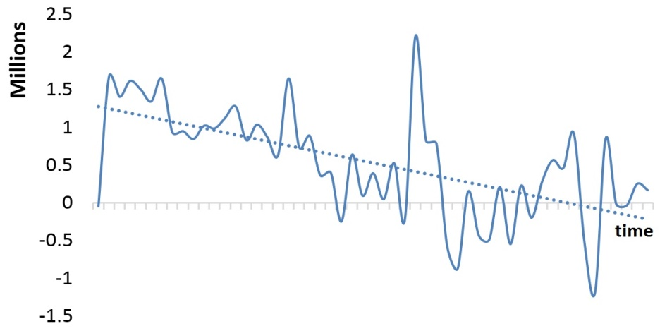
O2 | Sustained Failure  (B = -7060.4,  p = .05) | 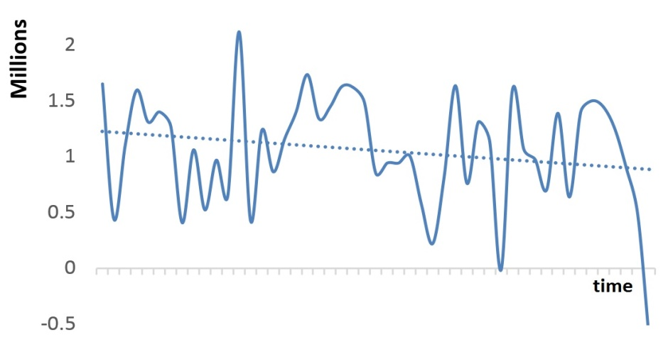
O3 | Episodic Failure  (B = -1135.3,  p = .42) | 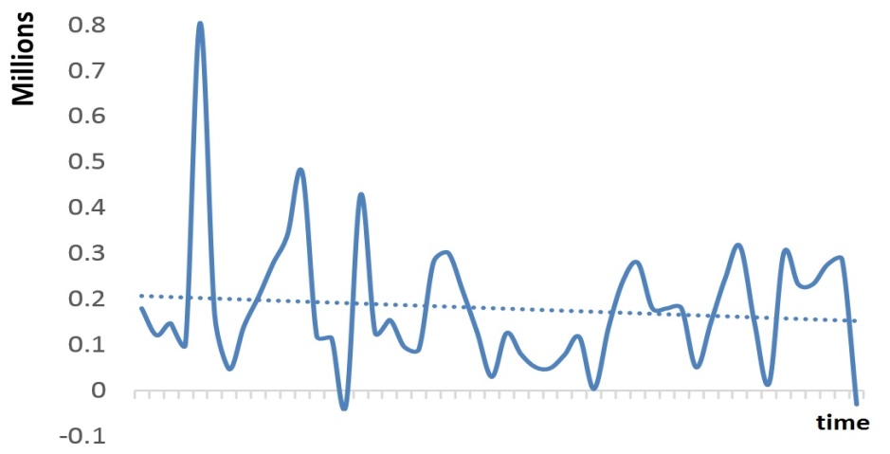
O4 | Episodic Failure  (B = -1929.5,  p = .60) | 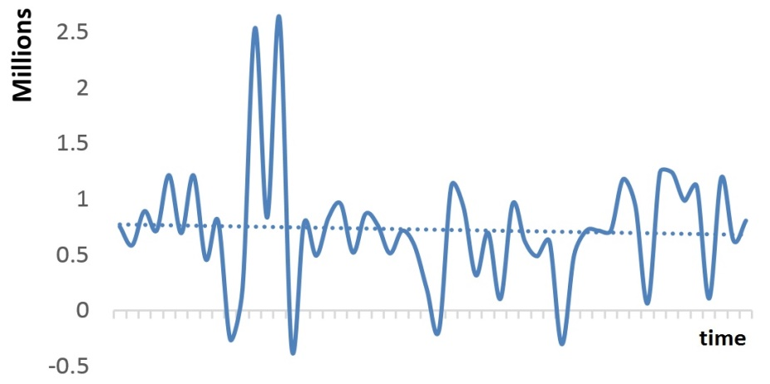
O5 | Episodic Success  (B = 32541,  p =.22) | 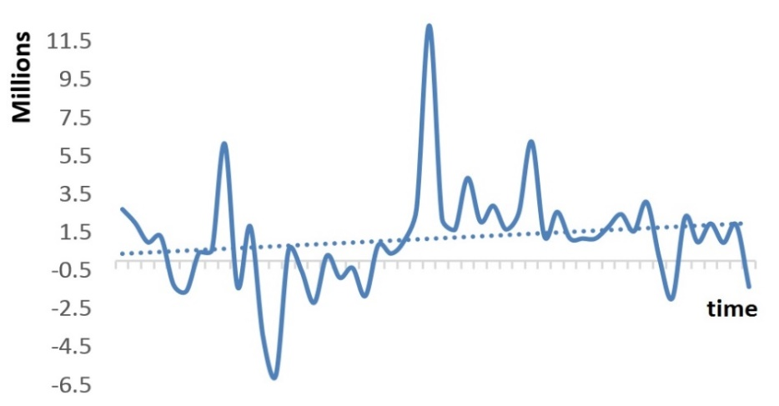
O6 | Episodic Success  (B = 1934,  p = .82) | 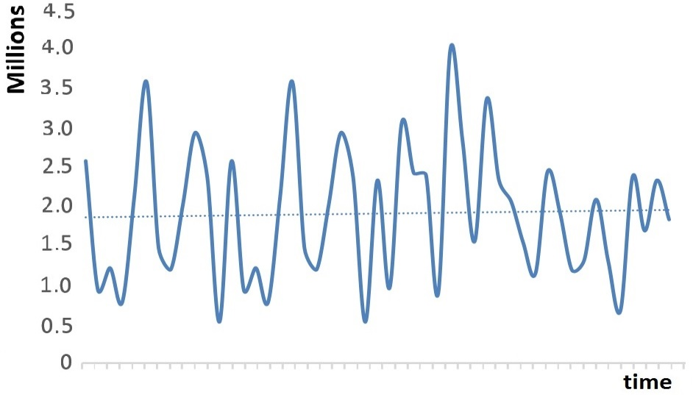
O7 | Sustained Success  (B = 17274,  p = .02) | 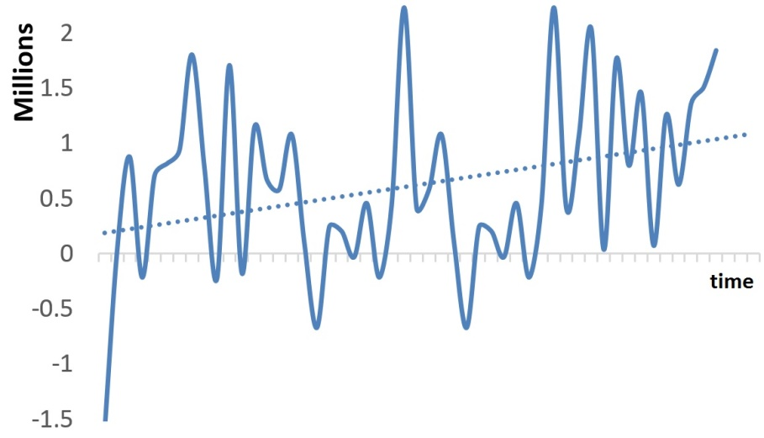

Appendix 2
Analysis of Validity Threat Arising from Endogeneity
Table A2: Random Effects Panel Regression Analyses for Managerial Search Effort (Lagged)
 | Model 1 |  | Model 2 |  | Model 3
Main Effects | β Coeff. (S.E) | Z-Score (Sig) | β Coeff. (S.E) | Z-Score (Sig) | β Coeff. (S.E) | Z-Score (Sig)
OrgPerf _{t-1} | -.018 (.061) | -.30 |  |  | -.328 (.118) | -2.77**
UnitPerf _{t-1} | -.118 (.075) | -1.57 |  |  | -.211 (.165) | -1.28
HAL_{Org t-1} |  |  | -.001 (.044) | -.02 | -.139 (.09) | -1.54
SAL_{Org t-1} |  |  | .034(.078) | .45 | .136 (.082) | 1.64
Interaction Effects
OrgPerf * UnitPerf _{t-1} |  |  |  |  | .329 (.186) | 1.76**
HAL_{Org} * UnitPerf _{t-1} |  |  |  |  | .206 (.089) | 2.32**
SAL_{Org} * UnitPerf _{t-1} |  |  |  |  | .191 (.065) | 2.92**
Control Variable
Reimbursement Rate _{t-1} | .211 (.080) | 2.62** | .002 (.128) | .02 | .180 (.147) | 1.22
Medicaid _{t-1} | .044 (.074) | .60 | .101 (.155) | .65 | .094 (.161) | .59
CaseMix _{t-1} | -.095 (.072) | -1.32 | -.084 (.135) | -.62 | -.200 (.138) | -1.44
Organizations | 7 |  | 7 |  | 7
Time Period
Observations | 273 |  | 262 |  | 262
R-squared
Within | 0.0004 |  | 0.0026 |  | 0.0328
Between | 0.4857 |  | 0.4020 |  | 0.5848
Overall | 0.1063 |  | 0.0775 |  | 0.1798
Wald-Chi (Sig) | 17.02** |  | 1.30 |  | 55.05***
Notes
**p<.05 *** p<.001.
Managerial search effort is the dependent variable.

For example, IBM mainframe utility IFAUSAGE macro supports collection of CPU time and other metrics for a task or a function. See MVS System Management Facilities (SMF), p.131, available at http://publibfp.dhe.ibm.com/epubs/pdf/iea2g2c1.pdf

