UNIVERSITY OF WAIKATO

Hamilton
New Zealand

Vegetative Effects of Fencing and Ungulate Herbivores
in Waingaro, New Zealand: A 10 Year Study

Pamela Kaval

Department of Economics
Working Paper in Economics 11/15
Revised April 2016
Pamela Kaval
Ecological Economist
Hawkes Bay, New Zealand

Email: pam98k@yahoo.com

Abstract
Fencing of remnant native vegetation and removing ungulate populations is commonly used for restoring native biodiversity throughout New Zealand. In this investigation, a complete tree and fern population count was conducted in 2006, 2010, and 2015 for permanent plots to determine if fencing made a difference in Waingaro, New Zealand. It was expected that fencing and the removal of ungulate browsing would increase the number of native plants and the number of palatable preferred plant species. The opposite was observed, with a decrease in native plants and a decrease in palatable species. Therefore, fencing and the removal of ungulate browsing may not be enough to increase the number of native species or increase the number of palatable species under a closed canopy within the timeframes investigated. The removal of non-native vegetation (for example, Selaginella kraussiana) may also be required.

Keywords
native bush regeneration; fencing; grazing exclusion; native vegetation rehabilitation; vegetation survey; browsing; ungulate; biodiversity restoration; Queen Elizabeth covenants; palatable vegetation; unpalatable vegetation

JEL Classification
Q2; Q57; Q12

Acknowledgements

The author would like to thank Thomas Wilding and Kevin Collins with their help in identifying, counting and collecting specimens on the study plots in 2006, 2010 and 2015. The author would also like to thank Chrissen Gemmill and Bruce Clarkson who helped create the idea for the project, as well as Kevin, Eva, Finn and Elmo Collins for their permission to conduct this study on their property. Thomas Wilding must also be acknowledged for his editing assistance.

1. Introduction

In the 1840’s, prior to European settlement, the Waingaro area (west coast, Waikato Region) of New Zealand was a conifer-broadleaved forest (Clarkson et al. 2002 from Leathwick et al. 1995). Canopy species were primarily kahikatea (Dacrycarpus dacrydioides) and totara (Podocarpus totara), in addition to kauri (Agathis australis), kanuka (Kunzea ericoides), mamangi (Coprosma arborea), rimu (Dacrydium cupressinum), tanekaha (Phyllocladus trichomanoides), and rewarewa (Knightia excelsa) (Clarkson et al. 2002, Allan 1961, Poole and Adams 1994 and Salmon 1994). During European settlement, a large proportion of these native trees were harvested; the cleared land was used as pasture for cows and sheep. Today, a large portion of Waingaro is still pastureland, while other parts are being subdivided into lifestyle blocks.

The creation and expansion of pastureland throughout Waingaro and the rest of New Zealand has reduced native forests and native biodiversity (Fahrig 2003, Saunders et al. 1991, Saunders and Norton 2001 and Wright and Cameron 1990). The native vegetation that remains is often confined to forest fragments (Harris and Burns 2000, Burns et al. 1999 and Smale et al. 2005). Since a large proportion of native vegetation in New Zealand is endemic, this depletion of native forestland is of concern to the New Zealand government, especially because over 70% of New Zealand (approximately 19 million hectares) is privately owned (QEII National Trust 2006; Ministry for the Environment 1997).

Harris and Burns (2000), Burns et al. (1999) and Smale et al. (2005) argued that fencing a piece of land in New Zealand to exclude stock will result in the return of a native forest. Consequently, if the native flora is restored, then native fauna (e.g. birds, geckos) should return with it. Since fencing can be an effective way to restore native flora and fauna to a property (Spooner et al. 2002, Lamb 1994 and Smale et al. 2005), the Queen Elizabeth II (QEII) National Trust was created to aid in the conservation of native forest on private land. QEII covenants often require a fence to be erected to surround protected sections of property (QEII National Trust 2006).

The effectiveness of vegetation reintroducing itself to fenced land has been the topic of many research projects in New Zealand. Smale et al. (2005) looked at vegetation in the Waikato Region of New Zealand, the same region as this investigation. The Smale et al. investigation focused on kahikatea (Dacrycarpus dacrydioides) forest fragments that had been fenced for up to 74 years and found that the longer the area had been fenced, the more indigenous plant species were present and the lower the numbers of adventive plant species. After 20 years of fencing, herbaceous pasture plants disappeared, after being out-competed by indigenous plants. Smale et al. concluded that, if no threatening weeds are present, it is possible that fencing alone may achieve near-natural states after 40 or 50 years (Smale et al. 2005).

Fencing can exclude grazing animals, such as cows and sheep, but it does not keep out feral goats (Capra hircus), which can impact the native flora and fauna (Sim and Saunders 1997) in New Zealand, and hence, alter the composition of the plant community. More specifically, cows, sheep and feral goats can reduce palatable species, and by doing this, promote less palatable species to flourish (Wardle et al. 2001).

In the Waingaro area, species that are considered unpalatable to ungulates include miro (Prumnopitys ferruginea), kiwakiwa (Blechnum fluviatile), Coprosma rhamnoides, Coprosma spathulata and the filmy fern or piripiri (Hymenophyllum sanguinolentum). Palatable and preferred browsing species include hangehange (Geniostoma rupestre var. ligustrifolium), mahoe (Melicytus ramiflorus), lancewood (Pseudopanax crassifolius), kamahi (Weinmannia racemosa) and tawa (Beilschmiedia tawa) (Bee et al. 2011, Bee et al. 2007, Husheer et al. 2005, Husheer et al. 2003, Forsyth et al. 2002 and Smale et al. 1995).

To contribute to the literature in this area, I monitored the vegetation on plots in Waingaro, New Zealand over a 10 year period to see if fencing and the removal of ungulate herbivores had a measurable effect on the plant populations. This short communication is a report of my findings.

2. Methods

This study was conducted on a 27 hectare plot of land located on the hill-country in Waingaro (Tainui Ecological Region, Raglan District), next to the mouth of the Waingaro River, where it enters the Raglan Harbour. Six hectares of the land were put into a Queen Elizabeth Trust (QEII) Open Space Covenant in 1998. Part of the regulations for this covenant was that a fence would be erected around the six hectares. This fence was completed in 1999.
In 2006, cows and feral goats were present on the unfenced uncovenanted land, while feral goats, but no cows, were present on the fenced covenanted land. In 2008, another fence was put up to keep cows out of the unfenced area. In 2011, an intense goat control program began, and in 2012, the Waikato Regional Council began possum control on the property and the surrounding area. Consequently, goat numbers in 2015 were likely much lower than 2006, although population estimates were not documented.

To sample vegetation, Elzinga et al. (1998) recommends placing quadrats along a randomly positioned transect as sampling units. Consequently, a randomly positioned transect was drawn. Random 10 metre-by-10 metre permanent plots were then selected in 2006: one within the covenanted (fenced since 1999) area and one in the uncovenanted (fenced since 2008) area. The plots are located inside the edge of the forest (the outside of the forest was pastureland or estuary) at an elevation of 60 metres above sea level.

Plant surveys were completed on 11 Mar 2006, 11 Aug 2010 and 11 Jan 2015, before and after the uncovenanted area was fenced. The same three people conducted the plant population counts on all three occasions. A complete tree and fern population count was conducted each time; grasses, club mosses and mosses were not counted.

To compare the similarity and diversity of the plots for each survey year, the Jaccard Index, or Jaccard Similarity Coefficient, was calculated (Jaccard 1912, Rizzo et al. 2003 and Smith 1990). The Jaccard Index equation used in this investigation was:

$$Jaccard Index=\frac{Number of species common to the 2 plots}{Number of species in the 2 plots}*100=\frac{c}{A+B-c}*100$$
where
c = number of species common to the 2 plots
A = number of species in the first plot
B = number of species in the second plot.

A Jaccard Index value of 100 percent is achieved if two plots have the exact same species, no more and no less, while the value is zero percent if they have no species in common.

3. Results
Both plot locations were found to be dominated by a closed canopy of kanuka (10-15 metres tall), a midstory of silver tree fern (Cyathea dealbata) (3 to 6 metres tall) and an understory of divaricating coprosma’s (Coprosma rhamnoides and Coprosma spathulata). Both plots only had one tree over 35 cm in diameter at breast height (dbh) and over 6 metres in height; this one large tree was a kanuka in the fenced plot and a miro in the uncovenanted plot. Where there was some groundcover in the plots, it appeared to be dominated by the non-native species Selaginella kraussiana. (Figure 1).

Figure 1. Pictures from First Survey in 2006
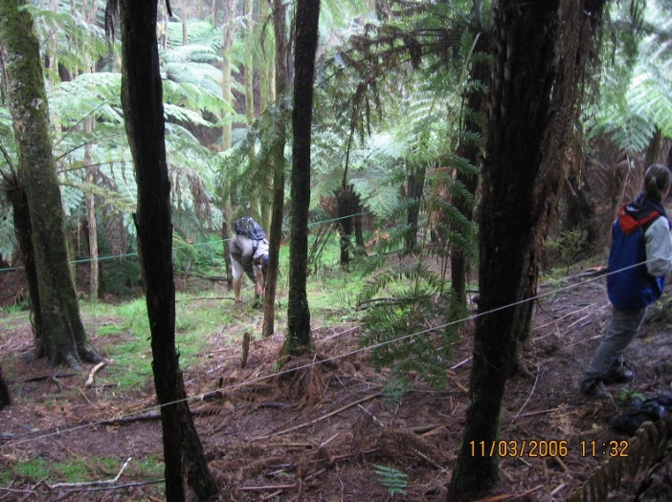

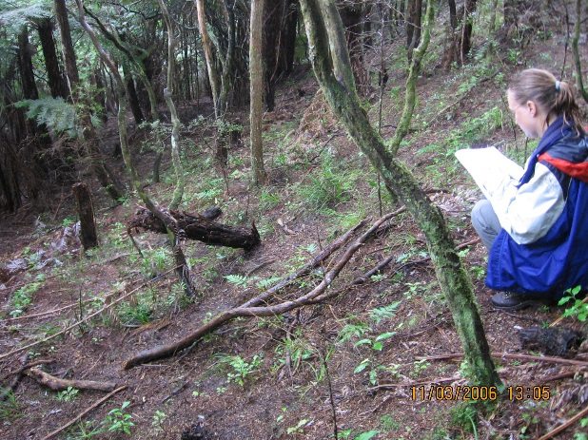

Notes: Uncovenanted (fenced since 2008, two years after this picture was taken) area (top). Covenanted (fenced since 1999) area (bottom). (Pictures courtesy of Kevin Collins).

In 2006, one noticeable difference in the small plants was the consistent browsing damage in the unfenced uncovenanted area (Figure 2). This browsing appeared to have stunted plant growth. Browsing damage to small plants was not observed in the covenanted fenced plot.
Figure 2. Mahoe (Melicytus ramiflorus)
A Preferred Palatable Species

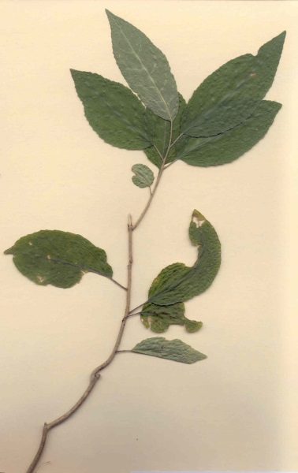
Notes: Plant has been browsed several times (arrowed). This plant was removed from just outside the unfenced plot in 2006. Browsing on Melicytus ramiflorus was evident within the unfenced plot.

Table 1 illustrates the results of the full vegetation count in the two plots. Species with the largest number of plants in both plots included Coprosma rhamnoides, coprosma spathulata, silver tree ferns, mahoe and myrsine. The Jaccard Index values were 56% in 2006, 53% in 2010 and 43% in 2015, indicating that the plots had fewer species in common as time went on, despite the similarity in the ecological conditions and their proximity.

The plants were then divided into three categories: unpalatable species, palatable species and other species. The unpalatable plants present in the plots included miro, kiwakiwa, Coprosma rhamnoides, Coprosma spathulata and piripiri. The palatable species included mahoe, lancewood, kamahi and tawa (Bee et al. 2011, Bee et al. 2007, Husheer et al. 2005, Husheer et al. 2003, Forsyth et al. 2002 and Smale et al. 1995).

Over the duration of the study, using data combined for both plots, the total number of palatable species decreased by 12% (unexpected), the total number of unpalatable avoided species decreased by 21% (expected), and the overall total number of native plants decreased by 12% (unexpected). Note that there were feral goats in both plots for the first (2006) and second (2010) counts, and very few, if any, goats present in 2015.

Table 1. Number of Individual Plants by Species in Uncovenanted and Covenanted Plots
Waingaro, New Zealand 2006, 2010 and 2015

For the covenanted plot (fenced since 1999), goats were present in the 2006 and 2010 counts, but cows were not. The results reveal that the number of palatable species decreased by 17% (unexpected), the number of avoided species increased by 33% (unexpected), and the number of native species remained relatively consistent (decreased by 2%) (unexpected). The results are the opposite of what was expected. Noticeably, of the palatable species in the covenanted plot, the number of mahoe increased (28 to 34), while the number of hangehange and lancewood decreased (48 to 34 and 11 to 3, respectively). In terms of the avoided species, the number of Coprosma rhamnoides almost doubled (20 to 37) (Figure 3).
Figure 3. Number of Palatable and Avoided Species in the Two Plots
(UC2008 = Uncovenanted Plot Fenced in 2008; C1999 = Covenanted Plot Fenced in 1999)

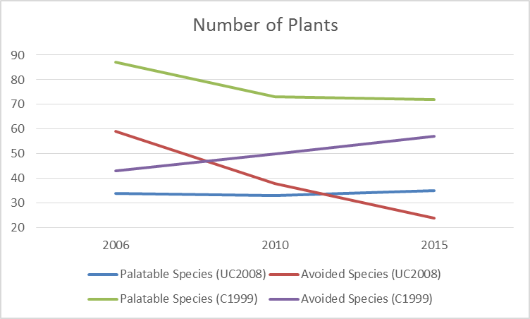

For the uncovenanted plot (fenced since 2008), with the removal of cows from the property in 2008, there was a negligible increase in the number of palatable species (one more plant). More specifically, the decrease in the number of lancewood (not expected) was offset by an increase in the number of mahoe (expected). There was, however, a substantial decrease in the number of avoided species (59%). This was expected and is primarily the result of a decrease in kiwakiwa from 35 in 2006 to 0 in 2015. The Selaginella kraussiana had grown over the kiwakiwa by 2010, smothering 16 of the original 35 plants. In 2015, all kiwakiwa were gone; this also appeared to be the direct result of the smothering by the Selaginella kraussiana. In addition, the number of native plants on the uncovenanted plot decreased by 27%; this also was not expected (Figure 3).

4. Discussion
Lindenmayer et al. (2010) stated that longitudinal studies yield many ecological surprises, or unexpected findings. The first surprise in this longitudinal study was that the number of native plants decreased by 11% (490 in 2006 to 435 in 2015), when it was expected that fencing an area would increase the number of native plants. Most of the decrease in the number of native plants was observed in the uncovenanted area (27%), as the numbers in the covenanted area remained relatively stable (decrease of 2%).

The second surprise was that fencing a piece of land did not lead to an increase in the number of native palatable species. In the covenanted area, the number of palatable species decreased from 87 plants in 2006 to 72 in 2015 (17% decrease). The number of palatable species, however, did not change much in the uncovenanted area, with 34 plants in 2006 and 35 in 2015. What I expected was that the palatable numbers would increase significantly with the removal of cows and goats.

One thing that I expected did occur: the number of avoided species decreased by 21% overall. That being said, there was an increase of 33% in the covenanted plot, which was not expected. In addition, the 59% decrease in the uncovenanted plot appeared to be the direct result of the overgrowth of the non-native plant Selaginella kraussiana and not cows or goats. Therefore, if there were no other information, a researcher could assume that the decrease in the number of unpalatable species was the direct result of the removal of ungulate species; this was not the case. Instead, it appeared to be the result of smothering by an invasive non-native plant.

Prior to the harvesting of large native trees, vegetation in the Waingaro area consisted of kahikatea, totara, kauri, kanuka, mamangi, rimu, tanekaha, and rewarewa (Clarkson et al. 2002). Many of these species are currently present on this property, even if they are not necessarily located in the plots. Present in the permanent plots were totara, kanuka, and rewarewa. Near the uncovenanted plot was a kahikatea over 30 metres in height. Several large totara and tanekaha were also observed on the property.

The property owners hope that the fencing will lead to an increase in the number of native palatable species, as these species can be absent from uncovenanted areas. However, the longitudinal study, to date, did not support this. Perhaps more time must pass before the benefits will be observed. It is possible that the results of this study were climatically driven (for example, drier conditions reducing plant survival), with a longer survey period needed to reveal the benefits of fencing. It is also worth keeping in mind that both plots support mature native vegetation, despite a history of grazing. And, although the abundance of most palatable species decreased with the removal of the ungulates, there was an increase in the number of one palatable species, the mahoe (21% increase in the fenced area and 35% increase in the uncovenanted area). In addition, one palatable species appeared in the fenced area that was not on the plot previously: a tawa.
As in all studies, there are always limitations. This paper presented results from three surveys over a 10 year period for two permanent plots in Waingaro, New Zealand. Since this was an unfunded project, time and resources were limited. If funding could be established in the future, replicate plots could be surveyed across the property and annual data could be collected.

Recommendations for future research include more studies on fencing, ungulates and vegetation, especially considering the effect of both native and non-native plant species, the effect of non-native groundcover, such as Selaginella kraussiana, and the difference in the effect of cows vs. feral goats.

References
Allan, H.H. 1961. (Reprinted 1982). Flora of New Zealand – Volume 1. Botany Division, Department of Scientific and Industrial Research.

Bee, J.N., Kunstler, G., Coomes, and D.A. 2007. Resistance and resilience of New Zealand tree species to browsing. Journal of Ecology. 95: 1014-1026.

Bee, J.N., Tanentzap, A.J., Lee, W.G., Lavers, R.B., Mark, A.F., Mills, J.A., and Coomes, D.A. 2011. Influence of foliar traits on forage selection by introduced red deer in New Zealand. Basic and Applied Ecology. 12: 56-63.

Burns, B.R., Smale, M.C., and Merrett, M.F. 1999. Dynamics of kahikatea forest remnants in Middle North Island: Implications for Threatened and Local Plants. Science for Conservation 113. Department of Conservation. Wellington, NZ. 23 pp.

Clarkson, B., Merrett, M., and Downs, T. 2002. Botany of the Waikato. Waikato Botanical Society Inc., Hamilton.

Elzinga, C.L., Salzer, D.W., and Willoughby, J.W. 1998. Measuring and monitoring plant populations. U.S. Department of the Interior: Bureau of Land Management. BLM/RS/ST-98/005+1730. 477 pp.

Fahrig, L. 2003. Effects of habitat fragmentation on biodiversity. Annual Review of Ecology, Evolution, and Systematics. 34: 487-515.

Forsyth, D.M., Coomes, D.A., Nugent, G., and Hall, G.M.J. 2002. Diet and diet preferences of introduced ungulates (Order: Artiodactyla) in New Zealand. New Zealand Journal of Zoology. 29:323-343.

Harris, R.J., and Burns, B.R. 2000. Beetle assemblages of kahikatea forest fragments. New Zealand Journal of Ecology. 24(1): 57-67.

Husheer, S.W., Coomes, D.A., and Robertson, A.W. 2003. Long-term influences of introduced deer on the composition and structure of New Zealand Nothofagus forests. Forest Ecology and Management. 181: 99-117.

Husheer, S.W., Hansen, Q.W., and Urlich, S.C. 2005. Effects of red deer on tree regeneration and growth in Aorangi Forest, Wairarapa. New Zealand Journal of Ecology. 29(2): 271-277.

Jaccard, P. 1912. The distribution of the flora in the alpine zone. New Phytologist. 11(2): 37-50.

Lamb, D. 1994. Restoration of degraded forest ecosystems for nature conservation. In: Conservation Biology in Australia and Oceania (eds. C. Moritz and J. Kikkawa) pp.101-114. Surrey Beatty and Sons, Chipping Norton.

Leathwick, J.R., Clarkson, B., and Whaley, P. 1995. Vegetation of the Waikato Region: Current and Historical Perspectives. Landcare Research Contract Report LC9596/022 to Environment Waikato, Hamilton.

Lindenmayer, D.B., Likens, G.E., Krebs, C.J., and Hobbs, R.J. 2010. Improved probability of detection of ecological 'surprises.' PNAS, 107(51): 21957-21962.

Ministry for the Environment. 1997. The State of Our Biodiversity. In: The State of New Zealand’s Environment 1997. GP Publications, Wellington.

Poole, A.L., and Adams, N.M. 1994. Trees and Shrubs of New Zealand. Landcare Research, New Zealand.

Queen Elizabeth II (QEII) National Trust. 2006. The QEII National Trust. www.nationaltrust.org.nz.

Rizzo, W.M., Wilson, G.D., and Fairchild, J.F. 2003. Water quality in streams of tallgrass prairie national preserve: Inferences from chemical, physical, and macroinvertebrate data. In: Fore, S. (ed.) Proceedings of the 18th North American Prairie Conference: Promoting Prairie. 127-135.

Salmon, J.T. 1994. The Reed Field Guide to New Zealand Native Trees. Reed Publishing, Wellington, New Zealand.

Saunders, A., and Norton, D.A. 2001. Ecological restoration at mainland islands in New Zealand. Biological Conservation. 99: 109-119.

Shannon, C.E. 1948. A mathematical theory of communication. Bell System Technical Journal, 27: 379– 423.

Sim, J., and Saunders, A. (Eds.) 1997. Predator workshop proceedings. 21-24 April 1997, St. Arnaud, Nelson Lakes.

Smale, M.C., Ross, C.W., and Arnold, G.C. 2005. Vegetation recovery in rural kahikatea (Dacrycarpus dacrydioides) forest fragments in the Waikato Region, New Zealand, following retirement from grazing. New Zealand Journal of Ecology. 29(2): 261-269.

Smale, M.C., Hall, G.M., and Gardner, R.O. 1995. Dynamics of Kanuka (Kunzea ericoides) Forest on South Kaipara Spit, New Zealand, and the impact of fallow deer (Dama dama). New Zealand Journal of Ecology. 19(2): 131-141.

Smith, R.L. 1990. Ecology and field biology. New York: Harper and Row; 1990. 922 pp.

Spooner, P., Lunt, I., and Robinson, W. 2002. Is fencing enough? The short-term effects of stock exclusion in remnant grassy woodlands in Southern NSW. Ecological Management and Restoration. 3(2):117-126.

Wardle, D., Barker, G.M., Yeates, G.W., Bonner, K.I, and Ghani, A. 2001. Introduced browsing mammals in New Zealand natural forests: Aboveground and belowground consequences. Ecological Monographs. 71(4): 587-614.

Wright, A.E., and Cameron, E.C. 1990. Vegetation management on Northern Offshore Islands. In Towns, D. R., Daugherty, C. H., Atkinson, I. A. (Eds.). Ecological Restoration of New Zealand Islands. Conservation Sciences Publications No. 2, 221-239. Department of Conservation, Wellington.

The geographic coordinate point in the centre of the two permanently established plots is Latitude -37° 44’, Longitude -174° 57’.

